Mechanical 'Done' and the Proven-Better-New Product Playbook
PM Daily Digest
2026-06-15

Mechanical ‘Done’ and the Proven-Better-New Product Playbook
By PM Daily Digest • June 15, 2026
This brief covers two strong PM themes from the latest sources: Mark Pincus’s proven-better-new framework for building successful products, and the shift toward machine-checkable specs when AI agents execute product work. It also includes concrete execution tactics, product case studies, leadership lessons, and one trust-and-safety workflow worth studying.

Big Ideas
- Proven, Better, New beats novelty-first product design. Mark Pincus says 8 of his 10 major launches became massive hits, and he now summarizes the approach as “Proven. Better. New.” [1] The logic: instincts are usually right, but ideas are often wrong, so start from what is already proven for the same platform, audience, and experience; make it clearly better for existing users; then add only a small layer of novelty [2]. Why it matters: it reduces avoidable failure. Apply it: write three lists before building—what is proven, what existing users would clearly value as better, and the smallest new idea worth testing [2].
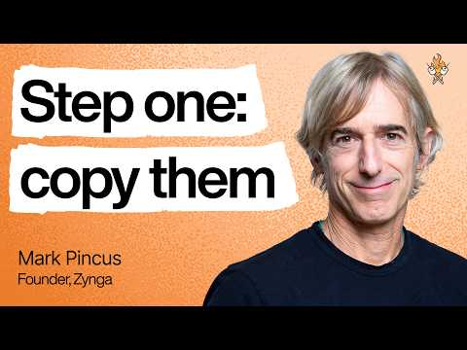 The hidden pattern behind successful products | Mark Pincus (FarmVille, Words with Friends, & more) (3:44)
- In agent workflows, “done” has to be mechanical. Aakash Gupta argues that humans used to fill in gaps in vague specs, but AI agents execute literal instructions, turning ambiguity into token waste and silent failure [3]. Why it matters: acceptance criteria are no longer optional polish; they determine whether the work can be verified at all. Apply it: define a binary finish line and the exact evidence a checker can confirm from the transcript [3].
“Defining ‘done’ was always the job. The agents just stopped letting us skip it.” [3]

Tactical Playbook
- Use a two-model completion loop for AI work. One model does the task and prints evidence; a second, cheaper model decides only whether the condition is met [3]. Why it matters: it separates generation from judgment. Apply it: keep the evaluator blind to intent and limited to pass/fail review of the transcript [3].
- Turn every agent spec into four fields. Gupta’s checklist is: Finish Line (binary outcome), Prove It (exact evidence in chat), Show Me (what is waiting on return), and an escape hatch to stop pointless retries [3]. Why it matters: each field removes a specific failure mode. Apply it: reject any spec that cannot be checked word-for-word by a machine [3].
- Use AI to kill weak ideas faster, not just ship them faster. Pincus argues AI should be a testing or failure machine that can try far more ideas in a day, helping teams distinguish belief from hope [2]. Why it matters: speed without selection can just produce more mediocre launches. Apply it: build cheap experiments around the uncertain “new” element and cut B+ concepts quickly when the signal is not obvious [2].

Case Studies & Lessons
- Words with Friends: Pincus describes it as proven Scrabble mechanics, better mobile polish, and a new social layer tied to friends on Facebook; the result was a hit with 14 million DAUs [2]. Why it matters: strong outcomes can come from disciplined recombination, not originality for its own sake. Apply it: pressure-test whether your “better” is visible to existing users before betting on the “new.”
- Zynga’s retention lens: Pincus says Zynga prioritized retention over virality and even tracked day-365 retention [2]. Why it matters: products that feel temporary rarely become durable businesses. Apply it: ask early what would make the product worth using a year from now, not just next week [2].
- Start smaller than your ambition suggests. Pincus says many big products began from humble starting points, including Facebook at Harvard and Zynga’s poker app on Facebook [2]. Why it matters: over-ambition can make teams miss product-market fit. Apply it: narrow the first use case until it feels almost uncomfortably specific [2].

Career Corner
- Stay close to the metal, but give people a hill to own. Pincus argues product leaders should remain deeply involved in important UX details while also making team members the “CEO” of their area, with operating control, plan, and budget [2]. He also says a CEO’s number-one job is to be right [2]. Why it matters: leverage comes from better decisions, not just more delegation. Apply it: give clear ownership boundaries, then stay personally involved in the few product choices that most affect user experience [2].

Tools & Resources
- Priority queues for AI moderation review. Brian at Musubi describes a tool that visualizes embedding spaces to surface the biggest disagreements between LLM and human moderation decisions first, reducing a long queue to five focused tasks a day [4]. Why it matters: review capacity goes to the highest-value policy gaps. Apply it: if you own trust, safety, or AI quality, look for ways to rank eval review by disagreement severity instead of processing cases in order.

Sources
- 𝕏 post by @lennysan
- The hidden pattern behind successful products | Mark Pincus (FarmVille, Words with Friends, & more)
- substack
- 𝕏 post by @ttorres

