Micro-Skills Beat Prompt Sprawl; OpenClaw Lands on Windows and Codex Ships Sites
Coding Agents Alpha Tracker
2026-06-03

Micro-Skills Beat Prompt Sprawl; OpenClaw Lands on Windows and Codex Ships Sites
By Coding Agents Alpha Tracker • June 3, 2026
The useful pattern today isn’t more prompt engineering — it’s smaller skills, tighter harnesses, and loops that survive model churn. Also covered: OpenClaw’s enterprise Windows push, Codex Sites plus Convex workflows, Copilot’s expanding agent stack, and concrete runtime updates from Cursor, LangSmith, and Microsoft.

🔥 TOP SIGNAL
The pattern worth stealing today: shrink the prompt surface, strengthen the harness. Kyle Daigle says GitHub has moved away from brittle mega-skills toward tiny composable skills [1], Theo argues AgentMD / Claude.md / system-prompt sprawl silently decays as models change and should be cut back to concrete project facts [2], and Boris Cherny says his own Claude Code workflow has already climbed from prompting directly to writing loops that prompt Claude for him [3]. Theo also points to benchmarks where Opus performs roughly 10-30% better in Cursor than in Claude Code, which is a strong reminder that harness choice can matter as much as model choice [2]. Cursor is making the same point from the infra side: a serious cloud agent needs durable execution and a powerful harness, not just a local agent moved to a server [4].
“My job is to write loops.” [3]

⚡ TRY THIS
- Do a prompt-debt cleanup pass before you test another model. Audit every AgentMD, Claude.md, system prompt, MCP server, plugin, and skill; delete stale files, keep only concrete project facts, remove behavior-steering fluff like think step by step or you're a skilled engineer, and leave unnecessary MCPs and skills off by default. Theo’s advice for new models: start with the smallest possible harness, then add tools only when the task actually needs them [2].
- Break one brittle mega-skill into micro-skills. Kyle Daigle’s pattern is to make each skill atomic and single-purpose, then compose them via orchestration instead of hiding everything inside one giant instruction blob. Share the pieces in a repo and run them from the CLI or Copilot desktop app; keep the underlying tool separate from audience instructions so the same summarizer can be reused for analysts, customers, or internal teams [1].
- Automate a backward-looking retro into GitHub. Kyle’s workflow pulls PRs, posts, Obsidian notes, Teams transcripts via Work IQ, and Slack, then asks the agent to say what happened this week, what worked, what didn’t, and what to change over the next 3-4 days. He runs this from the Copilot desktop app / CLI and posts the output into GitHub issues or discussions via agentic GitHub Actions [1].
- Turn repeated prompting into loops or precomputed programs. Boris Cherny’s progression at Anthropic: prompt Claude directly, then run 5-10 Claude instances in parallel, then write orchestration loops that do the prompting for you. For repeated tasks, have the model write a program you can run over and over instead of paying for fresh inference each time, and capture team-specific know-how as reusable skills, like how your team queries the database [3].

📡 WHAT SHIPPED
- OpenClaw landed on Windows with enterprise-shaped controls. The new Windows companion app can connect to claws on Windows or WSL, sandbox tool calls with Microsoft Execution Containers and process isolation, and gate access at the folder, clipboard, and internet level. Peter Steinberger also added observability, auto-permissions, non-binary folder access, and a harness plugin so you can layer OpenClaw on top of Copilot / Codex for persistent memory, heartbeats, and Slack / Teams use; the security push was driven by repeated can-I-use-this-at-work feedback, and the OpenClaw Foundation is meant to keep it model- and OS-agnostic [5].
- Codex added more day-to-day app-building surface area. OpenAI’s latest update adds website hosting and sharing for business-plan users, improved plugins and skills for broader roles, and visual annotation feedback inside docs, slides, sheets, and more. Riley Brown’s same-day practitioner take: Codex Sites plus the new Convex plugin make internal tools fast to build, including a todo app whose agent can write and edit the DB; current limitation, sites still cannot be public. Official details: openai.com/index/codex-for-every-role-tool-workflow/ [6, 7, 8, 9].
- GitHub Copilot is converging into one agent stack. Kyle Daigle says the CLI, desktop app, and cloud agents now share one SDK and harness, with the scope expanding from code completion into security remediation, issue handling, and repo / docs automation. Kent C. Dodds put the new GitHub Copilot App on roughly 30 broken workshop jobs in parallel and said it looked like it was working; PR: epicshop/pull/612 [1, 10, 11].
- Claude Code’s internal adoption signal from Anthropic is still strong. Boris Cherny says lines of code and PR volume per engineer have grown by many hundreds of percentage points since release, new-hire ramp-up dropped from weeks to about two days, and the product surface now spans CLI, desktop, iOS, Android, Slack, and GitHub, with plan mode emerging from actual usage [3].
- Cursor’s lesson post is blunt: runtime beats simple hosting. Cursor says good cloud agents require durable execution, a powerful harness, and infrastructure that gives agents realistic dev environments. External comparison worth noting: Theo says some benchmarks show Opus improving by roughly 10-30% in Cursor versus Claude Code. Lessons: cursor.com/blog/cloud-agent-lessons [4, 2].
- LangChain shipped practical branch-and-recover primitives. LangSmith Sandboxes GA now supports snapshots and cheap forks: capture a running sandbox, spin up 10 parallel branches for roughly the cost of one, and restore when the agent goes down the wrong path. Fleet access profiles let sandboxed agents call protected services without exposing the secret inside the environment; docs: sandbox snapshots and access profiles [12, 13, 14].
- Microsoft shipped smaller new models for code and reasoning. MAI-Code-1-Flash is a 5B model purpose-built for GitHub Copilot and VS Code and is rolling out to Copilot individual users in VS Code. MAI-Thinking-1 is a 35B reasoning model that Microsoft says beat Sonnet 4.6 in blind human side-by-side evaluations; Simon Willison highlights Microsoft’s statement that MAI-Code-1-Flash was built end-to-end using clean and appropriately licensed data [15].

🎬 GO DEEPER
- 6:29-7:48 — Kyle Daigle on the backward-looking loop. If you steal one workflow today, make it this one: mine PRs, notes, transcripts, and Slack, then turn the past week into a short forward plan [1].
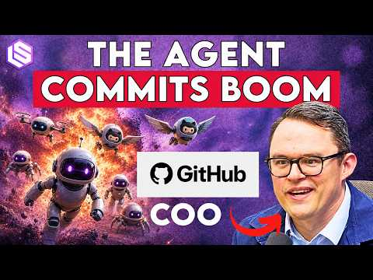 GitHub’s Agent Era: 14x Commits, 200M Developers, Copilot’s Next Act — Kyle Daigle (6:28)
- 12:11-13:27 — Kyle Daigle on micro-skills over mega-skills. A clean short argument for atomic skills that do one thing well and stay maintainable as workflows change [1].
GitHub’s Agent Era: 14x Commits, 200M Developers, Copilot’s Next Act — Kyle Daigle (12:11)
- 11:16-11:53 — Boris Cherny on climbing the abstraction ladder. Watch the jump from IDE autocomplete to 5-10 parallel Claude instances to loops that do the prompting for him [3].
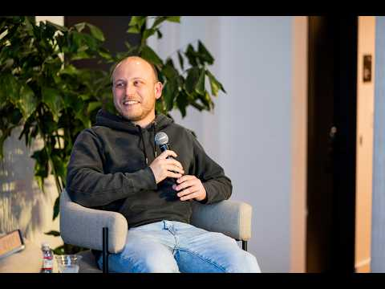 Boris Cherny: Claude Code & the Future of Engineering | Acquired Unplugged presented by WorkOS (11:16)
- PR worth studying — Kent C. Dodds’ Copilot App fix run. If you want a concrete artifact from multi-job agent debugging, start with epicshop/pull/612 [10, 11].
- Docs worth reading — Cursor cloud-agent lessons + LangSmith snapshots. Cursor’s post is useful for runtime architecture; LangSmith’s docs are the practical reference for fork / restore branching in sandboxes. cursor.com/blog/cloud-agent-lessons [4] and docs.langchain.com/langsmith/sandbox-snapshots [12].
Editorial take: the edge is moving away from giant custom prompt piles and toward maintainable runtimes — minimal harnesses, atomic skills, and loops you can still live with after the next model update [2, 1, 3, 4].

Sources
- GitHub’s Agent Era: 14x Commits, 200M Developers, Copilot’s Next Act — Kyle Daigle
- Your prompts are tech debt.
- Boris Cherny: Claude Code & the Future of Engineering | Acquired Unplugged presented by WorkOS
- 𝕏 post by @cursor_ai
- OpenClaw + Windows: Microsoft Build 2026
- 𝕏 post by @thsottiaux
- 𝕏 post by @thsottiaux
- 𝕏 post by @rileybrown
- 𝕏 post by @rileybrown
- 𝕏 post by @kentcdodds
- 𝕏 post by @kentcdodds
- 𝕏 post by @LangChain
- 𝕏 post by @BraceSproul
- 𝕏 post by @LangChain
- Microsoft’s new MAI models

