Microcosm, Genentech’s Origin Story, and Bryon Hargis’s Reading Stack
Recommended Reading from Tech Founders
2026-06-03

Microcosm, Genentech’s Origin Story, and Bryon Hargis’s Reading Stack
By Recommended Reading from Tech Founders • June 3, 2026
Mark Pincus’s endorsement of George Gilder’s Microcosm was the clearest high-signal recommendation today because it directly shaped how he framed an early cable/internet opportunity. Jake Becraft added a strong case for the Genentech origin story, while Bryon Hargis surfaced a broader stack spanning aerospace, entrepreneurship, and physics.

Most compelling recommendation

Microcosm — George Gilder
- Content type: Book [1]
- Link/URL: No direct resource URL was provided in the notes; context episode: The Hidden Pattern Behind Winning Products | Farmville creator Mark Pincus [1]
- Who recommended it: Mark Pincus [1]
- Key takeaway: Pincus said the book helped him argue in a TCI job interview that the company was positioned for the coming “information superhighway” before the internet existed [1]
- Why it matters: This was the strongest recommendation in today’s set because it was tied to a concrete action: Pincus used the book’s framing to position an industry thesis in an important career moment [1]
“Because I read this book by this guy, George Gilder called Microcosm, and I think that your company is positioned for this coming, you know, information superighway.” [1] 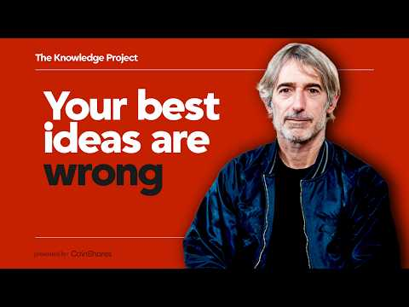 The Hidden Pattern Behind Winning Products | Farmville creator Mark Pincus (7:19)

Best company-building case study

Genentech origin story book
- Content type: Book [2]
- Author/creator: Not specified in the provided notes
- Link/URL: No direct resource URL was provided in the notes; context episode: Reimagining Biotech with Jake Becraft of Strand Therapeutics — Tim’s Founder Kitchen [2]
- Who recommended it: Jake Becraft, in conversation with Tim Ferriss [2]
- Key takeaway: Becraft called it one of the best business books he has read because it includes actual contracts, negotiations, mistakes, serendipitous moments, and unforced errors that had to come together for Genentech to survive [2]
- Why it matters: The recommendation points readers toward a company history grounded in operating detail rather than abstraction [2]

Broader reading stack from Bryon Hargis
Bryon Hargis surfaced the widest reading stack in today’s set, spanning aerospace memoir, startup management, and physics [3]
- Carrying the Fire: An Astronaut’s Journeys — Content type: Book. Author/creator: Michael Collins. Link/URL: Amazon. Who recommended it: Bryon Hargis. Key takeaway: Included in Hargis’s book recommendations. Why it matters: It adds an astronaut memoir to a list otherwise heavy on operators and technical material [3]
- Skunk Works: A Personal Memoir of My Years at Lockheed — Content type: Book. Author/creator: Not specified in the provided notes. Link/URL: Amazon. Who recommended it: Bryon Hargis. Key takeaway: Included in Hargis’s book recommendations. Why it matters: It adds Lockheed operating history to the same stack [3]
- The Hard Thing About Hard Things — Content type: Book. Author/creator: Ben Horowitz. Link/URL: Amazon. Who recommended it: Bryon Hargis. Key takeaway: Included in Hargis’s book recommendations. Why it matters: It is the clearest startup-management title in Hargis’s set [3]
- Gravitation — Content type: Book. Author/creator: Misner, Thorne, Wheeler. Link/URL: Amazon. Who recommended it: Bryon Hargis. Key takeaway: Included in Hargis’s book recommendations. Why it matters: It shows the list extends into fundamental physics [3]
- “Surely You’re Joking, Mr. Feynman!” — Content type: Book. Author/creator: Richard Feynman. Link/URL: Amazon. Who recommended it: Bryon Hargis. Key takeaway: Included in Hargis’s book recommendations. Why it matters: It adds a Richard Feynman title to a stack that already includes Gravitation [3]
- Perfectly Reasonable Deviations from the Beaten Track — Content type: Book. Author/creator: Richard Feynman. Link/URL: Amazon. Who recommended it: Bryon Hargis. Key takeaway: Included in Hargis’s book recommendations. Why it matters: Together with the other Feynman pick, it makes scientific reading a visible part of Hargis’s list [3]

What stands out
The highest-signal recommendations today were the ones attached to real decisions and real operating detail. Microcosm mattered to Mark Pincus because it helped him frame an approaching industry shift, while the Genentech origin story stood out because Jake Becraft emphasized the contracts, negotiations, mistakes, and lucky breaks behind a company’s survival. Hargis’s list broadens the mix toward aerospace, entrepreneurship, and physics [1, 2, 3]

Sources
- The Hidden Pattern Behind Winning Products | Farmville creator Mark Pincus
- Reimagining Biotech with Jake Becraft of Strand Therapeutics — Tim’s Founder Kitchen
- What America Is Missing Between Sanctions and Nuclear War (Bryon Hargis, Co-Founder & CEO of Castelion)

