Netris, Scaled Cognition, and the Open-Source Pressure Reshaping Early AI Bets
VC Tech Radar
2026-06-26

Netris, Scaled Cognition, and the Open-Source Pressure Reshaping Early AI Bets
By VC Tech Radar • June 26, 2026
Early-stage funding clustered around AI reliability, GPU-cluster networking, and world-model training, while Judgment Labs, 11x, and Legora offered fresh team and distribution signals. The broader backdrop is tougher: open-source competition is intensifying, compute remains scarce, and investors are shifting hard toward ROI, margins, and shipping velocity.

1) Funding & Deals
- Netris — $15M Series A led by a16z. Netris is building a network automation and multi-tenancy layer for AI GPU clusters across East-West, OOB, North-South, Ethernet, InfiniBand, RDMA, and RoCE environments [1, 2]. The operating signal is strong for this stage: the company says ARR grew 800% in the last 12 months, it has 35+ live AI cluster deployments, and operators run close-to-$1B data centers on the platform [1, 2]. Founder Alex Saroyan said Netris started in 2018 to make hyperscaler-grade network automation available to any operator [1].
- Scaled Cognition — $100M Series A led by Vinod Khosla and Khosla Ventures. Founders Dan Roth and Dan Klein say the company is focused on AI reliability, and Vinod Khosla framed the product as a fit for applications that cannot tolerate hallucinations, especially customer support [3, 4].
- General Intuition — $320M Series A at a $2.3B valuation. The company says it is training large action foundation models on billions of action-labeled gameplay clips from 17M monthly active users on Medal, then using world models to generate infinite training environments; the round was led by Khosla Ventures with General Catalyst, Eric Schmidt, and Jeff Bezos [5]. Vinod Khosla described it as a bet on winning the world-model race and on human-like intuition emerging from the system [6].

2) Emerging Teams
- Judgment Labs stands out as a serious agent-infrastructure team. Alex Shan entered Stanford at 16, spent time as the only undergraduate in Chris Manning’s NLP lab, coauthored papers with Manning and DeepMind researchers, and later built early agentic products at Juniper Networks [7]. Cofounder Andrew previously worked as an early research scientist at Together AI on post-training and evals, while Joseph joined from Datadog on systems and infrastructure [7]. The company is building an improvement layer for AI agents that monitors production data, surfaces failure modes, and aims to put agent improvement on autopilot; Lightspeed says it led both the seed and Series A, and Shan said the Series A was led without a deck or memo [7].
- 11x offers one of the clearest looks at an agent-native operating model. a16z says 11x’s revenue agents are already generating hundreds of millions of dollars in customer pipeline [8]. CEO Prabhav Jain previously led engineering at Brex and served as 11x’s CTO before becoming CEO, which a16z described as part of a broader technical-CEO pattern in agentic companies [9]. The company uses agents for qualification, deal handoff, codebase Q&A, PR verification, and CEO briefing workflows across Slack, Claude-based skills, LangSmith Fleet, Notion, Granola, and custom testing infrastructure [10, 11, 12, 13, 14].
- Legora has a meaningful startup-distribution wedge. Garry Tan called it the defining legal AI startup, and Cooley launched Cooley GO Lab on the Legora Portal to bring legal workflows and knowledge directly to YC founders [15, 16].

3) AI & Tech Breakthroughs
- Multi-model committees may be more important than a single frontier model in some workflows. A Reddit post highlighted a mixture-of-agents paper where a stack of cheaper open models beat GPT-4o on AlpacaEval 2.0 by 65.1 to 57.5, with the author arguing that decorrelated errors, not any one model’s strength, drove the improvement [17]. The same builder open-sourced a consensus-rnd implementation that requires multiple models to agree before changes are merged [18]. Another commenter pointed to Sakana AI’s Fugu as a related system operating at scale [19].
- Runway is pushing from generation tools toward autonomous creative execution. Runway says Agent 2.0 can turn a simple prompt into marketing briefs, campaign assets, and performance analysis across platforms [20]. Cofounder Cristóbal Valenzuela compared the shift from clip generation to finished video with the move from code autocomplete to models that write working software, and said the release had been years in the making [21].
- Judgment Labs is making a different infrastructure bet than first-generation agent tooling. The team says agents, not humans, will be the primary users of the product, and that the right platform should focus on behaviors, trajectories, and proactive self-improvement rather than latency and cost alone [7]. Lightspeed said it prefers companies whose core business lives or dies by agent quality, which fits the same direction of travel [7].

4) Market Signals
- Open-source pressure is rising from both competition and regulation. In a 20VC discussion, speakers said DeepSeek closed a $7.4B Series A at roughly a $50B valuation, with the founder committing about $3B and the Chinese state retaining governance control [22]. The same discussion said Zhipu AI’s GLM 5.2 beat GPT-5.5 on coding benchmarks and that roughly six Chinese open-source models now compete at or near US frontier performance, creating pricing pressure on closed-source middle-tier vendors [22]. Harry Stebbings separately argued that heavily subsidized open-source models are squeezing the number-three closed-source vendor, while Marc Andreessen agreed with the view that the US government could still effectively stop US companies from using, hosting, or serving open-weight models [23, 24, 25].
- Talent concentration and shipping velocity are still decisive. A 20VC episode and Harry Stebbings both highlighted Google losing Noam Shazeer and John Jumper to Anthropic within 48 hours [22, 23]. Harry Stebbings and Jason Lemkin framed the current startup model as lean, elite, highly compensated teams working intensely in person [23, 26]. Leo Polovets added that in deep tech, weekly versus monthly iteration cycles compound sharply over a roughly 24-month runway, and that even founder language about next week versus next year can signal shipping velocity [27].
The playbook for building the first 100 employees of a startup has fundamentally changed. [26]
- Capital is concentrating upward while compute remains scarce. Newcomer quoted Recursive CTO Josh Tobin saying GPUs are essentially sold out globally, with reservations running 6 to 18 months in advance, and that many foundation-model companies expect the crunch to worsen [28]. SaaStr said AI took roughly 80% of global VC in Q1 2026, with OpenAI, Anthropic, xAI, and Waymo pulling in about 65% of the quarter’s dollars; late-stage rounds captured about 82% of capital while fewer than 3% of deals absorbed nearly 80% of the money [29]. In Newcomer’s CVAI London survey, most respondents said there is an AI bubble, but 51% said it would not burst this year; 54% said Anthropic was the private unicorn they would most like to own at today’s price, while 33% chose OpenAI as the one they would most like to short [28].
- AI buyers and investors are moving from experimentation to ROI and margin discipline. Harry Stebbings argued that enterprise budgets are shifting from unconstrained token spending toward verified efficiency or revenue gains by 2027 [23]. In the same direction, a 20VC discussion cited the view that many Series A and B companies now fail to raise because delivery costs leave too little margin, not because growth is too slow [22]. That makes examples of real workflow automation more important: the same discussion described an AI VP of Finance agent that handled quotes, contracts, invoicing, Salesforce, bill.com, Brex, and QuickBooks tasks end to end [22].

5) Worth Your Time
- Judgment Labs / Lightspeed interview — the best primary source here on agent-improvement infrastructure, Alex Shan’s background, and the idea that agents will become the real users of agent tooling [7].
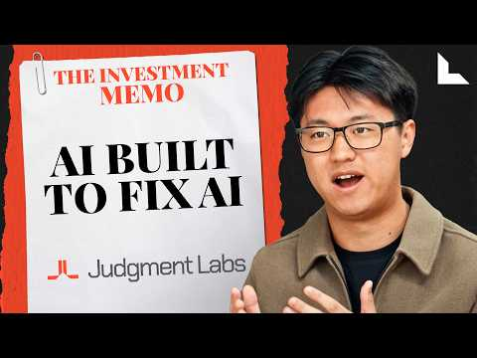 The Reason Your AI Agents Keep Failing | Alex Shan, Judgment Labs (12:15)
- a16z’s 11x thread — worth reading for concrete examples of qualification agents, handoff agents, codebase agents, and PR verification harnesses already running inside one company [8, 10, 11, 12, 13, 14].
- 20VC: Wall St’s $725BN AI Question — useful for one discussion that ties together frontier-lab talent moves, Chinese open-source competition, and the return of margin scrutiny [22].
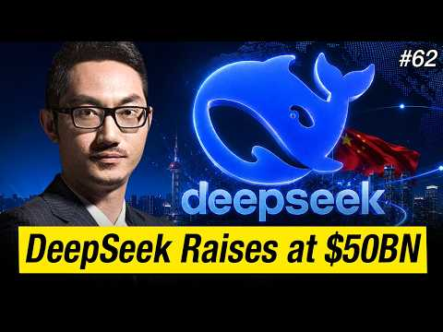 Wall St’s $725BN AI Question | The Rise of Open Source & How it Threatens OpenAI & Anthropic (48:39)
- Newcomer’s CVAI London notes — the strongest single read in this batch on compute shortages, bubble sentiment, Anthropic/OpenAI positioning, and unresolved agent form factors [28].
- TechCrunch on Forethought — a useful operator interview on finding PMF in customer-support AI, from pre-GPT RNN-based systems to copilots, voice agents, and browser agents [30].

Sources
- 𝕏 post by @alex_saroyan
- 𝕏 post by @a16z
- 𝕏 post by @ScaledCognition
- 𝕏 post by @vkhosla
- 𝕏 post by @gen_intuition
- 𝕏 post by @vkhosla
- The Reason Your AI Agents Keep Failing | Alex Shan, Judgment Labs
- 𝕏 post by @a16z
- 𝕏 post by @a16z
- 𝕏 post by @a16z
- 𝕏 post by @a16z
- 𝕏 post by @a16z
- 𝕏 post by @a16z
- 𝕏 post by @a16z
- 𝕏 post by @garrytan
- 𝕏 post by @MaxJunestrand
- r/artificial post by u/Chrono-Ctkm
- r/artificial comment by u/Chrono-Ctkm
- r/artificial comment by u/Chrono-Ctkm
- 𝕏 post by @runwayml
- 𝕏 post by @c_valenzuelab
- Wall St’s $725BN AI Question | The Rise of Open Source & How it Threatens OpenAI & Anthropic
- 𝕏 post by @HarryStebbings
- 𝕏 post by @emollick
- 𝕏 post by @pmarca
- 𝕏 post by @HarryStebbings
- 𝕏 post by @lpolovets
- CVAI London: European Democracies on Alert, Bubble Worries, Anthropic Bullishness, Agents & Compute Shortages
- What VCs Are Hunting Today: $100B in 10 Years
- The 7-Failure Rule: How Forethought AI Found Product-Market Fit with Co-Founder Deon Nicholas

