Open Multimodal Models and AI-Native Services Take Shape
VC Tech Radar
2026-07-16

Open Multimodal Models and AI-Native Services Take Shape
By VC Tech Radar • July 16, 2026
Open-weight multimodal models, AI-native enterprise services, and high-traction software-generation platforms lead the current startup signal. The key investor question is increasingly whether application adoption can translate into defensible workflows, data, and economics.

Funding & Deals
- TerraFirma announced a $100M Series A led by Kleiner Perkins. Additional early-stage operating color: the founding team says its v1 autonomous construction robots were built by four people using Raspberry Pi and Tupperware components; its first paid job involved operating the robots to demolish buildings for its landlord. [1, 2]

Emerging Teams
- ODE is positioning itself as an AI-native services company for enterprise adoption. Former Fractional AI co-founders Chris Taylor and Eddie Siegel have launched the venture with Anthropic, Blackstone, and Hellman & Friedman backing. Its model is to embed with non-AI companies, build bespoke software and integrations around frontier models, and redesign workflows rather than simply expose API calls. [3]
- ODE says more than half of its engineers are former founders, while its hiring strategy favors strong generalists who learn applied AI on the job. It targets measurable production value within three to six months, tied to revenue, growth, efficiency, or customer time-to-value. [3]
- Lovable is a notable application-layer traction signal. The AI software-building platform reports 50M+ apps built, 700M monthly visits to those applications, and roughly 1M new products created each week. It says users include nontechnical builders and engineers, and that some businesses built on the platform exceed $1M in revenue. [4]
- Its technical approach routes requests across commercial frontier models and uses post-training and reinforcement learning to address model mistakes in its workflow. [4]
- MCPBackend is an early watchlist company addressing the gap between AI-generated demos and maintainable SaaS. The founder describes MCP as a structured interface through which coding agents can understand backend capabilities, with the product emphasizing permissions, validation, secrets, migrations, observability, inspectability, and agent constraints. [5]

AI & Tech Breakthroughs
- Thinking Machines released Inkling, a multimodal model with open weights. The company says Inkling reasons across text, image, and audio, is trained from scratch, and is available for fine-tuning on Tinker. [6, 7]
- Investor commentary frames the release as a meaningful new independent open-model effort: Martin Casado calls it a highly capable frontier model not distilled from large labs, while Sarah Guo highlighted the accompanying design and training explanation. These are investor assessments, not independently verified model comparisons. [8, 9]
- The engineering conversation is shifting from raw agent autonomy to context and control. HumanLayer’s Dex Horthy drew on interviews with roughly 100 enterprise AI engineers, reporting that many had moved from LangChain and CrewAI to custom pipelines. His operating guidance includes intentional context compaction, restarting trajectory-poisoned sessions, and retaining human oversight at high-leverage architecture and design decisions. [10]

Market Signals
- AI-native implementation services are emerging as an enterprise-adoption layer. ODE argues demand is outstripping what traditional services firms provide, particularly for teams that can understand existing systems, redesign workflows with AI, and deliver production software. Its client base includes Blackstone portfolio companies and Anthropic clients. [3]
- Application traction does not remove the need for a durable moat. Lovable’s reported usage supports demand for bespoke software generation, including internal-tool replacement. [4] SaaStr’s framework identifies proprietary non-public data, network effects, sensor-plus-software systems, full-stack delivery, data flywheels, and forward-deployed context capture as potential AI defenses. [11]
- AI economics remain highly uneven across the stack. SaaStr estimates LLM-related cost of goods at roughly 70–80% for model companies, 50–60% for coding companies, about 10% for application companies, and 8–20% for traditional B2B companies adding AI. It also cautions that hyperscaler AI capex substantially exceeds current industry revenue and advises planning burn for a possible market pullback before a projected long-term revenue crossover. [11]

Worth Your Time
- ODE’s TechCrunch interview — useful for evaluating the forward-deployed, AI-native services thesis, including the distinction between model access and operational adoption.  Inside Ode with Anthropic, the startup betting AI services are the future of enterprise| Equity (1:13)
- Lightspeed on AI across the patient journey — a substantive discussion of the shift from administrative AI to clinical applications, where regulatory, trust, reimbursement, and domain expertise become central constraints. 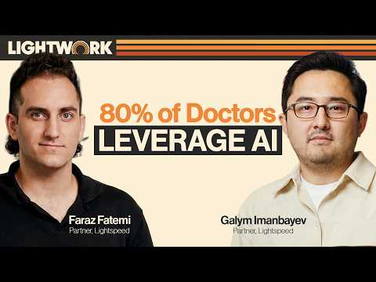 How AI Seeks to Change Every Step of the Patient Journey | Lightwork (11:18)
- The Pragmatic Engineer’s conversation with Dex Horthy — a practical framework for assessing whether agentic engineering products preserve code quality and architectural control as they automate more of the development lifecycle. [10]

Sources
- 𝕏 post by @tbpn
- 𝕏 post by @ajay_bcv
- Inside Ode with Anthropic, the startup betting AI services are the future of enterprise| Equity
- Former Intel CEO on What Went Wrong, What’s Next + Lovable CEO on the Real Promise of Vibe Coding
- r/SaaS post by u/bob__io
- 𝕏 post by @thinkymachines
- 𝕏 post by @miramurati
- 𝕏 post by @martin_casado
- 𝕏 post by @saranormous
- Context engineering with Dex Horthy
- Is Software Dead? No. It Just Got a Lot Harder to Win. The SaaStr AI Deep Dive with Rory O’Driscoll

