OpenAI's YC Token Offer, Enterprise AI Traction, and the Agent-Web Buildout
VC Tech Radar
2026-05-20

OpenAI’s YC Token Offer, Enterprise AI Traction, and the Agent-Web Buildout
By VC Tech Radar • May 20, 2026
OpenAI’s batch-wide YC financing offer was the clearest capital signal, but the deeper read is broader: enterprise AI teams are showing real traction, agent-era web infrastructure is emerging, and local or verification-first AI architectures are getting more investable.

Funding & Deals
- OpenAI made the clearest financing move in this batch: Sam Altman said OpenAI offered $2M in tokens to every startup in the current YC batch in exchange for equity. Outside observers compared it to Yuri Milner’s old practice of offering to invest across YC, while Altman and Garry Tan framed the upside as seeing what “tokenmaxxing” founders build. [1, 2, 3]
- The structure also sharpens platform-risk questions: Jason Calacanis warned YC founders that taking the tokens carries a non-zero risk OpenAI studies their product and ships adjacent functionality into its own free offering. [4]
- Seed pipeline worth a look: a vertical AI company selling finance workflow automation to mid-market CPG brands said it has 7 paying customers, just over $10K MRR, zero churn after seven months, and is raising a seed round. Its founders said win rates improved once they sold outcomes rather than AI. [5]

Emerging Teams
- Serval is one of the strongest traction signals here: the AI-native enterprise service management company is two years old and already serves 100+ customers, from AI-native startups to enterprises with hundreds of thousands of employees. Its architecture keeps workflows-on-databases as the core abstraction, but uses AI codegen to create and maintain workflows from natural language, split across an admin agent and a help-desk agent with approvals and permissions. Serval says it uses OpenAI for end-user interactions, Anthropic for automation/codegen, and benefits from strong economics because it is not reselling tokens. [6]
- p0 / Index looks like an early infrastructure play for agent traffic. Parag Agrawal said p0 launched Index so content owners can understand how AI agents use their work and earn revenue from it; he said the thesis is that agents will use the web 1000x more than humans, and that agents are already scaling on p0’s infrastructure. Early partners include The Atlantic, Fortune, PR Newswire, PitchBook, ZoomInfo, Tracxn, RocketReach, and several creators. [7, 8]
- Compute and physical-AI infrastructure keep producing new YC companies: General Instinct helps robotics teams run frontier models offline and with low latency on constrained devices including Jetsons, mobile NPUs, and ARM CPUs, while Zibra Labs says its HPC clusters let quantitative trading firms run 100x more backtests across massively parallel spot workloads on hyperscalers and neoclouds. [9, 10]
- Regulated and industrial wedges continue to surface: Panacea_Bio pairs FDA regulatory consultants with an AI platform to speed and lower the cost of biotech and medtech approvals, while Andustry says its AI-native brokerage saves manufacturers 30% and cuts sourcing time in half. [11, 12]

AI & Tech Breakthroughs
- Verification-first AI is becoming a real design pattern: Aurora exposes deterministic quantitative tools such as aurora_run, aurora_findings, aurora_verify, and aurora_what_if, keeps the LLM as a language layer around structured outputs, and uses a verifier so quantitative claims must be grounded or flagged as uncertain. The system runs locally, is Apache 2.0, and now includes 24+ methods, causal inference, streaming connectors, and signed bundles. [13, 14]
- Local inference looks increasingly plausible as product architecture: Andrew Chen argued that a very large share of LLM queries are simple enough for smaller local models, noted that consumer hardware can already run good models, highlighted privacy-sensitive categories, and pointed to browser/webGPU delivery as a zero-install way to cut compute costs. He also noted that growing global compute supply should keep pushing cloud token costs down. [15]
- Distributed training is now a governance problem, not just an infrastructure problem: a cited paper claims GPT-4-scale training could be done over consumer internet, on hardware below proposed compute-governance thresholds, for under $100M, and focuses on how to detect and stop that path. [16]
- Agent architectures are getting more operationally opinionated: the GBrain framework argues for parameterized skills, a thin harness, explicit resolvers, markdown-based memory, and a hard split between latent judgment and deterministic code. Garry Tan’s follow-up frames the resulting moat as “process power,” and he called just-in-time, markdown-defined dynamic skills one of the most powerful ideas in personal AI. [17, 18, 19, 20]

Market Signals
- Outcome-first selling is hardening into the new B2B AI playbook. One founder selling into CPG finance said demo conversion rose once the pitch changed from “we use AI agents” to “we recover deductions,” and argued that “depth of workflow coverage” is now the wedge as generic AI claims commoditize. The same founder said early vertical AI companies should target mid-market rather than enterprise because buyers are also users and cycles close in 3-6 weeks instead of stalling for months. [5]
“The AI part is implementation detail and not the value prop we thought it was going into it.” [5]
- The web’s agent layer is starting to look like a new distribution and monetization surface. Parag Agrawal said agents will use the web 1000x more than humans and that p0 is already seeing agent traffic scale on its infrastructure. Separately, a SaaS founder said AI traffic jumped 12x the day after shipping agent-friendly site changes including llms.txt, server-side rendering, structured data, and allowlisting major AI bots. [8, 21]
- Retention is getting tougher in SaaS even when acquisition is still available. Founders described rising churn pressure from subscription fatigue, AI saturation, cheaper clones, and poor onboarding, and said the focus is shifting toward churn, reactivation, and actual LTV rather than top-line MRR screenshots. [22]
- AI is widening the founder aperture but not removing team-quality filters. Sam Altman said he now wants to fund some non-technical founders who deeply understand users, but also reiterated that shared history and deep mutual respect between co-founders remain one of the strongest predictors of success. [23]
- Fundraising velocity still looks materially better in the US than Europe for some AI startups. One European company said it is adding about 6 customers per day yet still faces slow, repetitive diligence across around 10 EU VC conversations, while multiple US founders told the team it would likely fund faster in SF/NY. [24]

Worth Your Time

Sam Altman in conversation with Patrick Collison
Best in this batch for how AI changes founder selection and the ceiling for science and small teams. Altman says models are already helping excellent scientists find better ideas and make small discoveries, calls material science especially underappreciated, and describes seeing a small company run much of its work from a single Slack channel with agents. [23] 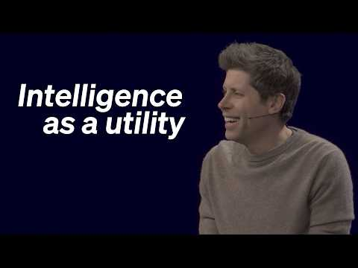 Sam Altman in conversation with Patrick Collison (41:20)

Sequoia’s interview with Serval CEO Jake Stauch
Useful diligence material on AI-native enterprise software. The key segment is the argument that “the product is the boundaries”: enterprise adoption depends on permissions, approvals, audits, logs, and scoped integrations, not just raw model capability. [6] 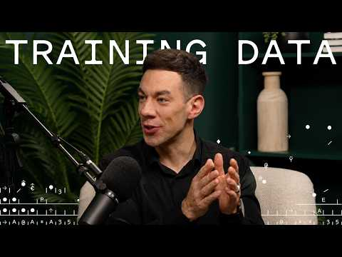 Rebuilding IT From the Ground Up for the AI Age: Serval’s Jake Stauch (8:48)

YC’s self-improving AI-native company talk
A compact framework for recursive improvement loops, “burn tokens, not headcount,” making everything legible to AI, and where humans still matter. [25, 26]

GBrain architecture thread and Garry Tan’s follow-up
The clearest material here on skills, thin harnesses, resolvers, deterministic layers, memory, and “process power” as a moat for AI-native startups. [17, 18]

Sources
- 𝕏 post by @sama
- 𝕏 post by @bosmeny
- 𝕏 post by @garrytan
- 𝕏 post by @Jason
- r/SaaS post by u/crazylocks
- Rebuilding IT From the Ground Up for the AI Age: Serval’s Jake Stauch
- 𝕏 post by @p0
- 𝕏 post by @paraga
- 𝕏 post by @ycombinator
- 𝕏 post by @ycombinator
- 𝕏 post by @ycombinator
- 𝕏 post by @ycombinator
- r/SideProject comment by u/Beautiful_Peak6908
- r/SideProject post by u/Beautiful_Peak6908
- 𝕏 post by @andrewchen
- 𝕏 post by @robi_rahman
- 𝕏 post by @TaylorPearsonMe
- 𝕏 post by @garrytan
- 𝕏 post by @garrytan
- 𝕏 post by @garrytan
- r/SaaS post by u/UptownOnion
- r/SaaS post by u/avsvishalmedia
- Sam Altman in conversation with Patrick Collison
- r/startups post by u/Babayaga1664
- 𝕏 post by @ycombinator
- 𝕏 post by @ycombinator

