Opus 4.7 Resets Coding-Agent Workflows as Codex Pushes Beyond the Terminal
Coding Agents Alpha Tracker
2026-04-17

Opus 4.7 Resets Coding-Agent Workflows as Codex Pushes Beyond the Terminal
By Coding Agents Alpha Tracker • April 17, 2026
Anthropic’s Opus 4.7 sparked the strongest practitioner reaction of the day: delegate bigger chunks, verify aggressively, and stop babysitting permissions. At the same time, Codex widened its surface area with computer use, plugins, and automation, while Cursor data showed developers moving into higher-complexity work.

🔥 TOP SIGNAL
Claude Opus 4.7 is the clearest step-function in coding agents today: Anthropic says it handles long-running, ambiguous, multi-step work better than 4.6, and early external signals point the same way—Cursor’s internal benchmark moved to 70% from 58%, while Notion saw a 14% eval lift with one-third the tool errors [1, 2, 3]. The bigger takeaway is workflow, not just scores: Anthropic engineers keep repeating the same pattern—delegate a whole task, give full context, enable autonomy carefully, and require verification before trusting the result [4, 5, 6].
“The model performs best if you treat it like an engineer you’re delegating to, not a pair programmer you’re guiding line by line.” [4]

🛠️ TOOLS & MODELS
- Claude Opus 4.7 / Claude Code: More agentic, more precise, better at long-running work, better at carrying context across sessions, and stronger on multi-file changes, ambiguous debugging, and whole-service review in one prompt [1, 7]. New knobs: auto mode for permission decisions, xhigh as the new default effort level, higher rate limits to offset higher token use, plus recaps and focus mode for long sessions [8, 9, 10, 11, 12].
- Codex: The surface area expanded fast: computer use, in-app browser, image generation/editing, 90+ plugins, multi-terminal, SSH into devboxes, thread automations, memory, and rich document editing [13, 14]. Romain Huet says the models are now in a “completely different league,” with a polished Codex app for connecting tools and delegating real work to agents, and that Codex has become something he starts almost every task with [15, 16].
- Codex anniversary signals: Codex CLI hit its first birthday as an open-source local coding agent [15, 17]. OpenAI-side builders also reset rate limits across plans and shipped official Intel Mac support for the Codex app after a Codex CLI-driven compatibility fix [18, 19, 20].
- Cursor: Opus 4.7 is live in Cursor, and the team describes it as more autonomous and more creative in reasoning [21]. Separate telemetry across 500 teams suggests better models are changing task mix, not just speed: high-complexity work rose 68%, overall AI usage rose 44%, and developers started taking on harder problems only after a 4–6 week lag [22, 23, 24].
- LangSmith / openevals v0.2.0: LangSmith now has a reusable evaluator template library with 30+ templates, including LLM-as-judge and rule-based code evaluators, plus a central Evaluators hub; the open-source openevals package added multimodal eval support for voice + image outputs [25, 26].
- Claude Code desktop app: caution flag. Anthropic’s desktop app was pitched as redesigned for parallel work and faster [27], but Theo’s hands-on pass found at least 40 bugs in under an hour, especially around hotkeys, permissions persistence, sidebars, and diff behavior [28, 29, 30]. For now, the practical signal is mixed.

💡 WORKFLOWS & TRICKS
- The new Opus 4.7 loop is: brief → autonomy → verification.
  - Start with the full task brief: goal, constraints, acceptance criteria [5].
  - Turn on auto mode when you want the agent to clear safe permission checks without babysitting [31, 32].
  - Set /effort to xhigh for most tasks; bump to max for the hardest sessions; drop lower when latency/token cost matters [33, 34].
  - Tell the agent exactly how to verify the work—put test/setup instructions in claude.md, add a /verify-app skill, or use Boris Cherny’s /go pattern: run end-to-end tests via bash/browser/computer use, then /simplify, then open a PR [35, 6].
  - Use recaps when you come back to a long session; use /focus when you only care about the final result [11, 12].
- Retune prompts when you swap models. Matthew Berman’s practical read on 4.7: it follows instructions more literally, so older prompts and harnesses can produce weird results if they relied on loose interpretation, all-caps emphasis, or lots of negative instructions. Rewrite prompts in direct, positive language and reread model-specific best practices when a new version lands [36, 37].
- Run more than one agent, but stop polling them manually. Boris says auto mode is what makes parallel Claudes actually useful because you can leave one cooking and switch to the next [32]. Warp is leaning into the same pattern: group sessions with branch/worktree/PR metadata, save tab layouts, and get desktop notifications only when an agent needs attention [38].
- Revisit tasks you used to consider blocked. Jediah Katz’s example is concrete: lack of tmux on Windows used to kill the idea of shipping tmux integration in Cursor; with a long-running harness, he just cloned tmux for Windows instead [39]. That lines up with Cursor’s broader telemetry: developers first do more of the same work, then start taking on harder problems once they trust the new model/harness stack [22, 24].
- For AI-assisted security work, don’t just burn more tokens. Discourse used multi-day GPT 5.4 xhigh scans and found 50 CVEs in its last monthly release [40]. Salvatore Sanfilippo’s sharper takeaway: run multiple instances with different prompts, pipelines, and sampling to explore the codebase from different angles, and spend context window budget on likely cross-file interactions instead of brute-forcing every combination [41].
- Codex is also becoming an automation surface, not just a coding chat. Riley Brown uses it for a daily Readwise workflow that turns bookmarked X posts into a topic-organized deck, and recommends the Excalidraw skill for rendering diagrams into docs [42]. Even if you never copy that exact setup, the pattern is worth stealing: pair thread automations with narrow skills/plugins for repeatable output [14, 42].

👤 PEOPLE TO WATCH
- Boris Cherny + Cat Wu: Best day-one operator guidance for Opus 4.7. Both are posting from inside Anthropic’s dogfooding loop, and both focus on workflow changes—auto mode, effort tuning, full upfront context, and verification—not benchmark screenshots [43, 44, 4, 35].
- Romain Huet + @thsottiaux: Best signal on where Codex is heading. Their posts make clear the shift from “coding agent” to a broader computer-use agent with plugins, browser, automation, memory, and SSH/devbox workflows [13, 16, 14, 45].
- Theo: Useful because he is both a builder and a hostile tester. He liked 4.7’s planning more than expected on a large-codebase modernization run, but also documented misses and surfaced brutal desktop-app bugs fast [46, 47, 48, 28].
- Jediah Katz / Cursor team: Strongest telemetry-backed voice today. The 500-team dataset and his tmux-on-Windows example both point to the same thing: better agents expand the feasible task set, not just throughput [22, 39].
- Simon Willison: Quiet production proof beats launch copy. He says most changes in datasette 1.0a28 were implemented with Claude Code and Opus 4.7 [49].

🎬 WATCH & LISTEN
- Matthew Berman — retune-your-prompts clip (8:18–9:34). Best short explainer on why a stronger coding model can still break your old harness: 4.7 follows instructions more literally, so you need to rewrite prompts instead of blaming the model swap [36].
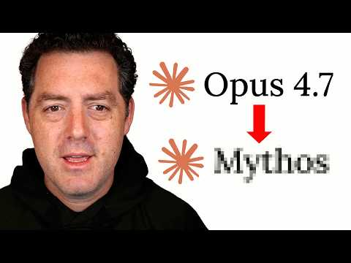 Opus 4.7 just dropped… and I’m confused. (8:18)
- Theo — why Codex matters to tool builders (6:43–7:47). A crisp explanation of the Codex stack split: the app is closed source, but the Codex CLI and app server are open, which is why other UIs can plug into it so easily [50].
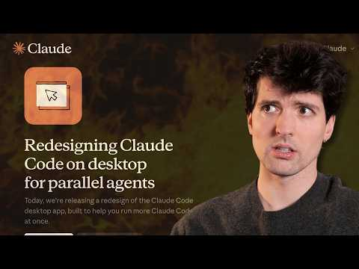 Claude’s new Cursor killer just dropped (6:43)

📊 PROJECTS & REPOS
- Codex CLI / app server: One-year-old open-source local coding agent; Theo notes the open CLI + app server are what let other teams build their own UIs on top [15, 17, 50].
- openevals v0.2.0: Open-source eval tooling from LangChain with new multimodal support for voice and image outputs—useful if your agent stack is growing beyond plain text [25].
- T3 Code: Theo’s pitch is straightforward: open core, nothing hidden, built to be trusted and customized, with scaffolding that makes the codebase easy for agents to work in [51]. Worth watching if you care about open, customizable GUI alternatives for agentic coding.
Editorial take: today’s durable edge is simple—bigger autonomous runs only help if your harness tells the agent what good looks like, how to verify it, and when to interrupt you. [5, 6, 38]

Sources
- 𝕏 post by @bcherny
- 𝕏 post by @claudeai
- 𝕏 post by @mikeyk
- 𝕏 post by @_catwu
- 𝕏 post by @_catwu
- 𝕏 post by @bcherny
- 𝕏 post by @bcherny
- 𝕏 post by @bcherny
- 𝕏 post by @bcherny
- 𝕏 post by @bcherny
- 𝕏 post by @bcherny
- 𝕏 post by @bcherny
- 𝕏 post by @romainhuet
- 𝕏 post by @thsottiaux
- 𝕏 post by @romainhuet
- 𝕏 post by @romainhuet
- 𝕏 post by @OpenAIDevs
- 𝕏 post by @thsottiaux
- 𝕏 post by @mariofilhoml
- 𝕏 post by @embirico
- 𝕏 post by @cursor_ai
- 𝕏 post by @cursor_ai
- 𝕏 post by @cursor_ai
- 𝕏 post by @cursor_ai
- 𝕏 post by @LangChain
- 𝕏 post by @LangChain
- 𝕏 post by @felixrieseberg
- 𝕏 post by @theo
- 𝕏 post by @theo
- 𝕏 post by @theo
- 𝕏 post by @_catwu
- 𝕏 post by @bcherny
- 𝕏 post by @bcherny
- 𝕏 post by @_catwu
- 𝕏 post by @_catwu
- Opus 4.7 just dropped… and I’m confused.
- 𝕏 post by @bcherny
- Millions of WordPress sites just got hacked… again
- 𝕏 post by @jediahkatz
- 𝕏 post by @samsaffron
- L’era cyber-AI non è una corsa ai token
- 𝕏 post by @rileybrown
- 𝕏 post by @bcherny
- 𝕏 post by @bcherny
- 𝕏 post by @thsottiaux
- 𝕏 post by @theo
- 𝕏 post by @theo
- 𝕏 post by @theo
- datasette 1.0a28
- Claude’s new Cursor killer just dropped
- 𝕏 post by @theo

