Orchestration-first agent coding: Codex CLI v0.105, spec-driven loops, and eval infra wars
Coding Agents Alpha Tracker
2026-02-27

Orchestration-first agent coding: Codex CLI v0.105, spec-driven loops, and eval infra wars
By Coding Agents Alpha Tracker • February 27, 2026
Today’s theme: orchestration beats raw generation. You’ll get concrete spec-first workflows from practitioners, major Codex CLI upgrades (v0.105), new PR autofix automation, and why shared eval infrastructure is suddenly a battleground.

🔥 TOP SIGNAL
Orchestration is becoming the core dev skill: Addy Osmani argues the enterprise frontier is orchestrating a modest set of agents with control/traceability, not running huge swarms [1]. In practice, that shows up as spec-first work: Brendan Long’s vibe-coding loop starts by writing a detailed GitHub issue (“90% of the work”), optionally having an agent plan, then having another agent implement [2].

🛠️ TOOLS & MODELS
- Codex CLI v0.105 (major QoL upgrade) [3]
  - New: syntax highlighting, dictate prompts by holding spacebar, better multi-agent workflows, improved approval controls, plus other QoL changes [3].
  - Install/upgrade: $ npm i -g @openai/codex@latest [3].
  - Practitioner reaction: “diffs are beautiful” and it’s “very, very fast now” [4].
- Codex app (Windows) — first waitlist batch invited [5]
  - Team says they’ll “expand from there” as they iterate through feedback [5].
- Model preference + benchmarkging signals (Codex 5.3)
  - Mitchell Hashimoto: Codex 5.3 felt “much more effective” than Opus 4.6; after switching back-and-forth, he hasn’t touched Opus for a week [6].
  - Romain Huet: GPT-5.3-Codex hit 90% on IBench at xhigh reasoning; says with speed gains, “xhigh doesn’t feel like a tradeoff anymore” [7].
  - Related run: “decided to run 5.3 codex on xhigh as well, its 90%… rip IBench, survived 3 months” [8].
- Cursor — Bugbot Autofix (PR issues → auto-fixes) [9]
  - Announcement: Bugbot can now automatically fix issues it finds in PRs [9].
  - Details: http://cursor.com/blog/bugbot-autofix [10].
- Devin AI (real production debugging)
  - swyx reports Devin investigated a production bug (Vercel org migration + forgotten key), asked for exactly what it needed, and verified the fix [11].
- FactoryAI Droids — “Missions” + terminal “Mission Control”
  - “Missions”: multi-day autonomous goals where you describe what you want, approve a plan, and come back to finished work [12, 13].
  - Mission Control: a terminal view of which feature is being built, which Droid is on it, tools used, and progress [14].
  - Examples FactoryAI says enterprises are running: modernize a 40-year-old COBOL module; migrate >1k microservices across regions; recalc 10 years of pricing; refactor a monolith handling 20M daily API calls with no downtime [13].
- OpenClaw — new beta bits [15]
  - Adds: external secrets management (openclaw secrets) [15, 16], CP thread-bound agents [15], WebSocket support for Codex [15], and Codex/Claude Code as first-class subagents via ACP [17].
- Omarchy 3.4 — agent features shipped
  - Release highlights include “new agent features (claude by default + tmux swarm!)” and a tailored tmux setup [18, 19].
- Harbor framework — shared agent eval infra momentum
  - Laude Institute frames Harbor as shared infrastructure to standardize benchmarks via one interface (repeatable runs, standardized traces, production-grade practice) [20].
  - swyx says his team is prioritizing migrating evals to Harbor and calls it dominant in RL infra/evals for terminal agents [21].

💡 WORKFLOWS & TRICKS
- Spec-driven agent work (make the spec the artifact)
  - Brendan Long’s repeatable loop for large vibe-coded apps:
    - Write a GitHub issue [2]
    - If it’s complex, have an agent produce a plan and update the issue [2]
    - Have another agent read the issue and implement it [2]
  - He claims a detailed enough issue is “90% of the work” and rewriting it is often what fixes problems [2].
- Enterprise-grade orchestration guidance (modest fleets, strong controls)
  - Addy Osmani’s concrete advice: spend 30–40% of task time writing the spec—constraints, success criteria, stack/architecture—and gather context in a resources directory; otherwise you “waste tokens” and LLMs default to “lowest common denominator” patterns [1].
  - For teams: codify best practices in context (e.g., MCP-callable systems or even markdown files) to raise the odds the output is shippable [1].
  - He also flags the real bottleneck: “Not generation, but coordination” [1].
- Close the loop: isolate the runtime so agents can run it
  - Kent C. Dodds: “get your app running in an isolated environment to close the agent loop” [22].
  - He points to his Epic Stack guiding principles—“Minimize Setup Friction” and “Offline Development”—as a practical way to make this easier [22].
- Hoard working examples, then recombine (prompt with concrete known-good snippets)
  - Simon Willison’s pattern: keep a personal library of solved examples across blogs/TIL, many repos, and small “HTML tools” pages, because agents can recombine them quickly [23].
  - His OCR tool story: he combined snippets for PDF rendering and OCR into a single HTML page via prompt, iterated a few times, and ended with a tool he still uses [23].
  - Agent tip: when asking Claude Code to reuse an existing tool, he sometimes specifies curl explicitly to fetch raw HTML instead of a summarizing fetch tool [23].
- Tests aren’t a moat anymore (agents can recreate them fast)
  - tldraw moved tests to a closed-source repo to prevent “Slop Fork” forks [24].
  - Armin Ronacher’s counterpoint: agents can generate language/implementation-agnostic test suites quickly if there’s a reference implementation [25].
- Security footnote from a vibe-coded app
  - In Simon Willison’s Present.app walkthrough, the remote-control web server used GET requests for state changes (e.g., /next, /prev), which he notes opens up CSRF vulnerabilities—he didn’t care for that application [26].

👤 PEOPLE TO WATCH
- Addy Osmani (Google Cloud AI) — clearest “enterprise reality check”: quality bars, traceability, and spec/context discipline, plus a strong stance that orchestration is the thing to learn [1].
- Simon Willison — consistently turns agent usage into transferable patterns (Agentic Engineering Patterns + “hoard examples” + codebase walkthrough prompts) [26, 23].
- Brendan Long — practical decomposition: write issues like a system design interview, then let agents execute [2].
- Nicholas Moy (DeepMind) — framing: “10x engineer” becomes “10 agent orchestrator,” measured by concurrent agents you can run effectively [27].
- Dylan Patel (Semianalysis) — adoption signal: Claude Code share of GitHub commits going 2%→4% in a month, with a broader estimate of total AI-written code around ~10% [28].

🎬 WATCH & LISTEN

1) Addy Osmani: “Learn orchestration” + the path to agent fleets (≈ 23:32–25:54)
Hook: Practical roadmap from single-agent prompting to multi-agent orchestration and coordination patterns—before you burn tokens on experimental swarms [1].
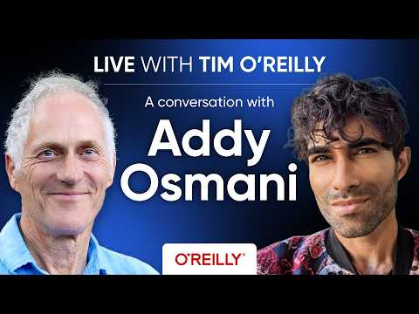 Live with Tim O’Reilly: A Conversation with Google Cloud AI Director Addy Osmani (23:31)

2) SAIL LIVE #6: why SWE-Bench got saturated (and what that says about evals) (≈ 29:49–33:48)
Hook: A clear explanation of how SWE-Bench is constructed, why it became the default “agentic coding” benchmark, and why that creates problems once it’s widely known and reused [29].
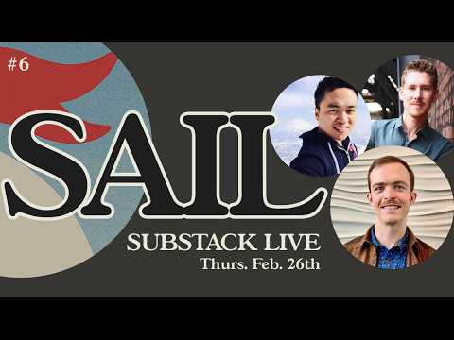 Distillation & How Models Cheat | SAIL LIVE #6 (29:49)

📊 PROJECTS & REPOS
- Agentic Engineering Patterns (Simon Willison) — a living guide of coding-agent practices and patterns (agentic engineering vs vibe coding framing) [26]
  - https://simonwillison.net/guides/agentic-engineering-patterns/ [26]
- Present.app (Simon Willison) — vibe-coded SwiftUI macOS presentation app where each “slide” is a URL; GitHub repo shared [26]
  - https://github.com/simonw/present [26]
- OpenClaw releases + docs (beta features shipping) [15]
  - https://github.com/openclaw/openclaw/releases [15]
  - Secrets docs: https://docs.openclaw.ai/cli/secrets [16]
  - ACP agents docs: https://docs.openclaw.ai/tools/acp-agents [17]
- Cursor Bugbot Autofix announcement + writeup [10]
  - http://cursor.com/blog/bugbot-autofix [10]
- Omarchy 3.4 release (61 contributors; agent features + tmux work) [18]
  - https://github.com/basecamp/omarchy/releases/tag/v3.4.0 [18]
- tldraw tests move discussion (tests closed-source) [24]
  - https://github.com/tldraw/tldraw/issues/8082 [24]

Editorial take: The leverage is shifting from “pick the best model” to “build the tightest loop”: spec → isolated runtime → tests/evals → approvals—and only then scale agents.

Sources
- Live with Tim O’Reilly: A Conversation with Google Cloud AI Director Addy Osmani
- Vibe Coding is a System Design Interview
- 𝕏 post by @thsottiaux
- 𝕏 post by @iannuttall
- 𝕏 post by @thsottiaux
- 𝕏 post by @mitchellh
- 𝕏 post by @romainhuet
- 𝕏 post by @adonis_singh
- 𝕏 post by @cursor_ai
- 𝕏 post by @cursor_ai
- 𝕏 post by @swyx
- 𝕏 post by @FactoryAI
- 𝕏 post by @matanSF
- 𝕏 post by @FactoryAI
- 𝕏 post by @steipete
- 𝕏 post by @steipete
- 𝕏 post by @steipete
- 𝕏 post by @dhh
- 𝕏 post by @dhh
- 𝕏 post by @LaudeInstitute
- 𝕏 post by @swyx
- 𝕏 post by @kentcdodds
- Hoard things you know how to do
- 𝕏 post by @cramforce
- 𝕏 post by @mitsuhiko
- Agentic Engineering Patterns
- 𝕏 post by @thenickmoy
- Dylan Patel Explains the AI War While Cooking | In-Context Cooking
- Distillation & How Models Cheat | SAIL LIVE #6

