Pattern Breakers and Kenneth Arrow’s Learning Loop Lead Today’s Picks
Recommended Reading from Tech Founders
2026-06-02

Pattern Breakers and Kenneth Arrow’s Learning Loop Lead Today’s Picks
By Recommended Reading from Tech Founders • June 2, 2026
Tim Ferriss and Tony Fadell surfaced the clearest authentic recommendations today: Mike Maples Jr.’s startup framework in Pattern Breakers, and Kenneth Arrow’s case that judgment is built through experience. Tim Ferriss also added narrower but useful picks on meaning in an AI-shaped world and on credible reading in bioelectronic medicine.

Most compelling recommendation

Pattern Breakers — Mike Maples Jr.
- Content type: Book
- Author/creator: Mike Maples Jr. [1]
- Link/URL: No direct URL was provided in the source.
- Who recommended it: Tim Ferriss, who said Maples taught him the fundamentals of angel investing in 2007/2008 and that he is revisiting his Kindle highlights now [1]
- Key takeaway: Ferriss pulled out one question from the book that he still finds worth revisiting: are your customers “interested” or “desperate”? [1]
- Why it matters: This was the strongest recommendation in the set because it came with both a long-term personal endorsement and a concrete framework readers can immediately apply [1]
“One simple distinction from the book worth revisiting often is this: are your customers interested or desperate?” [1]

Best paired read on AI and expertise
Tony Fadell’s recommendation worked best as a pair: a current article that restates Kenneth Arrow’s idea, and Arrow’s original paper. Together, they make a clear argument that AI should accelerate learning rather than remove the formative work that produces judgment [2]

Kenneth Arrow on “learning by doing”
- Content type: Article
- Author/creator: Not specified in the provided source.
- Who recommended it: Tony Fadell [2]
- Key takeaway: Productivity and expertise improve through experience, and the repetitive work early in a career is often where people learn the patterns that later become judgment [2]
- Why it matters: It translates an older economic idea into a current management question for AI adoption: what is lost if teams automate away the work juniors learn from? [2]

Learning by Doing
- Content type: Paper
- Author/creator: Kenneth Arrow [2]
- Who recommended it: Tony Fadell [2]
- Key takeaway: Fadell points readers back to Arrow’s original work to support the idea that expertise compounds through lived experience [2]
- Why it matters: It gives readers the primary source behind Fadell’s warning that organizations should preserve or replace the learning loop, not erase it [2]
“Knowledge can be taught, but judgement is built through lived experience.” [2]

Additional signals from Tim Ferriss

Riding the Leopard — Pachy McCormick
- Content type: Article / transcribed talk
- Author/creator: Pachy McCormick [3]
- Link/URL: No direct resource URL was provided in the source. Ferriss discussed it in Rabbit Hole: Does Tim Ferriss Dream In Japanese? [3]
- Who recommended it: Tim Ferriss, who said the piece had just been sent to him and that it caught his attention [3]
- Key takeaway: Ferriss highlighted its argument that when scarcity recedes, the dominant unresolved problem becomes meaning, with identity next; he also emphasized its references to Victor Frankl and Joseph Campbell [3]
- Why it matters: This was the clearest recommendation today that tried to move the AI conversation away from funding and toward purpose and identity [3]
“Across all of these books, by far the most common thing left to solve for post scarcity is meaning. 59% of books were about the search for meaning. Identity was next at 17%.” [3] 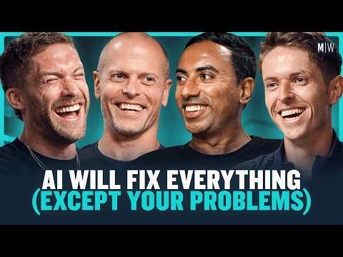 Rabbit Hole: Does Tim Ferriss Dream In Japanese? (53:36)

The Great Nerve — Kevin Tracy
- Content type: Book
- Author/creator: Kevin Tracy [3]
- Link/URL: No direct resource URL was provided in the source. Mentioned in Rabbit Hole: Does Tim Ferriss Dream In Japanese? [3]
- Who recommended it: Tim Ferriss [3]
- Key takeaway: Ferriss described Tracy as the most credible, highly published public scientist he would point to on vagus nerve stimulation [3]
- Why it matters: It is a useful filter for readers who want a more credible starting point in a category Ferriss framed as noisy and easy to get wrong [3]

Takeaway
The strongest authentic picks today were tied together by one theme: how expertise is built. Ferriss pointed to a durable startup lens for judging customer demand [1], Fadell argued that judgment comes from practice rather than abstraction [2], and Ferriss’s longer-form picks widened the frame to meaning and scientific credibility [3].

Sources
- 𝕏 post by @tferriss
- 𝕏 post by @tfadell
- Rabbit Hole: Does Tim Ferriss Dream In Japanese?

