Paul Graham’s Enduring Essays, Sparks of AGI, and WarGames
Recommended Reading from Tech Founders
2026-03-12

Paul Graham’s Enduring Essays, Sparks of AGI, and WarGames
By Recommended Reading from Tech Founders • March 12, 2026
Matt Mullenweg’s endorsement of Paul Graham’s essays is the strongest signal today because it comes with concrete, reusable founder lessons. Marc Andreessen and Reid Hoffman add two smaller but durable picks: Sébastien Bubeck’s Sparks of Artificial General Intelligence and the film WarGames.

Most compelling recommendation: Paul Graham’s essays
This stands out because the endorsement is both repeated and concrete. Matt Mullenweg says he returns to Paul Graham’s writing “again and again” [1], and the thread he resurfaced says the essays have served as a “business coach” for the last 10 years and are reread annually when product or team questions come up [2, 1].
“ok the secret is PG is my business coach for the last 10 years” [2]
- Title: Paul Graham’s essays
- Content type: Essays / blog
- Author/creator: Paul Graham [1]
- Link/URL: Source thread with the reread list: https://x.com/tibo_maker/status/2031679065099284971 [1]
- Who recommended it: Matt Mullenweg, who said he returns to Paul Graham’s writing repeatedly and highlighted a thread from @tibo_maker detailing the essays he rereads yearly [1, 2]
- Key takeaway: In the highlighted thread, the essays are treated as practical startup education and a reusable operating manual for customer development, idea generation, time management, founder involvement, and value creation [2]
- Why it matters: The source material ties the recommendation to concrete operating decisions: acting as first-line support, protecting maker time, using launch checklists, staying close to details, and focusing on creating value rather than extracting it [2]
The clearest lessons surfaced in the thread:
- Do things that don’t scale — founders should do manual work early; the poster says he still acts as the first customer support rep because that teaches more than dashboards [2]
- How to get startup ideas — the best ideas come from living at the edge of a problem, not from brainstorming market size [2]
- Maker’s schedule, manager’s schedule — makers need uninterrupted half-day blocks; the applied version here is no meetings and async Slack [2]
- Founder mode — standard delegation advice can be the wrong playbook for founders who need to stay close to details [2]
- How to make wealth — startups should create new value for people rather than extract it [2]
- Life is short / How to do great work — the broader frame is finite time and work that sits at the intersection of natural ability, obsession, and ambition [2]

Other durable picks

Sparks of Artificial General Intelligence (2023)
- Title: Sparks of Artificial General Intelligence (2023)
- Content type: Research paper
- Author/creator: Sébastien Bubeck [3]
- Who recommended it: Marc Andreessen [3]
- Key takeaway: Andreessen’s recommendation is concise but clear: the paper is “aging very well” [3]
- Why it matters: In a fast-moving AI cycle, the signal here is durability: he is pointing readers back to a 2023 paper as still worth attention now [3]

WarGames (1983)
- Title: WarGames (1983)
- Content type: Film
- Author/creator: Not specified in the source material
- Who recommended it: Reid Hoffman [4]
- Key takeaway: Hoffman uses the film as an example of an AI reasoning through “no win” scenarios and learning that escalation is not the right move [4]
- Why it matters: He presents it as a case for keeping humans in the loop, emphasizing that pure rationality needs compassion, context, and judgment—including moments when people refuse to trust what sensors appear to show [4] 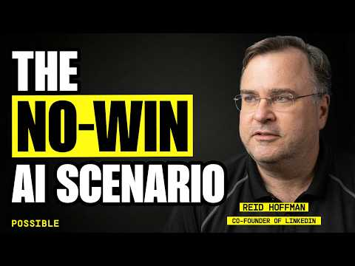 The AI Kept Choosing War (2:17)

Pattern across today’s recommendations
The shared trait is staying power: a paper that still holds up years later, an essay corpus reread as an operating manual, and a 1983 film still used to think through AI risk and human oversight [3, 2, 4]

Sources
- 𝕏 post by @photomatt
- 𝕏 post by @tibo_maker
- 𝕏 post by @pmarca
- The AI Kept Choosing War

