Paul Graham’s Essays, Hooked’s Staying Power, and Anthropic’s Platform Logic
Recommended Reading from Tech Founders
2026-05-14

Paul Graham’s Essays, Hooked’s Staying Power, and Anthropic’s Platform Logic
By Recommended Reading from Tech Founders • May 14, 2026
The clearest signal today was Garry Tan crediting Paul Graham’s essays with shaping how he thinks. The rest of the list spans durable product psychology, Anthropic’s platform strategy, Maria Popova’s curiosity engine, and Joseph Campbell’s philosophy of composure.

What stood out
Today’s strongest organic recommendations split between startup operating frameworks and broader resources for sharpening taste and curiosity [1, 2, 3, 4, 5].

Most compelling recommendation: Paul Graham’s essays
- Content type: Essay collection
- Author/creator: Paul Graham
- Link/URL: Not provided in the interview
- Who recommended it: Garry Tan
- Key takeaway: Tan said he discovered the essays online and that they gave him the language for ideas like “solve the money problem.”
- Why it matters: This was the strongest recommendation in today’s set because Tan described the essays as materially shaping how he thinks about building businesses. [1] 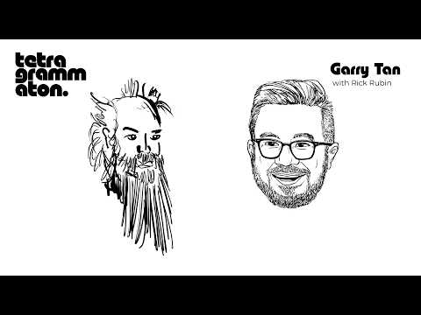 Garry Tan (5:59)

Companion pick from the same conversation: Hackers & Painters
- Content type: Book
- Author/creator: Paul Graham
- Link/URL: Not provided in the interview
- Who recommended it: Garry Tan
- Key takeaway: Tan called it the “perfect polymath book,” using it to capture Graham’s mix of hacker instincts and artistic range.
- Why it matters: It reads as the clearest single-book entry point into the worldview Tan was pointing readers toward. [1]
“He wrote a book called Hackers and Painters, which is the perfect polymath book.” [1]

Durable operator resources

Hooked
- Content type: Book
- Author/creator: Nir Eyal
- Link/URL: Not provided in the source post
- Who recommended it: Ryan Hoover
- Key takeaway: Hoover said two founders had already mentioned the book that morning and argued that, while tech has changed a lot in 12+ years, human psychology has not.
- Why it matters: It is a reminder that durable product lessons can survive major platform shifts when they are rooted in behavior rather than tooling. [2]

Krishna on how Anthropic thinks about the platform vs. application layer
- Content type: Video clip / X post
- Author/creator: Patrick O’Shaughnessy post featuring Krishna
- Link/URL: https://x.com/patrick_oshag/status/2054562883350962304 [6]
- Who recommended it: Brad Gerstner
- Key takeaway: Gerstner called it “must watch” and highlighted Krishna’s explanation that Anthropic is primarily building platform, while selectively building applications like Claude Code when it can express where the models are going or demonstrate value for the ecosystem.
- Why it matters: For AI builders, it is a compact explanation of how a frontier model company thinks about enabling customers, competing with them, and keeping both on the same underlying platform. [6, 3]
“Most of what we’re building is platform.” [3]

Resources that widen curiosity

The Marginalian
- Content type: Personal blog
- Author/creator: Maria Popova
- Link/URL: Not provided in the source post
- Who recommended it: David Perell
- Key takeaway: Perell said reading Popova was an “entry point into intellectual curiosity” and credited her with introducing him to more writers and ideas than almost anyone else.
- Why it matters: It is a strong meta-resource: one good source that can lead readers into many others. [4]

Reflections on the Art of Living: A Joseph Campbell Companion
- Content type: Book
- Author/creator: Joseph Campbell
- Link/URL: https://www.amazon.com/Reflections-Art-Living-Campbell-Companion/dp/0060926171 [5]
- Who recommended it: Packy McCormick
- Key takeaway: McCormick said he highly recommends it and pulled from it a set of ideas about following your own path, realizing your potential, and learning to stay composed amid intensity.
- Why it matters: Among today’s more philosophical picks, this was the most actionable: not just inspiration, but a usable standard for how to move through pressure without getting torn apart by it. [5]
“The goal is to live with godlike composure on the full rush of energy, like Dionysus riding the leopard, without being torn to pieces.” [5]

Sources
- Garry Tan
- 𝕏 post by @rrhoover
- 𝕏 post by @patrick_oshag
- 𝕏 post by @david_perell
- Riding the Leopard
- 𝕏 post by @altcap

