Persistent Sessions, Explicit Delegation, and 15× Agent Costs
Coding Agents Alpha Tracker
2026-07-21

Persistent Sessions, Explicit Delegation, and 15× Agent Costs
By Coding Agents Alpha Tracker • July 21, 2026
Persistent worker sessions emerge as a practical alternative to disposable sub-agents, alongside explicit coordinator/executor rules and fresh evidence that model choice can swing swarm costs by 15×. Also covered: TMUX orchestration, Kody discovery, Clerk’s agent-facing platform workflow, and context compaction.

🔥 TOP SIGNAL
Treat a worker session as durable project state, not a disposable sub-agent. AI Jason’s “sidekick” pattern sends revisions back to the same worker so it retains the prior conversation instead of rereading it; Boris Cherny separately reports Claude Code sessions running coherently for weeks, which he attributes to alignment, general intelligence, and memory. [1, 2]
The practical payoff is straightforward: use a high-judgment coordinator to make decisions, then keep execution attached to persistent workers—rather than repeatedly creating fresh agents with no task history. AI Jason says the alternative “advisor” setup is costly because the advisor must read the executor’s full history. [1]

⚡ TRY THIS
- Make every substantial subtask a persistent worker.
  - Have the main agent create a clear spec in a task folder.
  - Spawn one executor for implementation.
  - When review finds an issue, send the feedback to that same session—not a new agent.
  - Ask the worker to return a concise final summary only after the follow-up is complete.
- AI Jason’s demonstrated setup explicitly assigns the worker the executor role, tells it to read the spec first, and prohibits nested sub-agents. [1]
- Put delegation boundaries in your agent instructions. Define the primary agent as coordinator for design, planning, architecture, review, and tiny edits; delegate hands-on execution to a smaller-model worker. Add a role check such as “you are an executor; do the work yourself; do not spawn agents” to prevent uncontrolled nesting. [1]
- Run a zero-setup automation discovery interview before adopting Kody. Paste this into your preferred agent, then decide whether the proposed automations justify trying the tool:
“I’m deciding whether Kody would be useful for me. Read this capability guide and follow its links for anything you need more detail on. Then interview me about the tools I use, recurring chores I do by hand, and automations I’ve wished for. Finish with 3-5 specific things Kody could do for me, ranked by payoff versus setup effort, each with a concrete first step. Don’t set anything up yet — this works before I have an account.” [3]
- If you use Clerk’s agent skill/MCP, drive the production checklist through prompts. Fireship’s demo sequence was: ask the agent to handle sign-up/sign-in; ask it to add basic and premium plans; then ask for a user list. The demo produced auth pages, middleware, and a passing build, then pulled users from the API. [4]

📡 WHAT SHIPPED
- Cursor: a concrete agent-swarm economics datapoint. Cursor says a team of agents rebuilt SQLite from its 835-page manual into a Rust replica that passed 100% of a held-out test suite. The same task’s cost varied 15× by model mix—strong evidence that orchestration needs cost-aware routing, not just more agents. Read Cursor’s analysis. [5, 6]
- Open Agent Teams: AI Jason released an open skill in the AI Build Club repo that wraps TMUX-based multi-agent control behind start, send, wait, peek, and result operations. It supports parallel sessions and demonstrates recovery when an agent gets blocked by an interactive prompt. [1]
- Orca: presented as a packaged, open-source alternative to hand-rolled orchestration: built-in CLI orchestration, a session hierarchy view, Kanban, and token tracking. [1]
- Cursor context compaction: Kent C. Dodds says Cursor’s compaction optimizations are why he does not encounter a “dumb zone,” and argues that model-context babysitting should be automated rather than handled manually. [7]

🎬 GO DEEPER
- 2:02–3:02 — Persistent “sidekick” workers. A compact walkthrough of why follow-up work should return to the same agent session: the session keeps its task context rather than spending tokens reconstructing it. [1] 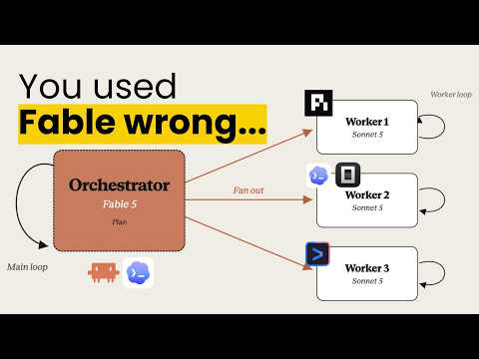 Tmux + Fable = Cut 35% less token (2:01)
- 26:09–26:35 — How Anthropic uses Claude Code internally. Boris Cherny says all of his code has been written with Claude Code since the previous November, and estimates Claude Code usage at about 90% across Anthropic; useful firsthand context for the shift toward many concurrent agent sessions. [2]  The Creator of Claude Code on The Hottest Piece of Software in the World | Odd Lots (26:09)
- Study the Kody capability guide before committing to an automation stack. The discovery prompt above is intentionally structured to surface recurring manual work, rank ideas by payoff versus setup effort, and avoid premature configuration. [3]
Editorial take: the durable edge is not maximizing agent count—it is preserving context in persistent workers, enforcing clear delegation boundaries, and routing work with cost in view. [1, 5]

Sources
- Tmux + Fable = Cut 35% less token
- The Creator of Claude Code on The Hottest Piece of Software in the World | Odd Lots
- 𝕏 post by @kentcdodds
- This $12 billion startup finally shipped something…
- 𝕏 post by @cursor_ai
- 𝕏 post by @cursor_ai
- 𝕏 post by @kentcdodds

