Personalized AI Learning Meets the Assessment Reckoning
AI in EdTech Weekly
2026-08-03

Personalized AI Learning Meets the Assessment Reckoning
By AI in EdTech Weekly • August 3, 2026
Andrew Ng’s $100M LearnVector launch, AI-resistant classroom experiments, and new under-the-hood AI literacy tools point to a common test: can technology personalize learning while keeping human reasoning visible and accountable?
The central question this week is not whether AI can generate more educational content, but whether it can make learning more individual without making learners less capable. Andrew Ng’s LearnVector announcement and a set of classroom experiments point to the same design test: AI should guide a learning path, expose thinking, and keep a human accountable for the result. [1, 2]

Personalized guidance is the new product bet
Andrew Ng launched LearnVector with a $100 million investment from Coursera and plans to collaborate with Coursera and Udemy. He describes the company’s goal as moving from one-to-many education to a custom learning guide for each person—one that plans a path, adapts to how the learner learns, and stays with them until mastery. [1]
The important part of the announcement is its warning as much as its promise. Ng says chatbots without guardrails can help students complete tasks and improve homework performance while leaving them less skilled through cognitive offloading; he also notes that chatbot advice is not always trustworthy. LearnVector’s proposed answer is not simply a more conversational chatbot, but a guided path built on authoritative learning materials. [1]
A concrete school model points in the same direction. Montessorium in Texas says its students grew at 2.6 times the nationally expected MAP rate in year one, with language growth averaging about 3.5 times the national norm. The account is school-reported, so the result is better treated as an implementation signal than a general effect size. Its design is notable nonetheless: subject-matter guides teach alongside adaptive apps, computers are treated as one classroom material rather than the center of the room, and students have weekly individual conferences with educators. [3]
The emerging product question is therefore not simply whether an AI tutor can personalize content. It is whether the system creates enough effortful practice, reliable content, and human relationship for personalization to become learning.

Assessment is shifting from polished output to visible reasoning
A Connecticut calculus experiment makes the shift tangible. Students had to explain the meaning of a derivative to “Devon,” an AI student with a specific misconception. Devon asked one question per turn, did not praise the student, and could return to an earlier confusion; the design prevented a learner from escaping with jargon or a definition that sounded right but could not survive questioning. [4]
Twenty-one students ran the simulation 29 times. Scores averaged 82 out of 100, and the five students who voluntarily tried again improved by an average of 33.6 points. The beta also exposed its limits: one attempt was not enough, feedback and retry mechanisms were needed, and the AI scoring was not objective, requiring educator cross-checking. [4]
At K–12 level, Vicki Davis describes a similar redesign. Her ninth graders use NotebookLM to produce podcasts from 20 sources, then explain the technology verbally without notes; she schedules three or four individual verbal interactions each semester. Nancy Frey recommends collecting the chatbot dialogue rather than only the final product, asking students to calculate the error rate of an AI-generated report, and using lateral reading to verify claims. For younger learners, she emphasizes “truth detective” and “information investigator” habits before direct chatbot use. [2] 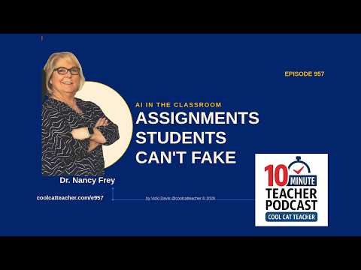 AI in the Classroom: Assignments Students Can’t Fake with Dr. Nancy Frey (0:40)
The practical response to AI-assisted work is becoming less about detecting a suspiciously polished essay and more about requiring explanation, source judgment, revision, and reflection. Timed writing and reflective questions such as what was most difficult also remain useful—not as a complete policy, but as ways to make the learner’s own thinking observable. [2]

AI literacy is moving under the hood—and into institutional workflows
A sponsored Vicki Davis demonstration presents CodeAI, the nonprofit formerly known as Code.org, as a free tool for students to inspect how AI works rather than merely type into a black box. Its “glass box” curriculum deliberately creates moments worth examining, including culturally biased outputs and incorrect answers, then uses teacher-led discussion to analyze them. [5]
CodeAI’s Karim Meghji argues that students should be in the driver’s seat: actively steering and questioning AI rather than passively remaining “in the loop.” The intended outcome is a healthy validation habit—asking whether to accept, challenge, and independently verify an answer. The product’s safety description is similarly candid: it uses pre- and post-filters and repeatedly tests hundreds of prompts, but acknowledges that no system will achieve complete protection against jailbreaks. [5] 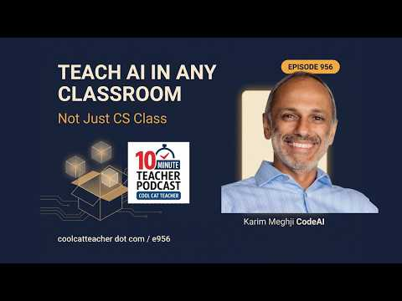 How to Teach AI in Any Classroom, Not Just CS Class — Episode 956 (3:11)
The same design logic is appearing in institutional tools. A Google for Education demonstration showed Gemini’s guided-learning mode asking questions instead of supplying a math answer; its Canvas tool generating HTML quizzes, interactive infographics, and apps that can be copied into Moodle or other HTML-capable spaces; and NotebookLM answering from selected sources rather than the open web. [6]
Workspace Studio extends that shift from learning content to administration. No-code agents can be triggered by events such as an email, a file upload, or a calendar meeting, then use Gemini and NotebookLM to triage requests, consult institutional documents, and draft responses. The demonstration explicitly leaves human review at the end of the workflow. [6] 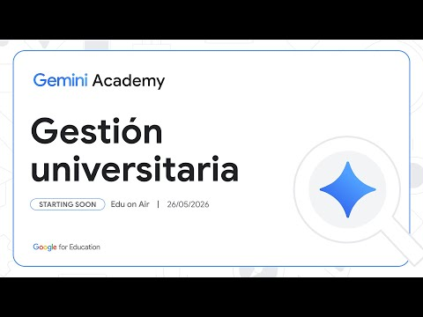 [Español] Academia Gemini: IA aplicada a la eficiencia de la gestión universitaria [Higher Ed] (15:34)
Policy is beginning to catch up with these capabilities. Spain’s Council of Ministers approved a draft Organic Law on the good use and governance of AI, which still has to go through Congress. The accompanying higher-ed guidance recommends a centralized inventory of AI uses, human supervision, explainability, and impact and risk assessments before deployment. [6]

Workforce learning is becoming an infrastructure problem
Andrew Ng argues that traditional education systems are too slow to prepare people for AI-shaped work: training should target the jobs of 2028 and beyond, including changing roles in marketing, recruiting, journalism, HR, and operations—not only software engineering. [7]
That pressure is already visible inside universities. EDUCAUSE reports that AI use is moving faster than policy, training, and institutional strategy; employees are experimenting independently and may put proprietary information into unsanctioned tools. Its recommendation is to establish governance first, share ownership across IT, HR, and senior leadership, and make AI literacy an early practical step. [8]
Access to advanced tools is also being widened at the research end. OpenAI says ChatGPT for Academic Researchers will give 10,000 scientists, mathematicians, and engineers free access to frontier models initially, expanding to 100,000 through 2027, with training and hands-on support. The program says researcher data will not be used to train models by default. That is an access initiative, not yet evidence that frontier-model access improves research or learning outcomes. [9, 10, 11]

What This Means
- For school and system leaders: Treat student-facing AI as an instructional-design decision, not a software rollout. A field report says education leaders are culling tools, prefer deeper implementation partnerships, and use a rough red/yellow/green logic: student-facing AI raises learning and safety concerns, teacher-facing AI needs alignment, and administrative AI is the easiest place to pursue efficiency. They also prefer pilots in their own context over vendor-produced research. [12]
- For assessment leaders: Require evidence of the process—explanation, source checking, dialogue, revision, and reflection—not only a finished artifact. The calculus beta suggests that retry and feedback are part of the learning design, while the K–12 examples show that transcripts and verbal defense can make understanding visible. [4, 2]
- For edtech product teams and investors: Personalization and engagement are not impact measures by themselves. The field’s current warning is that AI may accelerate the old problem of confusing clicks and activity with learning; products need a credible account of what changes in learner capability, for whom, and under what implementation conditions. [13]
- For higher-ed and L&D teams: Pair access with governance and skill development. The useful unit of planning is not “which tool should everyone use?” but “which work is changing, what new judgment is required, and what protected workflow lets people practice it safely?” [7, 8]

Watch This Space
- Independent evidence for AI-guided schools: LearnVector is a major commercial bet, while Montessorium offers an encouraging but school-reported result from one Texas campus. The next meaningful test is durable, independently evaluated learning—not another demonstration of personalization. [1, 3]
- AI in high-stakes observation and exams: Anecdotal teacher reports describe proposed microphone-based evaluation, a 360-degree camera that rates teaching, and AI glasses colliding with testing rules and classroom-recording concerns. Responses range from district bans to legal consultation and instructions to act as if people are always being filmed. These reports do not establish prevalence, but they show that schools are having to define consent, accessibility, evidence, and accountability before the technology is settled. [14, 15, 16, 17, 18]

Sources
- 𝕏 post by @AndrewYNg
- AI in the Classroom: Assignments Students Can’t Fake with Dr. Nancy Frey
- Maria Montessori and an AI Tutor Walk Into a Classroom…
- Make Them Teach It
- How to Teach AI in Any Classroom, Not Just CS Class — Episode 956
- [Español] Academia Gemini: IA aplicada a la eficiencia de la gestión universitaria [Higher Ed]
- China, Open Source & AI Competitiveness I Andrew Ng
- 3 AI Workforce Gaps Higher Ed Must Close | EDUCAUSE Exchange
- 𝕏 post by @OpenAI
- 𝕏 post by @OpenAI
- 𝕏 post by @OpenAI
- America Doesn’t Just Have a Skills Gap. It Has a Hiring Model Problem.
- The Great EdTech Pivot Is Coming
- r/Teachers post by u/sincerestfall
- r/Teachers comment by u/illbringthepopcorn
- r/Teachers post by u/thecooliestone
- r/Teachers comment by u/CrazyGooseLady
- r/Teachers comment by u/SierraGuyInCA

