Poetic’s AI-Compiler Thesis, Noble Mobile’s Seed, and New Signals on AI Specialization
VC Tech Radar
2026-06-11

Poetic’s AI-Compiler Thesis, Noble Mobile’s Seed, and New Signals on AI Specialization
By VC Tech Radar • June 11, 2026
A $10.3M seed for Noble Mobile leads the deal flow, while Poetic, Alta Ares, Lattice Health, and Serafis stand out as early-stage teams to watch. The deeper read is on AI-compiled software, industrial world models, agent verification, and why investors increasingly see specialization and voice-native data layers as key themes.

Funding & Deals
- Noble Mobile — $10.3M seed. Andrew Yang’s carrier startup said it raised a $10.3M seed round. [1] Yang previously founded Adventure for America. [1] The company charges $50 per month for unlimited data and gives up to $20 back to lighter users. [1] Noble says it launched in September and has reached millions in revenue with thousands of subscribers. [1] Yang says average subscriber spend is $42 per month and screen time is down 17%. [1] He cites Mark Cuban’s Cost Plus Drugs as inspiration for the model. [1]
- AI trip-planning startup — $6M led by Sequoia. The company said it raised $6M led by Sequoia. [2] Its product plans flights, hotels, and personalized itineraries that can be booked in one flow. [2] The product is already live and free to use. [2]

Emerging Teams
- Poetic. Markie Wagner’s company is building enterprise software that learns written and tacit business rules on-site and turns them into code. [3] The team is mostly engineers, many ex-Palantir, who spend weeks with customers to capture process detail. [3] Backers include Founders Fund, Kleiner Perkins, Genius Ventures, and OpenAI. [3] Current deployments include AIG, SoFi, and Chime; AIG CEO Peter Zaffino said Poetic has already achieved “99%+ quality outcomes on multi-hour processes.” [3]
- Alta Ares. Hadrien Canter’s defense AI startup is building a compact drone interceptor, about the size of a desk lamp, that uses AI software and radar to detect, catch, and destroy military drones. [4] France is testing Alta Ares models in the UAE. [4]
- Lattice Health. YC says Lattice Health monitors deployed medical-imaging AI and flags when accuracy starts to slip across X-rays, CTs, and MRIs. [5] The launch post highlighted @sparkcpark. [5]
- Serafis. YC’s launch describes Serafis as a podcast app for investors. [6] Its data platform is already live with top asset managers representing $70B+ in AUM. [6]

AI & Tech Breakthroughs
- AI as compiler, not runtime. Poetic says AI should compile business processes into deterministic code that runs cheaply and predictably, then regenerate that code when the world changes. [3] The company says this yields 100x less token usage and “nines of accuracy” on complex tasks. [3]
“Agents should do the thinking, code should do the doing.” [3]
- World model for the factory. Forgis-Labs says it is replacing bespoke industrial models with a single pipeline that predicts events across machines, robots, and processes from raw sensor streams. [7] The stack includes FactoryNet for pretraining data, HEPA for edge time-series event prediction, RASA for topology-driven reasoning, and TEMPO for natural-language explanations of raw sensor streams. [7] The team says five papers were accepted to ICML workshops. [7]
- SmithDB search infra. LangChain says it built a custom inverted index from scratch to support full-text search and JSON filtering across agent traces that can span hundreds of MBs while maintaining 400ms P50 latency. [8] Harrison Chase said this is the first in a planned series on how the company builds LLM infrastructure. [9]
- Verification-first agents. OMK is a local-first CLI that treats “done” as a verification problem, with a Goal → DAG → Route → Verify → Replay loop and artifacts including proof bundles, decision traces, and replay logs. [10] In the discussion, another builder said the proof that an agent actually completed a task is often harder than the retrieval step itself. [11]

Market Signals
- Specialization is becoming the VC moat. Foundation Capital says the AI and LLM cycle is pushing firms toward clearer bookends—growth platforms at one end and early-stage specialists at the other—and making it harder to do both. [12] Its own strategy is pre-product-market-fit technical seed, often before product or revenue, serving as first institutional investor 85% of the time. [12] Iconic says it is taking concentrated bets from seed onward and has built a 50-person support bench beyond the investment team. [12]
“With more competition, you have to have specialization.” [12]
- Contrarian infrastructure timing still matters. Foundation pointed to Cerebras as a 2015-2016 incubation alongside Benchmark, when AI chips were not a crowded trade. [12] Cerebras has now gone public. [12]
- Voice is emerging as a new system of record. a16z argues that the highest-value enterprise context still lives in conversations, and that LLMs are well suited to converting voice into structured, searchable data. [13] The firm describes the opportunity as large and still early. [13]
- Investor diligence still needs hard economics. Paul Graham relayed an AI startup generating roughly $400 in annual revenue per $1,000 of GPU hardware, or about a 40% annual return on GPU cost. [14] At the same time, SaaS operators say repeated “AI replaced this” and “10x that” claims are starting to blur together, making genuine traction harder to distinguish from attention farming. [15, 16]

Worth Your Time
- Web Summit panel on VC specialization. Useful for how AI is widening the gap between growth platforms and seed specialists. [12] 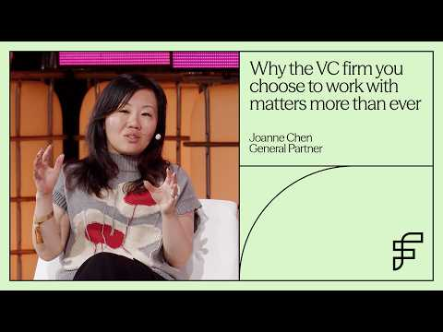 Why the VC firm you choose with matters more than ever | Web Summit Vancouver 2026 (5:26)
- Andrew Yang on Noble Mobile’s pricing model. Useful founder clip on the aligned-carrier thesis behind the new seed round. [1] 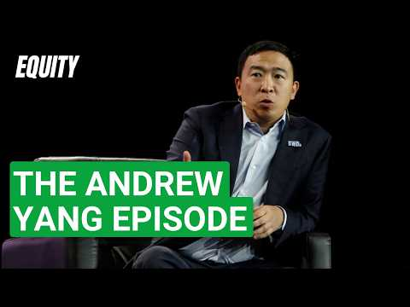 Why Andrew Yang is building instead of waiting for Washington | Equity Podcast (6:35)
- Return on Tokens (ROT). Best essay in this batch on why some enterprise AI stacks may move from agent runtimes toward AI-compiled software. [3]
- Everything Is Recorded Now. Strong framing for voice as the next major enterprise data layer. [13]
- LangChain on full-text search in SmithDB. Worth reading if you are diligencing observability, trace storage, or retrieval infrastructure for agent systems. [8]

Sources
- Why Andrew Yang is building instead of waiting for Washington | Equity Podcast
- 𝕏 post by @FDavidsonT
- Return on Tokens (ROT)
- 𝕏 post by @nathanbenaich
- 𝕏 post by @ycombinator
- 𝕏 post by @ycombinator
- r/deeplearning post by u/Ok-Arachnid5757
- 𝕏 post by @LangChain
- 𝕏 post by @hwchase17
- r/SideProject post by u/Fabulous-Lobster9456
- r/SideProject comment by u/Couponpicked
- Why the VC firm you choose with matters more than ever | Web Summit Vancouver 2026
- 𝕏 post by @a16z
- 𝕏 post by @paulg
- r/SaaS comment by u/dtporiprosu
- r/SaaS post by u/Minimum_Boss9220

