Quincy Jones Leadership, Cialdini Persuasion, and a High-Conviction AI Counterpoint
Recommended Reading from Tech Founders
2026-05-12

Quincy Jones Leadership, Cialdini Persuasion, and a High-Conviction AI Counterpoint
By Recommended Reading from Tech Founders • May 12, 2026
Today’s authentic founder recommendations clustered around leadership, persuasion, and cultural framing. The strongest pick was Ben Horowitz’s documentary recommendation for learning how elite teams manage ego, while Naval and Andreessen added a practical stack of books, videos, and one high-conviction AI article.

Most compelling recommendation

The Greatest Night in Pop
- Content type: Documentary
- Author/creator: Not specified in the provided notes
- Link/URL: Not provided; discussed as available on Netflix [1]
- Who recommended it: Ben Horowitz [1]
- Key takeaway: Horowitz pointed the host to the film for what it shows about Quincy Jones as a leader: he was exceptional at handling super-talented, difficult people and setting collaboration norms before the work started [1]
- Why it matters: This was the strongest recommendation in today’s set because it came with a concrete operating lesson, not just praise. The host said the documentary taught him a lot about Horowitz and even summarized Horowitz as “the Quincy Jones of technology” [1]
“Leave your ego at the door.” [1] 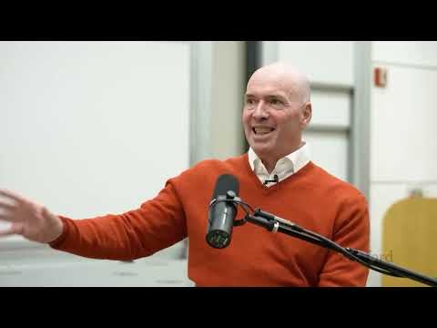 Stanford CS153 Frontier Systems | Ben Horowitz from a16z on Venture Capital Systems, Network Effects (2:30)

Naval’s practical learning stack
Naval Ravikant’s recommendations formed the clearest mini-syllabus of the day: persuasion, mission-setting, and what strong small teams feel like when they work well [2].

Influence
- Content type: Book
- Author/creator: Robert Cialdini
- Link/URL: Not provided
- Who recommended it: Naval Ravikant [2]
- Key takeaway: Naval called it the original book on persuasion, said the sequel is skippable except for anchoring, and highlighted Cialdini’s CLASSR framework: consistency, liking, authority, scarcity, social proof, and reciprocity [2]
- Why it matters: It was the most explicit framework recommendation in today’s notes [2]

Glengarry Glen Ross
- Content type: Movie
- Author/creator: Not specified in the provided notes
- Link/URL: Not provided
- Who recommended it: Naval Ravikant [2]
- Key takeaway: Naval said it was effectively the full extent of his sales training, and still recommended it [2]
- Why it matters: It is a concise cultural reference for how one founder thinks about learning sales [2]

Wind, Sand and Stars and Airman’s Odyssey
- Content type: Books
- Author/creator: Antoine de Saint-Exupery
- Link/URL: Not provided
- Who recommended it: Naval Ravikant [2]
- Key takeaway: Naval used Saint-Exupery’s writing to make a leadership point: inspire people to yearn for the mission rather than just assigning tasks [2]
- Why it matters: These were the clearest mission-building recommendations in today’s set [2]

Liftoff, The Macintosh Way, and Soul of a New Machine
- Content type: Books
- Author/creator: Not fully specified in the provided notes
- Link/URL: Not provided
- Who recommended it: Naval Ravikant [2]
- Key takeaway: Naval framed them as inspiring stories of small, highly competent teams whose members can rely completely on one another and therefore do their most creative work [2]
- Why it matters: This cluster is useful less as theory than as an operating ideal for company-building [2]

Repeat signal and other notable picks

Suicidal Empathy
- Content type: Book
- Author/creator: Gad Saad
- Link/URL: Amazon [3]
- Who recommended it: Marc Andreessen; Elon Musk separately called it “Worth reading” [4, 3, 5]
- Key takeaway: Andreessen said Saad’s argument is that some social reform movements are driven by a pathological form of empathy that ends up harming the people they claim to help, or harming the reformers themselves [4]
- Why it matters: It was the clearest repeated title in today’s notes [4, 3, 5]

Boomer Truth
- Content type: YouTube video
- Author/creator: Academic Agent / Nema Parvini
- Link/URL: Not provided
- Who recommended it: Marc Andreessen [4]
- Key takeaway: Andreessen called the two-hour video worth watching for its account of “Boomer Truth” as the habit of believing whatever television says, and for tracing how that pattern is breaking down [4]
- Why it matters: It was the most specific long-form video recommendation in Andreessen’s set of culture-oriented picks [4]

Article arguing humans will still have valuable work in the age of AI
- Content type: Article
- Author/creator: Not specified in the provided notes; reposted by John Ennis
- Link/URL: https://x.com/johnennis/status/2039064805827330362 [6]
- Who recommended it: Marc Andreessen [7]
- Key takeaway: The piece pushes back on the idea that humans will have nothing valuable left to do in an AI-heavy future [6]
- Why it matters: Andreessen gave it his highest recommendation, making it the clearest AI-related resource endorsement in today’s set [7]
“Absolutely lovely. Highest recommendation.” [7]

Sources
- Stanford CS153 Frontier Systems | Ben Horowitz from a16z on Venture Capital Systems, Network Effects
- 𝕏 post by @navalpodcast
- 𝕏 post by @GadSaad
- The Golden Age Thesis | Marc Andreessen on MTS
- 𝕏 post by @elonmusk
- 𝕏 post by @johnennis
- 𝕏 post by @pmarca

