Reusable Skills, Cloud Handoffs, and Verifier Loops
Coding Agents Alpha Tracker
2026-06-18

Reusable Skills, Cloud Handoffs, and Verifier Loops
By Coding Agents Alpha Tracker • June 18, 2026
Today’s strongest coding-agent pattern is turning successful runs into reusable systems: skills, automations, workflow code, and cloud jobs. Practical highlights span Cursor’s new cloud subagents, Theo’s Claude Code orchestration tricks, Codex automation and iOS workflows, Context Hub, and new open-model/sandbox tooling.

🔥 TOP SIGNAL
- The clearest shift today: strong practitioners are productizing successful agent runs instead of re-prompting from scratch. Riley Brown turns plain-English Codex sessions into reusable skills and timed automations [1], Theo has Claude Code load precomputed context and write JS workflows for staged sub-agents [2], and Boris Cherny reduces the durable pattern to one line: agent + advanced model + verifier in a loop [3].
- The common idea is timeless: capture good behavior once, then reuse it with guardrails instead of leaning on prompt hacks every time [1, 3].
“run Claude Code + an advanced model + a verifier in a loop” [3]

⚡ TRY THIS
- Turn a good run into a skill. Riley Brown’s workflow: ask the agent to do the task, push until the output is right, then say turn this into a skill called [Name]; when you learn a better format later, request the change and say update the skill [1]. His broader point: stop micromanaging files or using act as hacks — describe the change clearly in natural language [1].
- Schedule the boring stuff. Brown uses natural-language automations in Codex for both recurring and one-off tasks. Two prompt shapes that worked: do research every morning at 9am and send me a hook outline and set an automation in 35 minutes to upload this video to YouTube as a draft, send me a text when you do it [1, 4]. Pattern: if a task is useful once, ask whether it should recur or trigger later.
- Precompute context inside the skill. Theo’s Claude Code trick: make the skill execute a script on load so the model starts with facts already computed. His Repo Explorer skill keeps a ~/Explore Repos cache, lists current repos first, then clones only if the target is missing — useful when you want the agent to inspect real source without cluttering the active workspace [2].
- Make the agent show its orchestration code before you pay for it. Theo’s prompt is worth stealing: I want to audit the open PRs on this project... I want to use a workflow to break up all of this work. Before you run the workflow, please output the code you're going to use to run it so that we can read through it together [2]. That yields staged audit/rule/verify phases instead of blind tool-call flooding [2], and it pairs cleanly with Boris Cherny’s verifier-loop advice; just watch the burn rate, since Theo saw about $100 every 10 minutes with eight parallel agents on Fable [3, 2].

📡 WHAT SHIPPED
- Cursor cloud agents — /in-cloud spins up an isolated cloud VM for long-running or parallel work; environments save as snapshots for faster future startups and verified testing; local agents can be moved to cloud so work continues with the laptop closed. Changelog: cursor.com/changelog/cloud-in-agents-window [5, 6, 7, 8].
- Codex “Build iOS Apps” plugin — runs the app in an in-app browser, opens SwiftUI previews, and hot-reloads edits without leaving Codex. Greg Brockman called it “a much better way to build iOS apps” because it removes the copy-paste-build-screenshot loop [9, 10].
- LangSmith sandboxes in Harbor — LangSmith is now a first-class Harbor environment alongside Daytona, E2B, and Modal; Harbor supports Dockerfile snapshots, SDK profiles, and a full exec/upload/download lifecycle. Docs: docs.langchain.com/langsmith/sandbox-harbor [11, 12].
- Orca — Jason Zhou says Orca is now his favorite IDE, pointing to built-in file/diff review, a setup script, agent session discovery, and native mobile support. Repo: github.com/stablyai/orca [13].
- Context Hub — Andrew Ng and Rohit Prasad are building a “stack overflow for AI agents” so agents can fetch the latest API/SDK docs and contribute feedback back into the docs; Ng says it helps his agents make accurate calls to newer APIs and has accelerated his own coding work [14].
- Open-model options are widening — Codex App, CLI, and SDK can use any open-source model via OSS-mode providers, per Tibo’s config note [15]. Riley Brown is also testing GLM-5.2 both through Cursor’s custom-model path and in ZCode, which he describes as an “exact replica of Codex” with Telegram/Discord bot channels and access via a Coding Plan API key [1, 16, 17].

🎬 GO DEEPER
- 3:34–5:35 — Theo on Repo Explorer. Best demo of Claude Code’s “skills can execute scripts on load” advantage. You see the exact pattern: keep a repo cache outside the workspace, list what’s already there, clone only when needed, and feed the result back into the run [2].
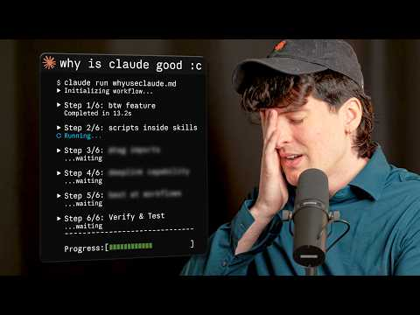 I hated making this video… (3:33)
- 6:10–8:09 — Riley Brown on turning a one-off task into a skill. Shows the full do task -> improve it -> turn this into a skill -> update the skill loop [1].
 9 AI Agent Trends To Get Ahead of 99% of People (6:09)
- 8:35–9:14 — Andrew Ng on Context Hub. Worth watching if your agents keep failing on recent SDKs or annoying API syntax; the point is simple: load fresher docs into the run [14].
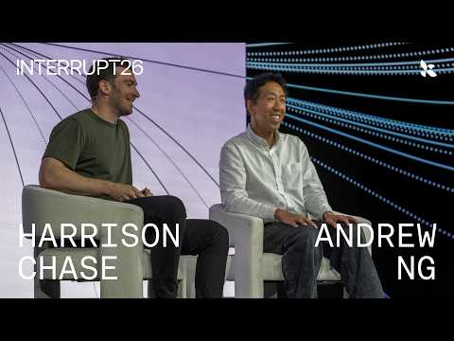 The Future of AI Agents with Andrew Ng | Interrupt 26 (8:34)
- Repo to inspect: Orca. If you want to study a mobile-aware agent IDE with built-in diff review and session discovery, start with github.com/stablyai/orca [13].
- Docs to inspect: Codex OSS mode + Harbor/LangSmith sandboxes. Two useful implementation docs if you’re standardizing infra instead of just testing apps: developers.openai.com/codex/config-advanced#oss-mode-local-providers and docs.langchain.com/langsmith/sandbox-harbor [15, 12].
Editorial take: the durable edge is shifting from clever prompts to reusable agent infrastructure — skills, automations, fresh docs, cloud runs, and verifier-backed loops. [1, 14, 5, 3]

Sources
- 9 AI Agent Trends To Get Ahead of 99% of People
- I hated making this video…
- 𝕏 post by @bcherny
- 𝕏 post by @rileybrown
- 𝕏 post by @cursor_ai
- 𝕏 post by @cursor_ai
- 𝕏 post by @cursor_ai
- 𝕏 post by @cursor_ai
- 𝕏 post by @kedytcom
- 𝕏 post by @gdb
- 𝕏 post by @LangChain
- 𝕏 post by @LangChain
- 𝕏 post by @jasonzhou1993
- The Future of AI Agents with Andrew Ng | Interrupt 26
- 𝕏 post by @thsottiaux
- 𝕏 post by @hqmank
- 𝕏 post by @rileybrown

