Reversible Agent Work Is Becoming the Real Productivity Layer
Coding Agents Alpha Tracker
2026-09-14

Reversible Agent Work Is Becoming the Real Productivity Layer
By Coding Agents Alpha Tracker • September 14, 2026
The strongest signals shift attention from raw code generation to reversible commit cleanup, clone-backed worktrees, model-routed subagents, and CI agents that learn from real logs.
Coverage is incomplete: some monitored sources or documents could not be processed. This brief covers the available verified material.
Coverage is incomplete: some monitored sources or documents could not be processed. This brief covers the available verified material.

🔥 TOP SIGNAL
The agent bottleneck is moving downstream—from generating code to controlling the artifact and the environment around it. Simon Willison released commit-rewriter 0.1 after coding-agent cruft and private-repository issue IDs made commit messages unfit for publication; the Python web app provides an editor and creates a timestamped branch before rewriting. [1] Peter Steinberger is attacking the other side of the problem with folder-clone worktrees he says should be ~80% faster and use less disk, while Theo’s sponsored Codesmith demo used actual CI logs to right-size runners. [2, 3]
The practical pattern is to make agent work cheap to isolate, inspect, and undo—not just cheap to generate. [1, 2, 3]

⚡ TRY THIS
- Clean agent-authored history before publication. Run uvx commit-rewriter path/to/repo—or omit the path from inside the repository. Edit the messages in its web UI, then submit: it creates a timestamped branch for rollback and rewrites every commit from the first edited commit through the latest. [1]
- Route subagents to the model they actually need. Lydia Hallie’s Fable 5.1 tip is CLAUDE_CODE_SUBAGENT_MODEL=opus: Fable spawns subagents, but hers rarely need Fable-level reasoning, and she says this saved “so much usage.” Addy Osmani amplified the tip. Treat it as a field anecdote, not a benchmark. [4, 5]
- Make CI tuning log-driven. In a Blacksmith/Codesmith setup, ask the agent to inspect real CI logs, identify CPU-heavy and lightly used jobs, recommend runner sizes, and apply the one-line GitHub Actions change. Theo reports three real T3 Code PRs merged in under five minutes and almost halving CI time; because the segment is explicitly sponsored, reproduce the before/after in your own pipeline. [3]
- Put a size and verification gate around generated code. A Vienna discussion summarized by @pidotdev warned that agents generating too much code poison their own context (“slippery slop”) and called out unreadable Astra code. Theo separately reports Fable putting a screenshot of a bug it introduced into a PR without noticing the bug. Keep diffs bounded, then require a fresh test or rendered-output review; a screenshot is evidence to inspect, not acceptance. [6, 7]

📡 WHAT SHIPPED
- commit-rewriter 0.1 — Simon Willison. A Python web app born from preparing Datasette security-release commits whose agent cruft and private issue references were not fit for publication; it preserves a rollback point before rewriting history. [1]
- Faster worktrees are headed for a release or dev channel—not stable yet. Peter Steinberger says folder clones across APFS, brtfs, XFS, and ReFS should make worktrees ~80% faster and save disk space. The implementation is written in Rust; he will test it for several weeks before trying to get it into Codex. [2, 8, 9]
- T3 Code now streams responses by default. Theo says the behavior is not token-by-token and will be toggleable before stable. He also says he is concerned T3 Code burns through Codex and Claude Code limits quickly enough to risk bans, then jokes that “the real rate limit was the quality of the client.” [10, 11, 12, 13]

🎬 GO DEEPER
- Theo — Codesmith/Blacksmith CI-agent demo. Watch the opening sponsor segment for the concrete loop: inspect actual CI logs → right-size runners → make a one-line GitHub Actions change → validate the resulting PRs. Theo reports three real T3 Code PRs in under five minutes and almost-halved CI; keep the sponsor context in mind. [3] 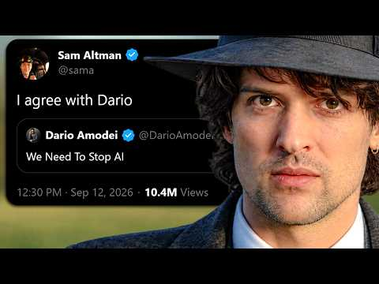 I think they mean it this time (0:57)
- Study the worktree substrate. Peter points to the Rust fs-safe implementation behind the folder-clone experiment; it is a future performance test, not yet a settled Codex feature. [8, 9]
- Romain Huet — Astra’s artifact-feedback loop. Huet asked Astra in Codex to build a Blender model and fly-by, then noted a ~30-minute first model/orbit, checks in daylight and dusk, and a follow-up request that built the interior, including 88 individually modeled window panes. The reusable pattern is inspectable artifact → environmental checks → concrete follow-up, not the nostalgic subject matter. [14, 15]
Editorial take: The alpha is not more autonomous generation; it is a reversible loop—usage-aware subagents, clone-backed worktrees, log-based feedback, and independent acceptance. [4, 2, 3, 7]

Sources
- commit-rewriter 0.1
- 𝕏 post by @steipete
- I think they mean it this time
- 𝕏 post by @lydiahallie
- 𝕏 post by @addyosmani
- 𝕏 post by @pidotdev
- 𝕏 post by @theo
- 𝕏 post by @steipete
- 𝕏 post by @steipete
- 𝕏 post by @theo
- 𝕏 post by @theo
- 𝕏 post by @theo
- 𝕏 post by @theo
- 𝕏 post by @romainhuet
- 𝕏 post by @romainhuet

