Robotics Scaling, Voice AI Capital, and the Rise of Background Agents
VC Tech Radar
2026-05-01

Robotics Scaling, Voice AI Capital, and the Rise of Background Agents
By VC Tech Radar • May 1, 2026
Capital signals centered on voice AI and founder-first programs, while early teams in ultrasound, billing, legal workflow, and AI education showed differentiated execution. The deeper read-through: robotics is converging on a scaling-law playbook, agents are moving into background labor, and governance plus token economics are becoming core diligence items.

Funding & Deals
- Voice AI is absorbing capital because enterprise adoption is now visible. Venture investors put more than $7B into voice AI startups in Q1, the highest level yet, and recent sizable rounds include ElevenLabs, Synthesia, and Runway [1]. The market is projected at $22B in 2026 and to nearly triple over the next five years [1]. The clearest enterprise proof point in the notes is Abridge: it launched 500 licenses at HonorHealth, uses proprietary models to generate EHR-ready notes plus follow-up, test-order, and prescription cues, and built a waitlist of 150+ additional doctors in under two months [1]. Privacy, accuracy, and malpractice concerns remain live, and Abridge’s mitigation is self-hosting plus practice-level access and retention controls [1].
- Forge Ventures is moving capital earlier in the founder-formation stack. The program backs AI builders before they have a product, company, or revenue, and offers selected builders $15K over 6-12 months for tools, API credits, subscriptions, and compute [2].

Emerging Teams
- Biotics AI is one of the clearest healthcare-device teams in the set. CEO Robby Bustami grew up in a family of obstetricians, specialized in computer vision, worked at IBM Watson, and partnered with Dr. Hisham El Gamal, an award-winning AI prenatal-ultrasound researcher, to build an AI copilot that plugs into any ultrasound machine and gives real-time feedback on fetal anatomy capture [3]. The company says about half of fetal malformation cases are misdiagnosed because of operator error; Biotics is FDA cleared, built its initial product for less than $100K, and said it plans launches with hospital partners and a network of roughly 15 maternal-fetal medicine specialists, including Maimonides [3].
- CodeMasterIp shows what a non-wrapper AI education product can look like. The solo founder says the product almost died as a generic ChatGPT-for-coding wrapper, then recovered after refocusing on a learning loop of chat → playground → challenge → community and writing about 40 custom system prompts so the AI behaves like a tutor rather than an oracle [4]. Six months in, the founder reports 800+ registered users, about 30% weekly return, and 4.2% free-to-paid conversion with $0 ad spend [4].
- YC launched two practical vertical-agent wedges. TaigaBilling automates insurance claim filing and follow-up for medical practices so clinicians can stay focused on patients; founders are Nanda Guntupalli and Adam Wax [5]. Andco uses AI agents to collect medical, police, and insurance documents for personal injury law firms so cases can close faster without added overhead; founders are Ryn Xue, D. Lee, and Mike Slemm [6].
- Uvilox AI is a strong accessibility-first product signal. The team says what began as a side project is now a real-time vision AI platform that lets deaf users call 911 in sign language while the system translates to voice, with reported latency under 80ms, 97.4% accuracy, support for 200+ signs, and HIPAA-compliant AES-256 encryption [7].

AI & Tech Breakthroughs
- Nvidia’s robotics stack is converging on an LLM-style scaling playbook. Jim Fan describes the path as world-model pretraining, action fine-tuning, then reinforcement learning [8]. DreamZero’s World Action Model jointly predicts next world states and actions from video and can zero-shot tasks or verbs not seen in training [8]. EgoScale pretrained an end-to-end dexterous policy on 21k hours of egocentric human video with only four hours of teleop, less than 0.1% of the mix, and surfaced a clean scaling law for dexterity, while Dream Dojo turns video world models into real-time neural simulators without explicit physics engines [8]. Fan’s data thesis is equally important: teleop should shrink toward negligible share, replaced by wearables and egocentric video [8].
- Edge perception economics continue to collapse. OVERWATCH packages multi-camera awareness onto a $500 Jetson Orin Nano using YOLOv8n TensorRT FP16, adaptive Kalman tracking, and self-calibrating cross-camera homography via RANSAC [9]. The system can derive a usable homography after about five seconds of co-visibility, self-heal when cameras move, and reproduce capabilities that in 2020 would have required custom hardware, weeks of calibration, and a larger compute budget [9].
- Deplodock makes the ML compiler stack unusually legible. The project is a roughly 5K-line pure-Python compiler that lowers PyTorch through six IR stages to raw CUDA, with fusion, GPU-aware tiling, async copies, register tiling, and bank-conflict avoidance built into the stack [10]. The author reports attention performance competitive with torch.compile and end-to-end compilation of Qwen2.5-7B [10].
- Context is turning into infrastructure, not just prompt engineering. Brockman says models become extremely capable when given the full context, and described a systems engineer handing a complex optimization design doc to a model that implemented the spec, instrumented it, profiled it, and iterated overnight [11]. OpenAI’s newly announced Chronicle extends that idea by plugging into Codex, observing a user’s computer activity, and forming memories so the model no longer has to be repeatedly re-briefed [11].

Market Signals
- Background agents are moving from demo to operating model. Sequoia says the task-endurance frontier moved from tens of minutes a year ago to hours today, and frames agents as a combination of reasoning, tool use, and persistence [12]. It argues that services is the new software and expects async, background, and dark-factory agents to overtake today’s supervised paradigm [12]. In GTM, Parallel says Actively customers using always-on per-account agents report 23% higher win rates, 25% higher revenue per rep, 2x conversion rates, and 2x faster ramp time [13].
The most important takeaway for the founders in this room is that services is the new software. [12]
- The cost side is still brutal. Brockman says demand for intelligence is effectively unlimited and that OpenAI still does not have enough compute; in the same interview, 2026 GPU availability was described as effectively rounding to zero [11]. Harry Stebbings’ source frames the frontier economics starkly: every $1 of run-rate revenue can require roughly $4-$5 of capex [14]. At the operating level, engineers at multiple companies report token spend up about 10x in six months; one seed-stage AI infra company went from about $200 to $3,000 per developer per month, and many teams are opting to increase budgets while they instrument ROI rather than clamp down on usage [15].
- Human attention, approvals, and provenance are becoming the scarce resources. Brockman says the bottleneck is shifting toward governance, security primitives, observability, and data provenance, and that human attention will become the critical limiting factor [11]. Envault is a useful design pattern here: short-lived project-scoped JWTs for agents, intercepted write requests that create pending_approvals, 202 Accepted responses with approval IDs, and explicit human review of key/value diffs before any secret mutation is allowed [16].
Human attention is going to be this incredibly scarce resource. [11]
- Frontier labs are now visible talent magnets in physical space. OpenAI’s 1.2M square feet and Anthropic’s 950K square feet make them the #2 and #4 SF tenants; together they exceed Salesforce’s current 1.0M square feet by more than 2x [17]. SaaStr’s read is that these are decade-long commitments signaling where Bay Area engineering demand is concentrating while legacy software footprints shrink [17].
- Build-time compression is reinforcing a code-commodity view. Sequoia cites a founder completing a three-year moonshot solo over a holiday, Brett Taylor rebuilding Sierra in a weekend, and Notion rewriting 8 million lines of code in six weeks [12]. In parallel, some founders say investors now treat AI-built code as easy to replicate and focus instead on revenue and stickiness; FactoryAI’s Matan says any released feature can be copied within two weeks [18, 19].

Worth Your Time
- Robotics’ End Game: Nvidia’s Jim Fan — the clearest single talk in the set on world-action models, egocentric-video pretraining, dexterity scaling laws, and neural simulation for robotics [8].
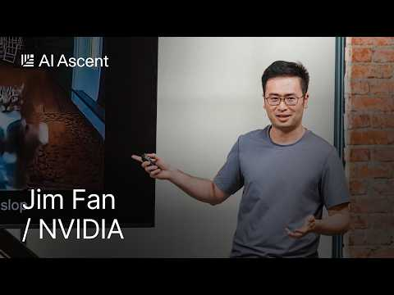 Robotics’ End Game: Nvidia’s Jim Fan (6:09)
- This is AGI: Sequoia AI Ascent 2026 Keynote — useful for long-horizon agent benchmarks, the services-as-software thesis, and the shift toward async agents [12].
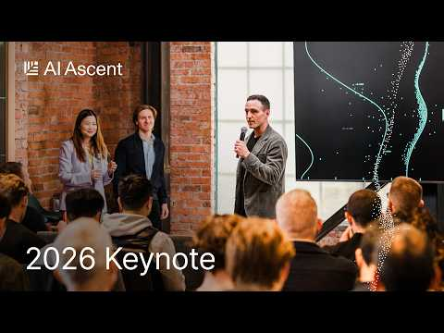 This is AGI: Sequoia AI Ascent 2026 Keynote (14:55)
- OpenAI’s Greg Brockman: Why Human Attention Is the New Bottleneck — the best operator conversation here on context systems, governance, and how fast agentic coding is moving [11].
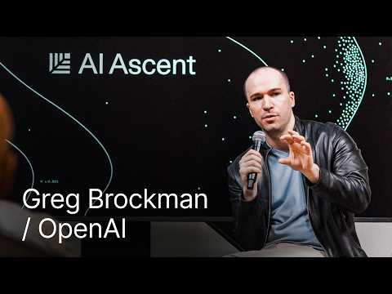 OpenAI’s Greg Brockman: Why Human Attention Is the New BottleneckOpenAI’s (15:05)
- The Pulse: token spend breaks budgets – what next? — a strong operator memo on 10x token-spend growth, $3,000-per-developer monthly examples, and why many teams are measuring ROI instead of slowing usage [15].
- Voice AI Investment Surges as Enterprise Applications Gain Traction — the best short sector read in the set on why voice AI capital is rising and how Abridge is translating that into deployment, while privacy and liability concerns remain live [1].
- When the Agents Pick the Models, OpenAI Comes Back to Life, and Thoma Bravo Just Wiped Out $5.1B on Medallia — worth reading if you are tracking how agent preferences could reshape model wars and B2B software durability [20].

Sources
- Voice AI Investment Surges as Enterprise Applications Gain Traction
- r/SideProject post by u/consciousnessunites
- Keeping Your Team Motivated When FDA Approval Isn’t Guaranteed l Build Mode
- r/SideProject post by u/OnlySaas
- 𝕏 post by @ycombinator
- 𝕏 post by @ycombinator
- r/SideProject post by u/Ok-Dare-5722
- Robotics’ End Game: Nvidia’s Jim Fan
- r/artificial post by u/Straight_Stable_6095
- r/MachineLearning post by u/NoVibeCoding
- OpenAI’s Greg Brockman: Why Human Attention Is the New BottleneckOpenAI’s
- This is AGI: Sequoia AI Ascent 2026 Keynote
- 𝕏 post by @p0
- 𝕏 post by @HarryStebbings
- The Pulse: token spend breaks budgets – what next?
- r/SaaS post by u/Dinanath_Dash
- Salesforce Has Quietly Cut 55% of Its SF Office Since 2019. OpenAI + Anthropic Took More Than All of It Back
- r/SaaS post by u/pink-supikoira
- 𝕏 post by @ThisWeeknAI
- 20VC x SaaStr: When the Agents Pick the Models, OpenAI Comes Back to Life, and Thoma Bravo Just Wiped Out $5.1B on Medallia

