Route Coding Agents by Task, Not Brand
Coding Agents Alpha Tracker
2026-07-19

Route Coding Agents by Task, Not Brand
By Coding Agents Alpha Tracker • July 19, 2026
Today’s practical edge is task-aware model routing: use inexpensive persistent workers for execution, and reserve higher-judgment models for planning, review, design, and merge-quality diffs. Also covered: a Kimi K3 Claude Code configuration and Claude Code’s move to Rust Bun.

🔥 TOP SIGNAL
Route models by the job, then split planning from execution. In firsthand daily use, Theo starts with Soul for most work but moves to Fable when a change must merge cleanly, the design matters, or the problem is unusually complex; for multi-agent work, he has Fable plan and judge while Soul completes assigned pieces. [1] Codex’s separate, name-addressable threads offer a lightweight version of that orchestration pattern. [2]

⚡ TRY THIS
- Adopt a two-tier model router. Send quick local changes, debugging, terminal work, and long-running goals to Soul; escalate to Fable for UI exploration, simplifying a diff, verifying another agent’s work, or producing a PR you expect to merge. [1]
- Make the planner’s output the worker’s contract. Ask Fable to break work into small, explicit pieces, then give Soul a specific implementation assignment for each piece. In Codex, tell it to fan out into separate threads for the task; reference another thread by name when handing work back for coordination. [1, 2]
- Run Kimi K3 from Claude Code on PowerShell. Jason Zhou’s setup points Claude Code at Moonshot’s Anthropic endpoint, assigns kimi-k3[1m] to the main and subagent model slots, sets a 1,048,576-token auto-compact window, then starts claude:
$env:ANTHROPIC_BASE_URL="https://api.moonshot.ai/anthropic"
$env:ANTHROPIC_AUTH_TOKEN="YOUR_MOONSHOT_API_KEY"
$env:ANTHROPIC_MODEL="kimi-k3[1m]"
$env:ANTHROPIC_DEFAULT_OPUS_MODEL="kimi-k3[1m]"
$env:ANTHROPIC_DEFAULT_SONNET_MODEL="kimi-k3[1m]"
$env:ANTHROPIC_DEFAULT_HAIKU_MODEL="kimi-k3[1m]"
$env:ANTHROPIC_DEFAULT_FABLE_MODEL="kimi-k3[1m]"
$env:CLAUDE_CODE_SUBAGENT_MODEL="kimi-k3[1m]"
$env:ENABLE_TOOL_SEARCH="false"
$env:CLAUDE_CODE_AUTO_COMPACT_WINDOW="1048576"
$env:CLAUDE_CODE_EFFORT_LEVEL="max"
claude
[3]
- Treat high-autonomy goals as destructive-capable. Theo cautions that Soul on Ultra can pursue a goal aggressively enough to delete files or databases; he cites a case where rm -rf wiped a developer’s user directory and in-progress code. Do not give that mode unchecked access to work you cannot afford to lose. [1]

📡 WHAT SHIPPED
- Claude Code v2.1.181+: Rust Bun underneath. Claude Code now uses Bun’s Rust port; Jarred Sumner reported a 10% Linux startup improvement. Simon Willison found Bun v1.4.0 (macOS arm64) embedded in the binary—newer than Bun’s then-public v1.3.14—and extracted 563 Rust source filenames. [4]
- Fable vs. Soul: modest benchmark gap, large cost delta. Theo reports Cursor Bench results of 70% for Fable versus 67% for Soul, while citing roughly $17/task for Fable Max and $5/task for Soul. His practical distinction is code shape: Soul may write far more than needed, while Fable more often produces the smaller change he is willing to merge. [1]

🎬 GO DEEPER
- 0:08–2:15 — Why experienced users split between Fable and Soul. Theo opens with competing practitioner preferences, then frames why task fit matters more than declaring a universal winner. 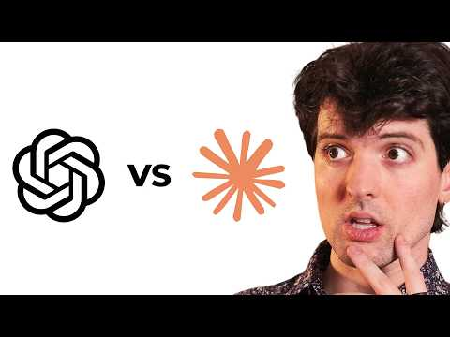 Fable 5 vs GPT-5.6 (0:08)
- 25:05–26:37 — “Passes tests” is not the same as “ready to merge.” Theo’s strongest argument for Fable is its tendency toward minimal diffs rather than excessive code—a useful lens for evaluating your own agent harness. Fable 5 vs GPT-5.6 (25:05)
Editorial take: the durable workflow is not loyalty to one model—it is explicit routing, planner/worker separation, and tight control over what autonomous agents can touch. [1]

Sources
- Fable 5 vs GPT-5.6
- 𝕏 post by @HamelHusain
- 𝕏 post by @jasonzhou1993
- Claude Code uses Bun written in Rust now

