Sandboxes, Self-Summarization, and TDD Loops Tighten the Coding-Agent Stack
Coding Agents Alpha Tracker
2026-03-18

Sandboxes, Self-Summarization, and TDD Loops Tighten the Coding-Agent Stack
By Coding Agents Alpha Tracker • March 18, 2026
The useful signal today was harness quality, not just model churn. New sandboxed execution layers, better long-horizon context handling, and concrete test/manual-test habits from experienced practitioners point to what actually improves coding-agent reliability.

🔥 TOP SIGNAL
Today’s clearest pattern: the harness is becoming the product. LangChain launched LangSmith Sandboxes and Open SWE around isolated execution, persistent sandboxes, curated toolsets, and workflow-native triggers, while Cursor said RL-based self-summarization cut compaction error by 50% on coding tasks that require hundreds of actions [1, 2, 3].
The practical takeaway is straightforward: safer execution plus better context compression is where reliability is improving right now—not just raw model swaps [1, 2, 3].

🛠️ TOOLS & MODELS
- GPT-5.4 mini — now available in ChatGPT, Codex, and the API. OpenAI says it is optimized for coding, computer use, multimodal understanding, and subagents, and is 2x faster than GPT-5 mini [4].
- Cursor Composer — now trained to self-summarize via RL instead of a prompt. Cursor says this cuts compaction error by 50% and improves success on long coding tasks with hundreds of actions [3].
- LangSmith Sandboxes — now in private preview. Key pieces: MicroVM isolation, an auth proxy so secrets never touch the runtime, persistent long-running sessions, state carryover, tunnels, and direct integrations with Deep Agents and Open SWE [1].
- Open SWE — new open-source framework for internal coding agents built on Deep Agents and LangGraph. It packages patterns LangChain says it observed across Stripe, Ramp, and Coinbase: isolated sandboxes, curated tools, Slack/Linear/GitHub invocation, AGENTS.md startup context, subagents, and middleware safety nets [2].
- Operator comparison: Codex vs. Claude Code — Theo said GPT-5.4 in Codex/T3 Code quickly diagnosed mixed TanStack versions and fixed a Vite+ migration, while his Claude Code run sat for 15+ minutes without changing code [5].

💡 WORKFLOWS & TRICKS
- Simon Willison’s low-drama loop: start every session by telling the agent how to run the tests, then add “use red-green TDD.” After tests pass, make it boot the server and hit the API with curl, because green tests still miss runtime failures. If you want an artifact, Showboat turns the manual test into a markdown log with commands and outputs [6].
“Tests are no longer even remotely optional.” [6]
- Conformance-first implementation: have the agent build a test suite from multiple working implementations, then code against that suite. Simon used behavior from Go, Node.js, Django, and Starlette to generate multipart upload tests first, then implemented the feature in Datasette [6].
- Keep AGENTS.md lean: Open SWE injects a root AGENTS.md into the system prompt for conventions, testing rules, and team patterns. Theo’s live Vite+ run shows the failure mode: bloated agent files packed with scaffold commands and irrelevant noise hurt the model; move bulky details to docs or skills instead [2, 5].
- Async bug-fix fanout: Felix Rieseberg’s internal Cowork loop is copyable:
  - Point the agent at the crash dashboard.
  - Have it separate fixable bugs from OS/kernel noise.
  - Write one markdown prompt per fixable bug.
  - Launch a remote Claude Code task for each prompt and let them run while you’re in meetings [7, 8].
- Sandbox rule of thumb: isolate first, then allow full permissions inside the boundary. Open SWE and LangSmith both follow this pattern, and LangSmith adds proxy-based access so credentials stay off the sandbox entirely [2, 1].

👤 PEOPLE TO WATCH
- Simon Willison — shared concrete operator playbooks today: Pragmatic Summit highlights plus new chapters on how coding agents work and subagents. Useful because they include reusable prompts, TDD/manual-test loops, and context tactics [6, 9, 10].
- Felix Rieseberg — useful voice on VM-based agent harnesses. The Cowork interviews connect VM isolation, markdown skills, Chrome integration, and internal bug-triage orchestration in one coherent workflow model [7].
- Theo — worth watching when you want an unpolished tool comparison instead of a vendor benchmark. Today he showed both a practical Codex/GPT-5.4 win and a sharp critique of noisy AGENTS.md files [5].
- Logan Kilpatrick — strong big-company signal: better models and harnesses let him get back into shipping production code at Google, but humans still own review, prioritization, and the “what should we build?” decision [11].
- DHH — notable because he was publicly skeptical for a long time. His shift from using AI as a better search/pairing tool to daily agent use is meaningful, and his framing is useful: agents amplify output without reducing the programmer to a project manager [12].

🎬 WATCH & LISTEN
- 2:39-3:37 — LangSmith Sandboxes as a tool: a short demo of the pattern. A deployed agent spins up a sandbox, generates HTML, renders it with a headless browser, and sends back a screenshot [13].
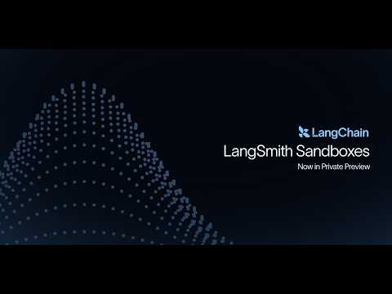 Introducing: LangSmith Sandboxes (Now in Private Preview) (2:38)
- 15:35-17:25 — Felix’s async bug-fix loop: Cowork reads a crash dashboard, filters fixable issues, writes per-bug markdown prompts, and fans out remote Claude Code runs [8].
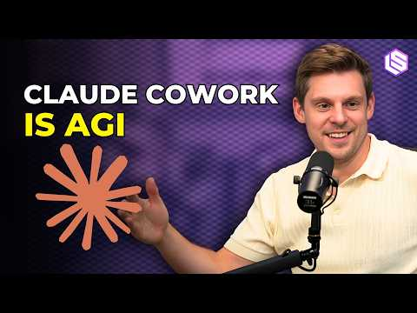 Why Anthropic Thinks AI Should Have Its Own Computer — Felix Rieseberg of Claude Cowork/Code (15:34)
- 44:29-46:40 — DHH on the flip: worth the segment for the mental-model update. He explains why late-2025 agents stopped feeling like bad autocomplete and started feeling like parallel cognitive leverage [12].
“It is more like I’ve grown 18 arms and seven more brains.” [12]

📊 PROJECTS & REPOS
- Open SWE — new open-source foundation for internal coding agents. The adoption signal here is architecture: LangChain says it packages the same core patterns seen in Stripe’s Minions, Ramp’s Inspect, and Coinbase’s Cloudbot [2].
- pi-autoresearch — worth watching because it was used in Shopify’s Liquid optimization run. That effort produced 93 commits from around 120 automated experiments and landed a 53% parse+render improvement on Liquid [6].
- Shopify/liquid PR #2056 — a strong proof artifact for autonomous optimization: the PR headline claims 53% faster parse+render and 61% fewer allocations after agent-driven micro-optimization work [6].
- multipart-form-data-conformance — small repo, clear pattern. It shows how to turn multiple existing implementations into a conformance suite the agent can target for a new implementation [6].
Editorial take: the durable edge right now is not one model release; it’s the harness—sandboxed execution, lean context, and ruthless verification. [1, 3, 6]

Sources
- Introducing LangSmith Sandboxes: Secure Code Execution for Agents
- Open SWE: An Open-Source Framework for Internal Coding Agents
- 𝕏 post by @cursor_ai
- 𝕏 post by @OpenAI
- They fixed Vite
- Fireside chat about agentic engineering at the Pragmatic Summit
- Why Anthropic Thinks AI Should Have Its Own Computer — Felix Rieseberg of Claude Cowork & Claude Code Desktop
- Why Anthropic Thinks AI Should Have Its Own Computer — Felix Rieseberg of Claude Cowork/Code
- 𝕏 post by @simonw
- 𝕏 post by @simonw
- Navigating the Future of AI with Logan Kilpatrick | Google Deepmind
- $100M+ Advice That’ll Piss Off Every Business Guru (ft. DHH)
- Introducing: LangSmith Sandboxes (Now in Private Preview)

