Sarah Guo’s LAB Benchmark, Reid Hoffman’s Future-Fiction Picks, and Paul Graham on Churchill
Recommended Reading from Tech Founders
2026-05-07

Sarah Guo’s LAB Benchmark, Reid Hoffman’s Future-Fiction Picks, and Paul Graham on Churchill
By Recommended Reading from Tech Founders • May 7, 2026
Sarah Guo made the clearest practical recommendation of the day with Harvey’s LAB benchmark for legal-agent evaluation and deployment. The rest of the list mixed Reid Hoffman’s future-facing fiction picks, Garry Tan’s endorsement of a Lulu Meservey interview, and Paul Graham’s Churchill productivity cue.

Why LAB led today’s list
The clearest recommendation was also the most practical. Sarah Guo did not just name a resource; she explained what it is for: a long-horizon, open-source legal agent benchmark that can help teams assess what legal agents can do now, plan deployment, and design human-agent cooperation [1].

LAB
- Content type: Open-source legal agent benchmark / article
- Author/creator: Harvey [1]
- Link/URL: http://x.com/i/article/2051782974098886656 [2]
- Who recommended it: Sarah Guo [1]
- Key takeaway: Guo called LAB the first long-horizon, open-source legal agent benchmark and said it helps legal teams answer “what can legal agents do today?”, plan deployment, and design human-agent cooperation [1]
- Why it matters: This was the most concrete, deployment-oriented recommendation in the set, with a clear role in evaluating agents inside a hard domain [1]
“LAB is the first long-horizon, open-source legal agent benchmark… it will help legal teams answer ‘what can legal agents do today?’, plan deployment, and design human-agent cooperation.” [1]

Worldview builders

The Culture series
- Content type: Science fiction books
- Author/creator: Iain M. Banks [3]
- Link/URL: No direct resource URL was provided; source context: https://www.youtube.com/watch?v=brscUjmA2To [3]
- Who recommended it: Reid Hoffman [3]
- Key takeaway: Hoffman pointed to the series as a vision of how AI and human beings can help create the future together [3]
- Why it matters: Of Hoffman’s picks, this was the most explicit AI-and-human futures recommendation [3] 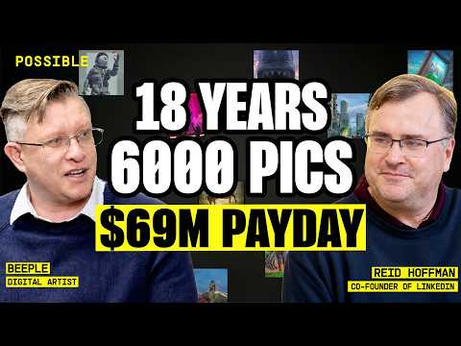 How Beeple’s $69 MILLION sale was just the beginning. (56:56)

Murderbot
- Content type: TV series
- Author/creator: Not specified in the provided notes
- Link/URL: No direct resource URL was provided; source context: https://www.youtube.com/watch?v=brscUjmA2To [3]
- Who recommended it: Reid Hoffman [3]
- Key takeaway: He said the Apple television series contains elements that make him optimistic about the future and highly recommended it [3]
- Why it matters: This was Hoffman’s most direct screen recommendation in response to a question about optimism [3]

Sherlock
- Content type: TV series
- Author/creator: Not specified in the provided notes
- Link/URL: No direct resource URL was provided; source context: https://www.youtube.com/watch?v=brscUjmA2To [3]
- Who recommended it: Reid Hoffman [3]
- Key takeaway: Hoffman praised Benedict Cumberbatch’s Sherlock as an example of taking something old and making it “very present future,” with a through line of humanism [3]
- Why it matters: The recommendation points to a specific standard for modernizing older material without losing its human core [3]
“how you can take this old thing and make it very present future. It’s like a through line of humanism.” [3]

Operator reading and watching

Winston Churchill’s collected works
- Content type: Books
- Author/creator: Winston Churchill [4]
- Link/URL: No direct resource URL was provided; source context: https://x.com/paulg/status/2051979280989511874 [4]
- Who recommended it: Paul Graham [4]
- Key takeaway: Graham highlighted the scale of Churchill’s output and noted that dictation changes the medium, not the cognitive work [4]
- Why it matters: The recommendation reads as a standard-setting example of sustained written output while carrying major operating responsibilities [4]
“He mostly dictated them, but that’s just as much work for the brain, if not for the hand.” [4]

My first interview with @lulumeservey, Founder of Rostra
- Content type: Video interview shared on X
- Author/creator: ti_morse
- Link/URL: https://x.com/ti_morse/status/2051740965485113473 [5]
- Who recommended it: Garry Tan [5]
- Key takeaway: Tan’s endorsement was simple and strong: he compared Lulu Meservey to “The Wolf” from Pulp Fiction [5]
- Why it matters: The interview spans topics including Palmer Luckey, Elon, culture after the X acquisition, loyalty, and Jensen Huang’s metric-making, making it a broad operator conversation rather than a narrow founder profile [6]

Bottom line
If you save one item from today’s set, save LAB. It was the only recommendation paired with a clearly stated job to do right now: benchmark what legal agents can actually do and think more concretely about deployment and human-agent collaboration [1].

Sources
- 𝕏 post by @saranormous
- 𝕏 post by @gabepereyra
- How Beeple’s $69 MILLION sale was just the beginning.
- 𝕏 post by @paulg
- 𝕏 post by @garrytan
- 𝕏 post by @ti_morse

