Scaling customer reality, designing friction for AI agents, and lessons from Claude Code + AI sales reps
PM Daily Digest
2026-02-20

Scaling customer reality, designing friction for AI agents, and lessons from Claude Code + AI sales reps
By PM Daily Digest • February 20, 2026
This edition focuses on scaling customer feedback into business-impact decisions (with a clear maturity model), designing the right friction for AI agents, and concrete operating loops from AI product case studies (Claude Code/Cowork and ShowMe). It also includes meeting guardrails to prevent proposal-to-commitment drift, plus a practical AI PM tool stack.

Big Ideas

1) Customer feedback has maturity phases—and teams need to upgrade their approach as they scale
Bir Khan (VP Product at Enterpret) shared a maturity framework that maps how teams evolve in customer feedback handling as org size and feedback volume grow .
- Phase 1 (1–3 PMs): Intuition works; you can read most feedback (a few hundred items) and use simple tools like spreadsheets and quick AI summaries .
- Phase 2 (5–6 PMs, ~2k–5k feedback/year): Bias creeps in (over-relying on power users), LLMs struggle with context, and manual tagging becomes a recurring tax; insights arrive in batches—often after decisions are already made .
- Phase 3 (6+ PMs, >5k feedback/year): Manual workflows break; “volume-based” prioritization fails across segments (e.g., a few enterprise requests can matter more than many low-revenue requests); teams need a shared view of customer reality linked to revenue/retention/satisfaction metrics .
Why it matters: If your tooling stays “Phase 1/2” while your org moves into Phase 3, you’ll feel it as slower planning cycles, more manual work, and leaders becoming disconnected from what customers are saying .
How to apply: Use the phase descriptions as a diagnostic in your next planning retro: identify your current phase and explicitly decide what you’ll stop doing manually (e.g., tagging) vs. what must become continuously updated intelligence .
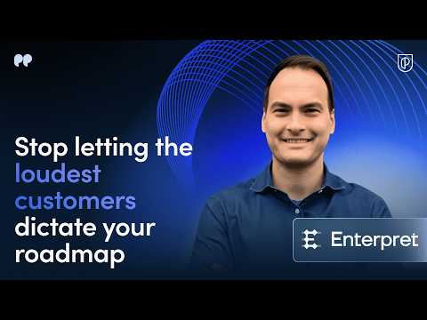 Product Strategy Lessons from Notion, Stripe & Google | Enterpret VP of Product (2:29)

2) Some “growth problems” are product problems in disguise
Andrew Chen’s heuristic from “20+ years working in startups”: most founders don’t have a growth problem—they have a product problem disguised as a growth problem .
Why it matters: It’s a reminder to pressure-test the underlying product value (and user reality) before defaulting to acquisition tactics.
How to apply: When growth stalls, run a quick product-reality check: what are the top recurring pain points, which are tied to high-value segments, and what’s the measurable impact of fixing them (see the tactical dashboards below) .

3) In agentic AI, the “breakthrough” is often the interaction model—not raw capability
Sachin Rekhi frames a shift in AI tooling as a change in how tools interact with users:
- Claude Code: “controlled power” via confirmations, scoped access, and visible actions .
- OpenClaw: “frictionless autonomy,” with full system access and multi-step execution without approvals—bringing risks like unintended destructive actions, prompt injection with real consequences, silent data exposure, and zero audit trail .
He draws a parallel to Zoom: removing friction (no accounts, one-click links, simple setup) drove adoption , but also enabled Zoom-bombing—because some “friction” was actually security .
Why it matters: PMs designing AI agents will win or lose on where they place checkpoints (approvals, scope limits, audit logs)—not just on model performance .
How to apply: Treat “friction” as a design lever: remove it from onboarding and obvious flows, but add it back exactly at high-risk actions (data access, destructive commands, external communications) .

4) Roles are blurring: “everyone codes,” and generalists may be rewarded
In a conversation about Claude Code, Boris Cherny describes teams where PMs, designers, and others code, and argues many of the most effective people “cross over disciplines” . He also predicts roles may get “murkier,” to the point where “software engineer” gets replaced by “builder,” with “everyone’s going to be a product manager and everyone codes” .
Why it matters: If your org is adopting AI coding tools, the competitive advantage may shift toward hybrid builders who can connect product, design, business, and user context—not just write code .
How to apply: Encourage (and reward) cross-functional “small loop” work: rapid prototyping, direct user contact, and shipping plus measurement—especially in early exploration .

Tactical Playbook

1) Planning: prioritize feedback by business impact, not just volume
Enterpret’s guidance: traditional feedback analysis overweights counts (tickets/requests) and can be misleading; instead, quantify feedback with business context—revenue impact, NPS impact, and customer segment fit .
Step-by-step: 1. Define your weighting dimensions: revenue impact, NPS/satisfaction impact, and segment/ICP fit . 2. Connect data sources: integrate CRM/customer revenue data into your feedback system so requests can be ranked by revenue influence, not just number of mentions . 3. Build a planning dashboard: rank feature requests and complaints by revenue/retention/satisfaction potential (vs. “loudest voice wins”) . 4. Avoid “stale tagging” at scale: if manual tagging can’t keep up with tens of thousands of records, treat that as a system constraint (not a people problem) .

2) Scoping: use AI to accelerate discovery—but don’t skip direct user research
Khan’s stance is explicit: “Nothing beats talking to users directly”—AI doesn’t replace it . But AI can act as a force multiplier to validate hypotheses quickly and identify the right users to talk to .
Step-by-step: 1. Write your hypothesis and ask: “What are the top pain points users mentioned about [flow]?” to get an answer grounded in your existing feedback corpus . 2. Ask for targeting lists: “Who requested [integration] over the last six months?” so you can reach out for interviews . 3. For alpha/beta recruiting: ask for customers who complained about the current capability—they’re strong early-access candidates . 4. Before key customer meetings, ask for a short brief: top issues, past feature requests, and sentiment over time to reduce prep time .

3) Post-launch: make “before/after” dashboards a habit (so you can prove impact)
Khan argues many teams “ship the feature, celebrate and move on,” without building the muscle to learn from launches . The fix: launch-specific dashboards and before/after analysis to quantify outcomes .
Step-by-step: 1. Define the pre-launch baseline (tickets, request volume, revenue impact, sentiment) . 2. Ship. 3. Track the post-launch delta and package it for leadership. 4. Use a concrete narrative: “We were getting X complaints, shipped the fix, now we’re getting Y—here’s customer impact” .
Example metric: a login bug fix reduced support tickets from 2,000/week to 200/week (90% reduction) .
Product Strategy Lessons from Notion, Stripe & Google | Enterpret VP of Product (12:45)

4) Stakeholder management: prevent “proposals” from silently turning into commitments
A recurring pitfall from a leadership-meeting pattern: a proposal floated under urgency shifts from “what if we just…” to “okay, so we’re doing this,” and soon it’s on a slide as a commitment . Even with guardrails like “This isn’t commitment” and “We need to validate first,” “9 times out of 10, the first proposal becomes the plan” .
Step-by-step (lightweight meeting guardrail): 1. Label agenda items explicitly as Explore / Decide / Commit (don’t rely on verbal caveats alone) . 2. Require a named validation step when someone says “we need to validate first” (owner + what “validated” means + when you’ll revisit) . 3. If you must set timing, separate “date for the date” (decision date) from delivery commitments .

5) Designing agent friction: relocate checkpoints instead of removing them
Rekhi’s punchline: “Friction isn’t the enemy. Badly placed friction is.” Winners won’t choose between speed and safety—they’ll redesign where friction lives so users get both .
Step-by-step: 1. List the agent’s high-risk actions (data access, deletions, sending messages, system changes) . 2. Decide which require confirmations and scoped access, and ensure visible actions and an audit trail in UX . 3. Remove friction elsewhere (setup, joining, onboarding), but treat security friction as intentional, not accidental .

Case Studies & Lessons

1) Claude Code: a “build for the model six months from now” bet + adoption metrics
Lenny shared that Claude Code launched one year ago and “today it writes 4% of all GitHub commits, and DAU 2x’d last month” .
A core product bet (from Cherny):
“We bet on building for the model six months from now, not for the model of today… we first started seeing [the] inflection with Opus 4.0 and Sonnet 4.0… that was when our growth really went exponential.”
Takeaways for PMs: - If your product is gated by model capability, your roadmap may need to anticipate near-term model shifts . - Track adoption with concrete leading indicators (e.g., commit share, DAU acceleration) .

2) Cowork: spotting latent demand from “misuse,” then building a safer, more accessible product
Cherny describes a “latent demand” pattern: users “abuse” a product to do things it wasn’t designed for—and that teaches you where to take it next .
In Claude Code, they saw extensive non-coding use cases (e.g., growing tomato plants, genome analysis, recovering corrupted photos) and people “jumping through hoops to use a terminal” . That became a signal to build something purpose-built .
Implementation detail: Cowork was created by putting Claude Code into the desktop app; it included “a very sophisticated security system” with guardrails (including shipping a virtual machine), was built in ~10 days (entirely with Claude Code), and launched early while still “rough around the edges” to learn from feedback .
Takeaways: - Misuse is a discovery channel: watch for repeated “workarounds” that indicate demand . - Accessibility often requires safety/guardrails, not just a new surface area .

3) ShowMe: multi-agent AI sales reps, staged rollout, and visibility as a trust mechanism
ShowMe’s origin: lots of website visitors weren’t converting; putting a human sales rep in front of visitors improved conversion, but it was too costly for unqualified leads—AI could filter and route accordingly . They also found a free trial motion didn’t work due to a complex product and late “aha moment” .
What they built: AI “digital workers” that behave like teammates—sales skills (voice/text/video calls, screen share, demos, phone calls, messaging) plus operational skills (reporting via Slack/email, sharing metrics) .
How it evolved: - MVP in ~2 weeks: voice agent narrating selected product videos with Q&A; used by a first external customer despite clunkiness . - Expanded to support different buyer stages (e.g., pricing, customer stories) and added a realistic avatar (HeyGen) and a Zoom-like UI because users were already trained on video-call affordances—and talked more to the AI “as a human” . - Split complex conversations into multiple agents (greetings/discovery, qualifying, pitching) due to model limitations and voice-latency constraints .
Quality + rollout loop: - Start with a POC, validate what the customer is trying to prove, and roll out via A/B tests (often starting with lower-quality leads) before full rollout over 1–2 months . - Build customer confidence via visibility: share conversations in Slack, log into CRM, and provide dashboards so customers can see interaction quality—not just be told it’s good . - Use customer reviews to generate tests and rerun conversations until passing, building a growing “battery” of tests to preserve improvements over time .

4) Zoom: removing friction drove adoption—then security had to catch up
Zoom’s advantage versus Webex was removing friction (no accounts, one-click links, simpler setup, fast joins, effortless screen share), which drove adoption . But it also enabled Zoom-bombing, illustrating that some friction was actually security .
PM takeaway: Optimize friction placement, not friction elimination .

Career Corner

1) Become more of a generalist (and learn to cross boundaries)
Cherny’s advice: “try to be a generalist more than you have in the past,” noting that many effective engineers and PMs “cross over disciplines” (product + infra, product + design, business sense, user empathy) . He describes a team dynamic where “everyone codes,” including PM, EM, designer, finance, and data science .
How to apply: Pick one adjacent skill to deepen over a quarter (e.g., code enough to prototype, or do more user conversations) and use it to close a loop end-to-end on a small feature .

2) Practical portfolio signal: owning outcomes across startup + enterprise contexts
A job seeker summary (ProductManagementJobs) highlights an arc many PMs will recognize: - Founded a hyperlocal food delivery startup: managed a team of 20+, did 50+ customer interviews, built roadmap and GTM; learned from failure about product-market fit and unit economics . - Owned product frontend for an enterprise AI platform used by Fortune 500 supply chain teams, translating complex AI workflows into intuitive interfaces .
How to apply: If you’re job searching, capture this as an “outcomes + learning” narrative: what you shipped, what changed, and what you learned from failure (explicitly called out as valuable) .

Tools & Resources

1) An “AI PM tool stack” (one tool per category)
Aakash Gupta shared a tool stack used by top AI PMs, recommending you only need one tool per category .
- Building
  - Vibe Coding: Cursor, Claude Code, Windsurf, Replit, Warp
  - Prototyping: Lovable, Bolt, v0, Magic Patterns, Base44
- Productivity
  - Dictation: Wispr Flow, superwhisper, Tactiq, Speechify
  - Meetings: Granola, Fathom, Otter.ai, tl;dv, Fireflies
  - General LLMs: Claude, ChatGPT, Gemini, Kimi, Grok
- Automation
  - Simple Agents: Zapier, Lindy, Relay, Bardeen, Parabola
  - Full-Featured Agents: n8n, make, Activepieces, Workato, Tray
- Discovery
  - User Research: NotebookLM, Perplexity, Elicit, Consensus, Grain
  - Customer Intelligence: Dovetail, Unwrap, Enterpret, Monterey, Viable

2) Watch / read
- Product School (Enterpret VP Product): “Product Strategy Lessons from Notion, Stripe & Google” https://www.youtube.com/watch?v=AMUe4wBvNpw
- Lenny’s Podcast (ShowMe): “Building AI Sales Reps…” https://www.youtube.com/watch?v=5jMleOuL7So
- Lenny’s Podcast (Boris Cherny / Claude Code): “Head of Claude Code…” https://www.youtube.com/watch?v=We7BZVKbCVw

3) Reading for stakeholder-meeting dynamics
- “How Chaos Gets Codified” (linked from the Reddit thread): https://notthoughtleadership.substack.com/p/how-chaos-gets-codified-when-proposals
(You just need one in each category)
BUILDING
Vibe Coding
- Cursor, Claude Code, Windsurf, Replit, or Warp
- You want to be able to build your own operating system
- My guide: [https://www.news.aakashg.com/p/pm-os](https://www.news.aakashg.com/p/pm-os)
Prototyping
- Lovable, Bolt, v0, Magic Patterns, or Base44
- A prototype is a key pair to the PRD these days
- My guide: [https://www.news.aakashg.com/p/ai-prototyping-tutorial](https://www.news.aakashg.com/p/ai-prototyping-tutorial)
PRODUCTIVITY
Dictation
- Wispr Flow, superwhisper, Tactiq, Speechify
- You talk 2x faster than you type. Use that
- My guide: [https://www.news.aakashg.com/p/speechify-aakash-bundle](https://www.news.aakashg.com/p/speechify-aakash-bundle)
Meetings
- Granola, Fathom, Otter.ai, tl;dv, or Fireflies
- Never take manual meeting notes again
- My guide: [https://www.news.aakashg.com/p/ai-stack-pm](https://www.news.aakashg.com/p/ai-stack-pm)
General LLMs
- Claude, ChatGPT, Gemini, Kimi, or Grok
- Find your favorites and master prompt engineering
- My guide: [https://www.news.aakashg.com/p/prompt-engineering](https://www.news.aakashg.com/p/prompt-engineering)
AUTOMATION
Simple Agents
- Zapier, Lindy, Relay, Bardeen, or Parabola
- Start here if you’ve never automated a workflow
- My guide: [https://www.news.aakashg.com/p/practical-ai-agents-pms](https://www.news.aakashg.com/p/practical-ai-agents-pms)
Full-Featured Agents
- n8n, make, Activepieces, Workato, or Tray
- Graduate here when simple feels limiting
- My guide: [https://www.news.aakashg.com/p/ai-agents-pms](https://www.news.aakashg.com/p/ai-agents-pms)
DISCOVERY
User Research
- NotebookLM, Perplexity, Elicit, Consensus, or Grain
- Use AI at every step to make it faster
- My guide: [https://www.youtube.com/watch?v=rzAGo_XML1U](https://www.youtube.com/watch?v=rzAGo_XML1U)
Customer Intelligence
- Dovetail, Unwrap, Enterpret, Monterey, or Viable
- Go from unstructured data to usable inputs
- My guide: [https://www.news.aakashg.com/p/ai-customer-intelligence](https://www.news.aakashg.com/p/ai-customer-intelligence)
Want a pro version of each?
↳ Grab my bundle: [https://bundle.aakashg.com/](https://bundle.aakashg.com/)
What would you add to the list?
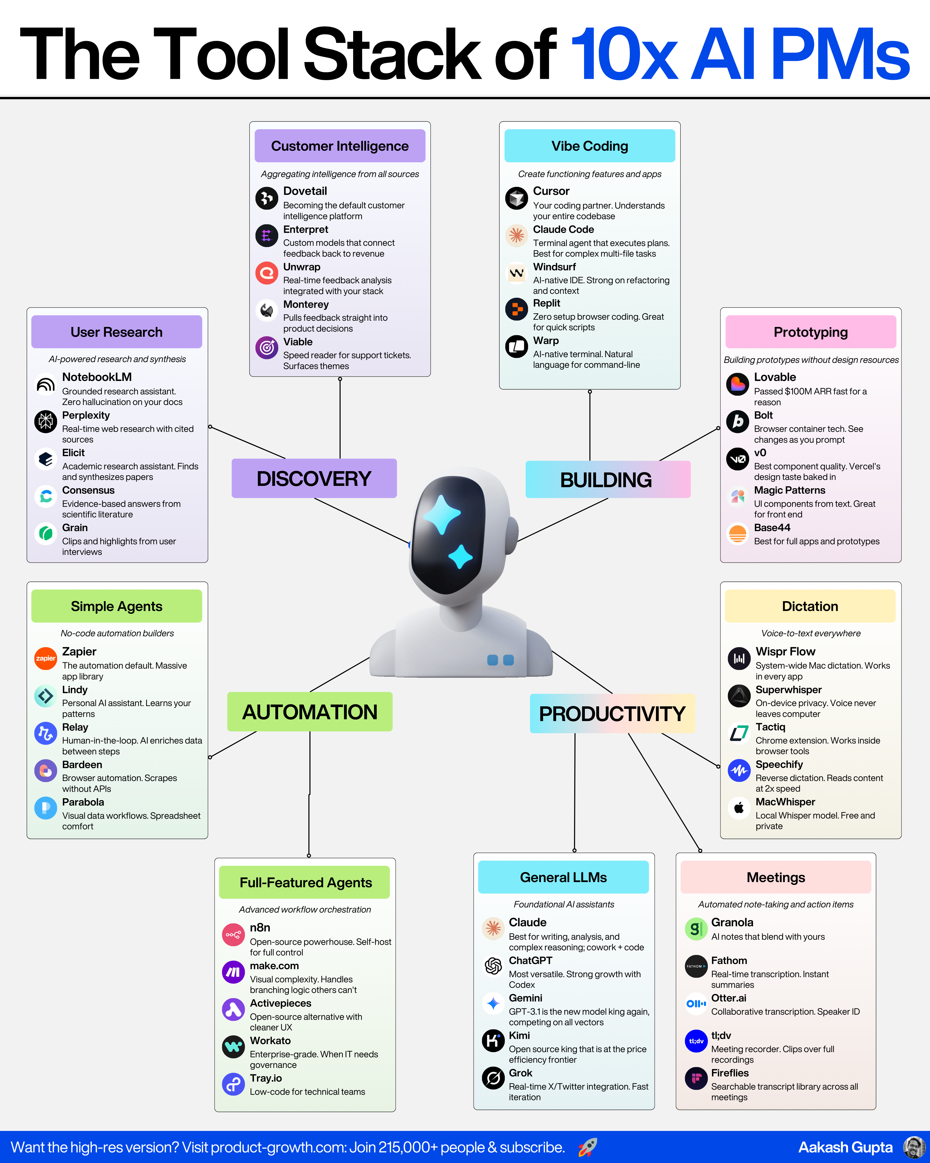](https://substack.com/@aakashgupta/note/c-216964525)

Sources
- Product Strategy Lessons from Notion, Stripe & Google | Enterpret VP of Product
- 𝕏 post by @andrewchen
- 𝕏 post by @sachinrekhi
- Head of Claude Code: What happens after coding is solved | Boris Cherny
- r/prodmgmt post by u/Direct_Donut287
- 𝕏 post by @lennysan
- 𝕏 post by @lennysan
- Building AI Sales Reps: How ShowMe Orchestrates Voice, Video, and Multiple Agents to Close Deals
- r/ProductManagementJobs post by u/anton_cat
- [This is tool stack of the best AI PMs I’ve talked to:
(You just need one in each category)
BUILDING
Vibe Coding
- Cursor, Claude Code, Windsurf, Replit, or Warp
- You want to be able to build your own operating system
- My guide: [https://www.news.aakashg.com/p/pm-os](https://www.news.aakashg.com/p/pm-os)
Prototyping
- Lovable, Bolt, v0, Magic Patterns, or Base44
- A prototype is a key pair to the PRD these days
- My guide: [https://www.news.aakashg.com/p/ai-prototyping-tutorial](https://www.news.aakashg.com/p/ai-prototyping-tutorial)
PRODUCTIVITY
Dictation
- Wispr Flow, superwhisper, Tactiq, Speechify
- You talk 2x faster than you type. Use that
- My guide: [https://www.news.aakashg.com/p/speechify-aakash-bundle](https://www.news.aakashg.com/p/speechify-aakash-bundle)
Meetings
- Granola, Fathom, Otter.ai, tl;dv, or Fireflies
- Never take manual meeting notes again
- My guide: [https://www.news.aakashg.com/p/ai-stack-pm](https://www.news.aakashg.com/p/ai-stack-pm)
General LLMs
- Claude, ChatGPT, Gemini, Kimi, or Grok
- Find your favorites and master prompt engineering
- My guide: [https://www.news.aakashg.com/p/prompt-engineering](https://www.news.aakashg.com/p/prompt-engineering)
AUTOMATION
Simple Agents
- Zapier, Lindy, Relay, Bardeen, or Parabola
- Start here if you’ve never automated a workflow
- My guide: [https://www.news.aakashg.com/p/practical-ai-agents-pms](https://www.news.aakashg.com/p/practical-ai-agents-pms)
Full-Featured Agents
- n8n, make, Activepieces, Workato, or Tray
- Graduate here when simple feels limiting
- My guide: [https://www.news.aakashg.com/p/ai-agents-pms](https://www.news.aakashg.com/p/ai-agents-pms)
DISCOVERY
User Research
- NotebookLM, Perplexity, Elicit, Consensus, or Grain
- Use AI at every step to make it faster
- My guide: [https://www.youtube.com/watch?v=rzAGo_XML1U](https://www.youtube.com/watch?v=rzAGo_XML1U)
Customer Intelligence
- Dovetail, Unwrap, Enterpret, Monterey, or Viable
- Go from unstructured data to usable inputs
- My guide: [https://www.news.aakashg.com/p/ai-customer-intelligence](https://www.news.aakashg.com/p/ai-customer-intelligence)
Want a pro version of each?
↳ Grab my bundle: [https://bundle.aakashg.com/](https://bundle.aakashg.com/)
What would you add to the list?
](https://substack.com/@aakashgupta/note/c-216964525)

Product Strategy Lessons from Notion, Stripe & Google | Enterpret VP of Product
Product Strategy Lessons from Notion, Stripe & Google | Enterpret VP of Product
Product Strategy Lessons from Notion, Stripe & Google | Enterpret VP of Product
Product Strategy Lessons from Notion, Stripe & Google | Enterpret VP of Product
Product Strategy Lessons from Notion, Stripe & Google | Enterpret VP of Product
Product Strategy Lessons from Notion, Stripe & Google | Enterpret VP of Product
Product Strategy Lessons from Notion, Stripe & Google | Enterpret VP of Product
Product Strategy Lessons from Notion, Stripe & Google | Enterpret VP of Product
𝕏 post by @andrewchen
Product Strategy Lessons from Notion, Stripe & Google | Enterpret VP of Product
Product Strategy Lessons from Notion, Stripe & Google | Enterpret VP of Product
𝕏 post by @sachinrekhi
𝕏 post by @sachinrekhi
𝕏 post by @sachinrekhi
𝕏 post by @sachinrekhi
𝕏 post by @sachinrekhi
𝕏 post by @sachinrekhi
𝕏 post by @sachinrekhi
𝕏 post by @sachinrekhi
𝕏 post by @sachinrekhi
Head of Claude Code: What happens after coding is solved | Boris Cherny
Head of Claude Code: What happens after coding is solved | Boris Cherny
Head of Claude Code: What happens after coding is solved | Boris Cherny
Head of Claude Code: What happens after coding is solved | Boris Cherny
Head of Claude Code: What happens after coding is solved | Boris Cherny
Head of Claude Code: What happens after coding is solved | Boris Cherny
Product Strategy Lessons from Notion, Stripe & Google | Enterpret VP of Product
Product Strategy Lessons from Notion, Stripe & Google | Enterpret VP of Product
Product Strategy Lessons from Notion, Stripe & Google | Enterpret VP of Product
Product Strategy Lessons from Notion, Stripe & Google | Enterpret VP of Product
Product Strategy Lessons from Notion, Stripe & Google | Enterpret VP of Product
Product Strategy Lessons from Notion, Stripe & Google | Enterpret VP of Product
Product Strategy Lessons from Notion, Stripe & Google | Enterpret VP of Product
Product Strategy Lessons from Notion, Stripe & Google | Enterpret VP of Product
Product Strategy Lessons from Notion, Stripe & Google | Enterpret VP of Product
Product Strategy Lessons from Notion, Stripe & Google | Enterpret VP of Product
Product Strategy Lessons from Notion, Stripe & Google | Enterpret VP of Product
Product Strategy Lessons from Notion, Stripe & Google | Enterpret VP of Product
Product Strategy Lessons from Notion, Stripe & Google | Enterpret VP of Product
Product Strategy Lessons from Notion, Stripe & Google | Enterpret VP of Product
Product Strategy Lessons from Notion, Stripe & Google | Enterpret VP of Product
Product Strategy Lessons from Notion, Stripe & Google | Enterpret VP of Product
r/prodmgmt post by u/Direct_Donut287
r/prodmgmt post by u/Direct_Donut287
r/prodmgmt post by u/Direct_Donut287
r/prodmgmt post by u/Direct_Donut287
r/prodmgmt post by u/Direct_Donut287
r/prodmgmt post by u/Direct_Donut287
r/prodmgmt post by u/Direct_Donut287
r/prodmgmt post by u/Direct_Donut287
𝕏 post by @sachinrekhi
𝕏 post by @sachinrekhi
𝕏 post by @sachinrekhi
𝕏 post by @sachinrekhi
𝕏 post by @sachinrekhi
𝕏 post by @lennysan
𝕏 post by @lennysan
𝕏 post by @lennysan
𝕏 post by @lennysan
Head of Claude Code: What happens after coding is solved | Boris Cherny
Head of Claude Code: What happens after coding is solved | Boris Cherny
Head of Claude Code: What happens after coding is solved | Boris Cherny
Head of Claude Code: What happens after coding is solved | Boris Cherny
Head of Claude Code: What happens after coding is solved | Boris Cherny
Head of Claude Code: What happens after coding is solved | Boris Cherny
Head of Claude Code: What happens after coding is solved | Boris Cherny
Building AI Sales Reps: How ShowMe Orchestrates Voice, Video, and Multiple Agents to Close Deals
Building AI Sales Reps: How ShowMe Orchestrates Voice, Video, and Multiple Agents to Close Deals
Building AI Sales Reps: How ShowMe Orchestrates Voice, Video, and Multiple Agents to Close Deals
Building AI Sales Reps: How ShowMe Orchestrates Voice, Video, and Multiple Agents to Close Deals
Building AI Sales Reps: How ShowMe Orchestrates Voice, Video, and Multiple Agents to Close Deals
Building AI Sales Reps: How ShowMe Orchestrates Voice, Video, and Multiple Agents to Close Deals
Building AI Sales Reps: How ShowMe Orchestrates Voice, Video, and Multiple Agents to Close Deals
Building AI Sales Reps: How ShowMe Orchestrates Voice, Video, and Multiple Agents to Close Deals
Building AI Sales Reps: How ShowMe Orchestrates Voice, Video, and Multiple Agents to Close Deals
Building AI Sales Reps: How ShowMe Orchestrates Voice, Video, and Multiple Agents to Close Deals
Building AI Sales Reps: How ShowMe Orchestrates Voice, Video, and Multiple Agents to Close Deals
Building AI Sales Reps: How ShowMe Orchestrates Voice, Video, and Multiple Agents to Close Deals
𝕏 post by @sachinrekhi
𝕏 post by @sachinrekhi
𝕏 post by @sachinrekhi
Head of Claude Code: What happens after coding is solved | Boris Cherny
Head of Claude Code: What happens after coding is solved | Boris Cherny
Head of Claude Code: What happens after coding is solved | Boris Cherny
r/ProductManagementJobs post by u/anton_cat
r/ProductManagementJobs post by u/anton_cat
r/ProductManagementJobs post by u/anton_cat
[This is tool stack of the best AI PMs I’ve talked to:
[This is tool stack of the best AI PMs I’ve talked to:
[This is tool stack of the best AI PMs I’ve talked to:
[This is tool stack of the best AI PMs I’ve talked to:
[This is tool stack of the best AI PMs I’ve talked to:
[This is tool stack of the best AI PMs I’ve talked to:
[This is tool stack of the best AI PMs I’ve talked to:
[This is tool stack of the best AI PMs I’ve talked to:
[This is tool stack of the best AI PMs I’ve talked to:
[This is tool stack of the best AI PMs I’ve talked to:
Product Strategy Lessons from Notion, Stripe & Google | Enterpret VP of Product
Building AI Sales Reps: How ShowMe Orchestrates Voice, Video, and Multiple Agents to Close Deals
Head of Claude Code: What happens after coding is solved | Boris Cherny
r/prodmgmt post by u/Direct_Donut287

