Screen-Context Memory Lands in Codex as Builders Tighten Agent Workflows
Coding Agents Alpha Tracker
2026-04-21

Screen-Context Memory Lands in Codex as Builders Tighten Agent Workflows
By Coding Agents Alpha Tracker • April 21, 2026
Codex Chronicle pushes coding agents closer to continuous desktop context. The bigger pattern across today’s notes: harness quality, workflow structure, and bounded autonomy are increasingly deciding whether agents feel magical or useless.

🔥 TOP SIGNAL
OpenAI’s new Chronicle research preview is the clearest product signal today: Codex can now build memory from recent screen context, so it can help with ongoing work without you re-explaining what you were doing [1, 2]. Multiple OpenAI folks say it has already changed how they use Codex, though it’s still early, token-heavy, and limited to Mac + Pro for now [3, 4]. Practical upshot: coding agents are moving from “remember my prompt” to “remember my desktop state” [1, 4].

🛠️ TOOLS & MODELS
- Codex / Chronicle (research preview): Chronicle extends last week’s Codex Memories preview with recent screen context. Availability is Mac + Pro to start, and setup is: Settings → Personalization → Memories → Chronicle [1, 3, 5].
- Codex for live web/game iteration: NicolasZu’s workflow runs the app inside Codex: play the game, point at UI, take screenshots, use a Codex-made building tool, and watch changes land without refreshing [6]. Embiricos says this is the broader Codex shipping pattern: powerful/manual first, then default product later — his example is tmux → Codex app [7].
- Kimi 2.6 / KimiCode: Moonshot is claiming 58.6 SWE-Bench Pro, 76.7 SWE-bench Multilingual, 54.0 HLE w/ tools, plus 4,000+ tool calls, 12+ hour runs, and 300 parallel sub-agents [8]. More useful than the bench talk: Salvatore Sanfilippo tested it on a real PR review and says it caught an out-of-bounds read bug GPT 5.4 initially missed; he now treats it as a low-cost open-weight hedge [9].
- Claude Opus 4.7 / Claude Code: Theo reports worse solutions, more refusals, and more “getting lost,” and argues a big chunk is harness/context damage rather than pure model IQ regression [10]. His practical fixes: disable the 1M context default with CLAUDE_CODE_DISABLE_1M_CONTEXT=1, keep skills/MCPs/plugins lean, and expect the new tokenizer to use roughly 1.35x-1.47x more tokens on some workloads [10].
- Cursor CLI: small but useful terminal-agent upgrade. New commands: /debug for root-cause hunts, /btw for side questions without derailing the run, /config, /update-cli-config, and /statusline [11, 12, 13, 14].

💡 WORKFLOWS & TRICKS
- Give coding agents the same PR-review packet every time. Salvatore’s pattern is dead simple: pass the repo directory, the issue link, and the patch file, then ask: “Please evaluate this pull request against this code base.” [9] In his test, Kimi found the OOB read, Opus was faster and caught a ZWJ edge case plus missing tests, and GPT needed follow-up [9].
- Break planning into stages, not one mega-prompt. HumanLayer’s updated flow is Questions → Research → Design → Structure → Plan → Implement. Two high-value details: hide the original ticket during research so the agent doesn’t bias itself toward a premature solution, and keep prompts under roughly 40 instructions instead of stuffing everything into one huge plan command [15].
- Read code, not thousand-line plans. Same HumanLayer takeaway: use higher-level design/structure checkpoints for alignment, then review the actual code. Their claim is you can still get 2-3x speed while preserving ownership [15].
- Move heavyweight agents off your laptop. Ben Vinegar’s setup: spin up a VPS or home Linux VM, connect over SSH + Tailscale, keep long-running work alive in tmux, and run real end-to-end DB tests there instead of mock-heavy local loops [15]. Benefits: safer than local YOLO mode, more compute, better battery life, and less dependency on perfect local internet [15].
- Bound autonomy by risk. Pinterest’s Snowflake ops agent is a good template: intake → validate → gather context via MCP sub-agent → generate SQL from templates → review/repair → PR [15]. The agent is read-only, escalates when needed, and execution still goes through human approval plus existing CI/CD, which is the right pattern for production data systems [15].
- Pick agent-friendly toolchains. Mitchell Hashimoto says go doc and gopls feel like “agent superpowers,” to the point that he reversed his earlier view that Go had no place anymore [16]. If your agents live in the terminal, boring CLI ergonomics can beat prettier human tooling.

👤 PEOPLE TO WATCH
- Salvatore Sanfilippo — High-signal because he compares models on a real open-source PR, not a canned bench. His Kimi/Opus/GPT review is easy to copy tomorrow [9].
- Theo — Worth watching if you want to separate model regressions from harness/context regressions. His current thesis: too much bad context, bad tool glue, and routing weirdness can make a model look dumber than it is [10].
- Mitchell Hashimoto — Good source for language/tooling takes that actually change workflow choices. His latest: Go’s CLI stack is unusually agent-friendly, and Go + Zig is a strong split for high-level/concurrent vs zero-dep low-level work [16].
- DHH — Still a useful anti-hype compass. His line today: AI gives designers prototyping superpowers, but large, critical apps like Basecamp still need programmer review or even reimplementation before merge [17].
- Alexander Embiricos — Best window into where Codex is going. His “manual/configurable first, defaults later” framing explains why some Codex powers still feel like power-user features today [7].

🎬 WATCH & LISTEN
- 8:03-12:36 — Kimi 2.6 on a real PR review. Salvatore walks through the exact patch-review prompt and shows Kimi surfacing an out-of-bounds read. Watch this instead of another leaderboard screenshot if you care about real code-review behavior [9].
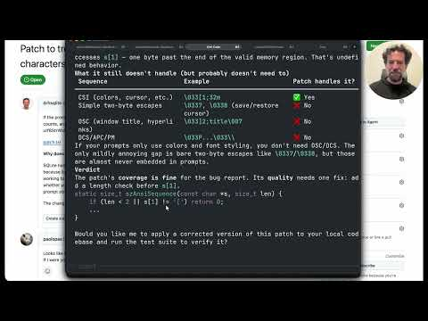 Analizziamo la stessa patch con Kimi 2.6, Opus 4.7, GPT 5.4 (8:03)
- 24:17-28:32 — What an “agentic loop” actually is. Riley Brown gives the cleanest beginner-to-practitioner explanation here: model + tools + iteration until the model decides the task is done. Good clip to align a team before you start debating frameworks [18].
 Open Claw Runs My $11M Business: How To Get Rich In The New Era Of AI Agents (Even As A Beginner!) (24:17)
- 33:46-34:12 — Theo’s fastest Claude Code fix. Tiny segment, high leverage: if Claude Code feels worse lately, he shows the env var to disable the default 1M context route and explains why he thinks it matters [10].
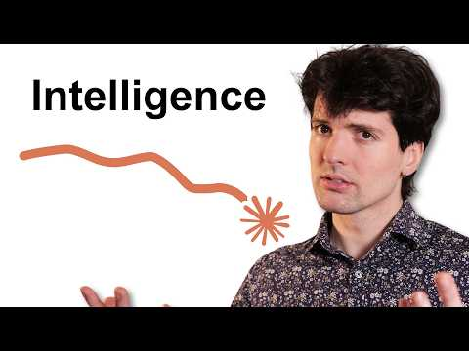 Did Claude really get dumber again? (33:46)

📊 PROJECTS & REPOS
- QClaw: Tencent’s new agent tool was reportedly built with QClaw in 5 days and is 99% AI-written; the pitch is dead simple — no terminal, no setup, WhatsApp/Telegram sends the order, your computer does the work [19]. Peter Steinberger says it’s a strong option for people uncomfortable with the terminal, and Tencent is also pushing eval/harness improvements back into OpenClaw’s open-source repo [20].
- HumanLayer’s open prompts / QR-SPI workflow: public prompts hit the top of HN, were downloaded by roughly 10,000 people, and Huntley says he found public evidence of use at Uber and Block [15]. More important than the prompts themselves is the workflow structure.
- Orchestrator AI: new multi-agent platform from G2I for complex engineering. Reported features include coordinator/implementer/auditor/reviewer/validator/researcher roles, self-pruning context memory, up to 16 agents per task, and benchmark claims of 100% path coverage on some API evals plus 8.4% lift on SWE-bench Pro over GPT 5.4 high [15].
- OpenClaw adoption signal: OpenRouter says the open-source app consumed 18 trillion tokens on its platform last month, roughly $1.8M of spend there alone — a useful sign that open-source coding agents are no longer niche experiments [15].
- MCPorter 0.9.0: handy utility release if you live in MCP land — call MCPs from TypeScript or CLI, now with per-server tool filtering, sturdier stdio shutdowns, OAuth docs, and schema-declared string coercion [21].
Editorial take: the edge is moving away from raw model bragging rights and toward cleaner context plumbing — screen memory, lean harnesses, bounded autonomy, and workflow structure are where the real gains are. [2, 10, 15]

Sources
- 𝕏 post by @OpenAIDevs
- 𝕏 post by @gdb
- 𝕏 post by @thsottiaux
- 𝕏 post by @embirico
- 𝕏 post by @thsottiaux
- 𝕏 post by @NicolasZu
- 𝕏 post by @embirico
- 𝕏 post by @Kimi_Moonshot
- Analizziamo la stessa patch con Kimi 2.6, Opus 4.7, GPT 5.4
- Did Claude really get dumber again?
- 𝕏 post by @cursor_ai
- 𝕏 post by @cursor_ai
- 𝕏 post by @cursor_ai
- 𝕏 post by @cursor_ai
- AIE Miami Keynote & Talks ft. OpenCode. Google Deepmind, OpenAI, and more!
- 𝕏 post by @mitchellh
- 𝕏 post by @dhh
- Open Claw Runs My $11M Business: How To Get Rich In The New Era Of AI Agents (Even As A Beginner!)
- 𝕏 post by @Shuyusyz
- 𝕏 post by @steipete
- 𝕏 post by @steipete

