Smalltalk Best Practice Patterns Leads Picks on Code, Ecosystems, and Institutions
Recommended Reading from Tech Founders
2026-04-09

Smalltalk Best Practice Patterns Leads Picks on Code, Ecosystems, and Institutions
By Recommended Reading from Tech Founders • April 9, 2026
Today’s strongest organic recommendations center on one high-conviction programming book, two books about systems and motivation, and two videos on California policy and education design. DHH’s praise of Smalltalk Best Practice Patterns stands out for its unusually specific use case.

What stood out
After filtering for direct, organic recommendations, today’s strongest picks split into two useful clusters: builder craft and institutional design. The clearest signal is David Heinemeier Hansson’s endorsement of Smalltalk Best Practice Patterns because he gives both a very strong ranking and a specific reason to read it: learning how to structure methods and classes [1].

Most compelling recommendation

Smalltalk Best Practice Patterns
- Content type: Book
- Author/creator: Kent Beck
- Who recommended it: David Heinemeier Hansson
- Key takeaway: DHH calls it his #1 recommendation for programmers who want to learn the nitty-gritty of structuring methods and classes, and says it remains his favorite book on tactical programming patterns [1]
- Why it matters: This is the strongest pick today because the recommendation is both high-conviction and highly specific: it tells readers exactly what skill the book helps build [1]
“Small Talk Best Practices is my number one recommendation for any programmer who want to learn the nitty gritty of how to structure a method and a class…” [1] 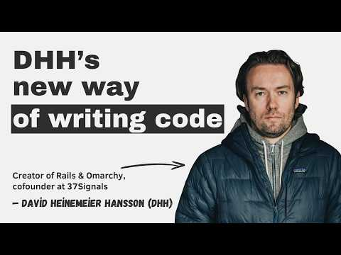 DHH’s new way of writing code (97:49)

Books that explain how builders operate

Regional Advantage
- Content type: Book
- Author/creator: AnnaLee Saxenian
- Who recommended it: Reid Hoffman
- Key takeaway: Hoffman points to it as a useful explanation for why Silicon Valley outstripped Boston, emphasizing that looser non-compete rules let network effects and knowledge spread across the region instead of being locked inside individual companies [2]
- Why it matters: It is a strong systems-level recommendation for readers trying to understand how policy and labor mobility shape startup ecosystems [2]

Man’s Search for Meaning
- Content type: Book
- Author/creator: Viktor Frankl
- Who recommended it: David Heinemeier Hansson
- Key takeaway: DHH invokes Frankl’s idea that finding a “why” helps people endure discomfort, and applies that lesson directly to the frustrations of building with computers [1]
- Why it matters: This is the clearest mindset recommendation in the set because it connects meaning to persistence in technical work [1]

Two watches on institutions

How Matt Mahan Thinks He Can Save California
- Content type: Podcast/video episode
- Author/creator: The All-In Podcast
- Link/URL: https://x.com/theallinpod/status/2035888224308957611 [3]
- Who recommended it: Marc Andreessen
- Key takeaway: Andreessen says the episode is worth watching and praises Matt Mahan as an outstanding mayor; the discussion covers California’s public-sector unions, pension liabilities, housing regulation and fees, and energy policy [3, 4]
- Why it matters: It is the most concrete policy resource in today’s set, with a clear topic map for readers focused on California’s operating environment [4]

A 200 year vision for American Education
- Content type: Video
- Author/creator: @delk and the Primer team
- Link/URL: https://x.com/delk/status/2041875924811915664 [5]
- Who recommended it: Scott Belsky
- Key takeaway: Belsky says the team has been reimagining “school for what’s ahead” for more than five years and argues that education should prepare the next generation for resilience, flexibility, courage, and mastery [5]
- Why it matters: It is the clearest education-design recommendation today, and it makes the desired outcomes explicit instead of talking about schooling in generalities [6, 5]

Bottom line
The highest-signal pattern today is specificity. The best recommendations are not generic praise; they come with a precise lesson, whether that’s how to structure code, how regions compound knowledge, how to endure hard technical work, or what institutions should optimize for [1, 2, 4, 5]

Sources
- DHH’s new way of writing code
- AI’s Expanding Attack Surface
- 𝕏 post by @pmarca
- 𝕏 post by @theallinpod
- 𝕏 post by @scottbelsky
- 𝕏 post by @delk

