The 4-Hour Workweek, Dead and Alive Players, and Systems-First AI Reads
Recommended Reading from Tech Founders
2026-04-17

The 4-Hour Workweek, Dead and Alive Players, and Systems-First AI Reads
By Recommended Reading from Tech Founders • April 17, 2026
Today’s strongest authentic recommendations split between operator classics and AI resources focused on coordination, systems, and industry constraints. The clearest endorsement came from Brian Dean, who described using The 4-Hour Workweek as a literal playbook when he was starting from scratch.

What stood out
Only organic recommendations are included below. The strongest pattern today: the best resources were about operating systems for work—how to act, how to define the life you’re building toward, how to spot truly novel companies, and how to think about AI as coordination and industry structure rather than model capability alone [1, 2, 3, 4].

Most compelling recommendation

The 4-Hour Workweek
- Content type: Book
- Author/creator: Tim Ferriss
- Link/URL: Not provided in source material
- Who recommended it: Brian Dean, in conversation with Tim Ferriss
- Key takeaway: Dean says the book changed what he thought was possible in 2008: while broke and living in his dad’s basement, he treated it like a literal startup manual, completed the exercises before moving on, used Dreamlining, and narrowed his goal to $3K/month passive income for a Thailand backpacker lifestyle [1]
- Why it matters: This was the clearest proof-of-use recommendation in today’s set. The endorsement came with a detailed account of implementation, not just praise [1]
“It blew my mind.” [1] 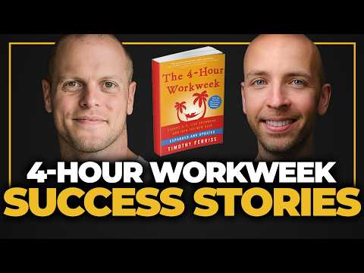 From Dad’s Basement to Selling Two Companies — 4-Hour Workweek Success Story (0:53)

Operator frameworks worth reopening

Ready, Fire, Aim
- Content type: Book
- Author/creator: Michael Masterson
- Link/URL: Not provided in source material
- Who recommended it: Brian Dean
- Key takeaway: Dean recommends it to inexperienced founders because it pushes action over analysis paralysis. His test is blunt: if you finish it and still do nothing, you are probably not ready [1]
- Why it matters: It is a practical corrective for early founders who spend time on setup work instead of starting and learning from traction [1]

Dead and Alive Players
- Content type: Essay
- Author/creator: Not specified in source material
- Link/URL: Not provided in source material
- Who recommended it: Tobi Lütke
- Key takeaway: Lütke uses the essay to judge companies: if an LLM could reliably predict a company’s next move, it may be operating like a “dead” player; the interesting companies do something genuinely unexpected [2]
- Why it matters: It gives readers a compact lens for separating predictable execution from actual novelty [2]

Systems-first AI reads

Research paper on long-horizon ML research engineering (title not specified in source material)
- Content type: Research paper
- Author/creator: Not specified in source material
- Link/URL: https://arxiv.org/pdf/2604.13018v1 [5]
- Who recommended it: Sarah Guo
- Key takeaway: Guo highlighted the paper’s argument that long-horizon ML research engineering is a systems problem of coordinating specialized work over durable project state, not just a local reasoning problem [3, 5]
- Why it matters: It is the cleanest single statement in today’s set against the “monolithic AI” narrative and toward systems+model thinking [5]

Stop Building Agents. Start Harnessing Goose
- Content type: Article / blog post
- Author/creator: Adam Miller
- Link/URL: https://www.linkedin.com/pulse/stop-building-agents-start-harnessing-goose-adam-miller-b9xgc/ [6]
- Who recommended it: Jack Dorsey
- Key takeaway: Jack’s summary was just four words: “goose is all you need” [6]
- Why it matters: Even with minimal commentary, this was a very direct signal that Jack thought this specific article was worth sharing as-is [6]

Dwarkesh Podcast: the Jensen Huang episode
- Content type: Podcast / video
- Author/creator: Dwarkesh Podcast; guest Jensen Huang
- Link/URL: Episode link not provided in source material; the post says it is available on YouTube, Apple Podcasts, and Spotify [4]
- Who recommended it: Clement Delangue
- Key takeaway: Delangue strongly agreed with Huang’s view that restricting AI exports would slow innovation, progress, and U.S. technology and economic leadership in pursuit of a danger that has not yet been shown to be real [7]
- Why it matters: The episode is framed around concrete industry questions—Nvidia supply chains, TPUs, hyperscalers, China export policy, and chip architectures—rather than generic AI commentary [4]

Bottom line
If you only open one resource today, start with The 4-Hour Workweek for the strongest evidence that a recommendation was actually used step by step [1]. If your focus is AI, start with Sarah Guo’s paper pick, then pair it with Jack’s Goose article and the Jensen Huang episode for three different angles on systems, tools, and industry constraints [3, 5, 6, 4, 7].

Sources
- From Dad’s Basement to Selling Two Companies — 4-Hour Workweek Success Story
- Tobi Lütke x Jess Hertz: Invisible Work
- 𝕏 post by @saranormous
- 𝕏 post by @dwarkesh_sp
- 𝕏 post by @saranormous
- 𝕏 post by @jack
- 𝕏 post by @ClementDelangue

