The Beginning of Infinity, Liang Wenfeng, and Two Current AI Reads
Recommended Reading from Tech Founders
2026-06-04

The Beginning of Infinity, Liang Wenfeng, and Two Current AI Reads
By Recommended Reading from Tech Founders • June 4, 2026
Kjun Chu’s explanation of why David Deutsch’s The Beginning of Infinity changed her model of progress is the clearest high-signal recommendation in this batch. Bill Gurley adds a Liang Wenfeng study pair, while Clement Delangue and Marc Andreessen surface two current AI reads they found worth attention.

Most compelling recommendation

The Beginning of Infinity — David Deutsch
This was the richest recommendation in the notes because Kjun Chu did not just name the book; she explained how it changed her model of progress. She said it moved her from seeing history as cyclical to seeing progress as the result of constructing and layering good explanations that are hard to vary and have broad reach. [1]
- Content type: Book [1]
- Author/creator: David Deutsch [1]
- Link/URL: Mentioned in What it takes to trust AI [1]
- Who recommended it: Kjun Chu [1]
- Key takeaway: Progress comes from the construction and layering of good explanations; the strongest explanations both fit the phenomenon and extend to other phenomena. [1]
- Why it matters: It is the clearest worldview-shaping recommendation in this batch, and it comes with a reusable standard for judging ideas. [1]
“The idea he puts forward is that the construction and layering on of good explanations is what results in progress over time.” [1] 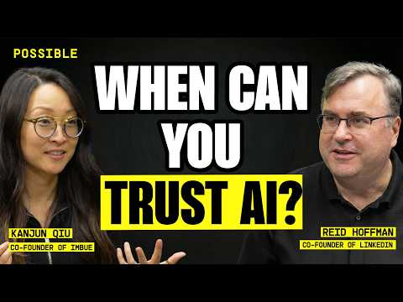 What it takes to trust AI (49:53)

Best founder-study pair
Bill Gurley’s recommendation was less about a single article and more about a reading habit: if Chinese founders and investors study leading US founders closely, US readers should do the same in reverse. He singled out Liang Wenfeng of DeepSeek as “one to watch” and pointed to two useful entry points. [2]
“Chinese founders/investors read all they can about leading US founders. Good practice to do the same in reverse. Liang Wenfeng (DeepSeek) is one to watch.” [2]

Liang Wenfeng recent-moves profile
- Content type: Article / profile
- Author/creator: Not specified in the provided notes
- Link/URL: Recent moves profile [2]
- Who recommended it: Bill Gurley [2]
- Key takeaway: Gurley singled Liang Wenfeng out as a founder worth watching closely. [2]
- Why it matters: It gives readers a current snapshot of the founder Gurley highlighted. [2]

Liang Wenfeng interview translation
- Content type: Interview translation / article
- Author/creator: Not specified in the provided notes
- Link/URL: Translation of earlier long-form interviews [2]
- Who recommended it: Bill Gurley [2]
- Key takeaway: Gurley paired the current profile with translated primary-source material from earlier interviews. [2]
- Why it matters: Taken together, the pair offers both recent context and longer-form founder voice. [2]

Two current AI reads getting authentic praise

MAI-Thinking-1 tech report
- Content type: Tech report / paper
- Author/creator: Not specified in the provided notes
- Link/URL: PDF [3]
- Who recommended it: Clement Delangue [4]
- Key takeaway: Delangue called the report “amazing” in a reply to its announcement. [4]
- Why it matters: It was the clearest research-report endorsement in this batch. [4]

I Built an AI Company. Here’s Why AI…
- Content type: Article [5]
- Author/creator: Not specified in the provided notes
- Link/URL: The Free Press [5]
- Who recommended it: Marc Andreessen [5]
- Key takeaway: Andreessen said it contained “wise words” and matched what he is seeing “on the ground every day.” [5]
- Why it matters: Even with limited detail in the notes, this stands out as a current-state AI signal from an investor saying the piece tracks lived reality. [5]

What stands out
The strongest recommendations here were tied either to a clear mental-model update or to a credible read on current AI reality. Kjun Chu supplied the deepest model-changing explanation through Deutsch’s book on progress [1], Bill Gurley turned Liang Wenfeng into a concrete cross-border study prompt [2], and Delangue plus Andreessen surfaced two AI documents they found worth readers’ time [4, 5].

Sources
- What it takes to trust AI
- 𝕏 post by @bgurley
- 𝕏 post by @asadovsky
- 𝕏 post by @ClementDelangue
- 𝕏 post by @pmarca

