The Little Prince as a Yearly Reset, Plus Fiona Fung’s Leadership-Shaping Picks
Recommended Reading from Tech Founders
2026-06-22

The Little Prince as a Yearly Reset, Plus Fiona Fung’s Leadership-Shaping Picks
By Recommended Reading from Tech Founders • June 22, 2026
Today’s strongest organic recommendations came from Fiona Fung, who shared one book she rereads yearly to remember what matters, two fiction authors she recommends broadly, and one film she says shaped her leadership principles.

What stood out
Today’s strongest organic recommendations came from one conversation with Fiona Fung. The signal was narrower than a multi-source day, but stronger in one important way: each recommendation came with a specific reason, not just a title drop. [1]

Most compelling recommendation

The Little Prince
- Content type: Book
- Author/creator: Not specified in the source notes
- Link/URL: Not provided in the source notes
- Who recommended it: Fiona Fung
- Key takeaway: Fung said this is the one book she recommends everyone read at least once a year because it helps her remember what is truly important. [1]
- Why it matters: This was the clearest high-conviction pick in today’s set because it was tied to both a repeat habit and a specific purpose: returning to what matters most. [1] 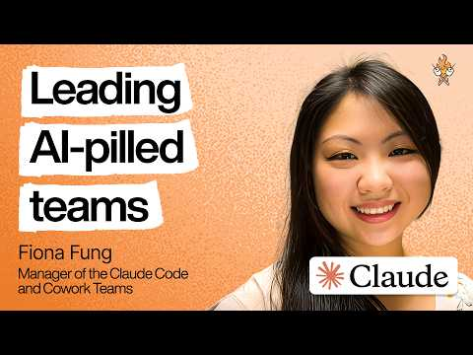 Building the most AI-pilled engineering team in the world | Fiona Fung (Anthropic) (87:54)

Other picks with clear reasoning

Margaret Atwood
- Content type: Fiction author
- Author/creator: Margaret Atwood
- Link/URL: Not provided in the source notes
- Who recommended it: Fiona Fung
- Key takeaway: Fung recommends Atwood to everyone and said she values how Atwood’s work reads like speculative fiction that can plausibly happen to a society. [1]
- Why it matters: This is useful as a reading direction for people who want fiction that sharpens their thinking about social trajectories. [1]

Haruki Murakami
- Content type: Fiction author
- Author/creator: Haruki Murakami
- Link/URL: Not provided in the source notes
- Who recommended it: Fiona Fung
- Key takeaway: Fung recommends Murakami to everyone for his magical realism style. [1]
- Why it matters: This was a style-led recommendation rather than a single-title pick, making it a useful starting point for exploratory reading. [1]

Nausicaä of the Valley of the Wind
- Content type: Film
- Author/creator: Not specified in the source notes; Fung noted the film was based on a manga. [1]
- Link/URL: Not provided in the source notes
- Who recommended it: Fiona Fung
- Key takeaway: Fung said the heroine Nausicaä left a lasting footprint on her and inspired many of her leadership principles. [1]
- Why it matters: Among today’s non-book recommendations, this had the clearest learning value because Fung tied it directly to her leadership principles. [1]

Bottom line
If you only save one item, save The Little Prince. It was the day’s strongest recommendation because Fiona Fung framed it as a book worth revisiting every year to reset attention on what matters. The rest of her picks add color around the same pattern: fiction and film she uses to think about society, imagination, and leadership. [1]

Sources
- Building the most AI-pilled engineering team in the world | Fiona Fung (Anthropic)

