Tim Ferriss’s AI Foresight Pick Leads Today’s Operator and History Recommendations
Recommended Reading from Tech Founders
2026-03-27

Tim Ferriss’s AI Foresight Pick Leads Today’s Operator and History Recommendations
By Recommended Reading from Tech Founders • March 27, 2026
Tim Ferriss provides the day’s clearest high-conviction pick with Leopold Aschenbrenner’s Situational Awareness, then rounds out the list with durable operator resources on execution, prioritization, scaling, category design, and AI workflows. Balaji Srinivasan adds two books he uses to make political and historical systems thinking more concrete.

Most compelling recommendation
Only clearly organic recommendations with enough context to be useful are included below.
- Situational Awareness: The Decade Ahead — Content type: Essay / online article. Author/creator: Leopold Aschenbrenner. Link/URL: Not provided in the source material. Who recommended it: Tim Ferriss. Key takeaway: Ferriss says the essay’s AI predictions have had a staggering hit rate and recommends it to people trying to understand what is coming next. Why it matters: It is the strongest-conviction recommendation in today’s set and the clearest direct pointer to an AI-foresight resource. [1]
“the number of actual hits, predictive hits, that Leopold had, is staggering. It is just really about as close to clairvoyant as you could possibly be.” [1] 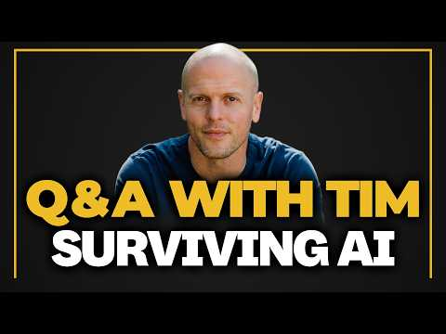 Q&A with Tim — The Upcoming AI Tsunami and Building Offline Advantage (2:56)

What stood out
Today’s authentic recommendations split cleanly between operator frameworks for prioritization, execution, scale, and category design, and perspective-building books that make history or lived experience more concrete. [1, 2]

Operator and growth picks
- The Effective Executive — Content type: Book. Author/creator: Peter Drucker. Link/URL: Not provided in the source material. Who recommended it: Tim Ferriss. Key takeaway: A classic, short book with high bang-for-buck on execution. Why it matters: Ferriss presents it as a compact execution manual rather than a long management system. [1]
- The 80/20 Principle and Living the 80/20 Way — Content type: Books. Author/creator: Richard Koch. Link/URL: Not provided in the source material. Who recommended it: Tim Ferriss. Key takeaway: Ferriss says these never get old for prioritization and stresses that Koch is a practitioner, not just a theorist. Why it matters: This is a direct recommendation for better focus and decision quality from someone Ferriss says “walks the talk.” [1]
- High Growth Handbook — Content type: Book. Author/creator: Elad Gil. Link/URL: Not provided in the source material. Who recommended it: Tim Ferriss. Key takeaway: It offers frameworks for deciding what to do and not do based on company scope, scale, and ambitions, especially in venture-backed settings. Why it matters: It is today’s most targeted scaling recommendation for founders dealing with growth-stage complexity. [1]
- Blue Ocean Strategy — Content type: Book. Author/creator: Not specified in the source material. Link/URL: Not provided in the source material. Who recommended it: Tim Ferriss. Key takeaway: Avoid crowded categories when possible and create a category of one instead. Why it matters: Ferriss frames it as a practical way to make the road ahead less competitive. [1]
- I built an AI assistant that works while I sleep — Content type: Podcast episode. Author/creator: Chris Hutchins, All the Hacks. Link/URL: Not provided in the source material. Who recommended it: Tim Ferriss. Key takeaway: Hutchins explains how he built an OpenClaw-based workflow, and Ferriss adds that newer Claude desktop features now cover some of the same beginner use cases. Why it matters: It is the most concrete workflow-level AI recommendation in today’s set. [1]

Books that widen judgment
- Travels with Charley — Content type: Book. Author/creator: John Steinbeck. Link/URL: Not provided in the source material. Who recommended it: Tim Ferriss. Key takeaway: Ferriss points to it as an example of doing interesting real-world things that rise above AI-generated analysis, and also calls it a hilarious, accurate, enjoyable ride through the U.S. Why it matters: It is today’s clearest recommendation for sharpening perspective through lived observation rather than more abstract analysis. [1]
- How China Works — Content type: Book. Author/creator: Not specified in the source material. Link/URL: Not provided in the source material. Who recommended it: Balaji Srinivasan. Key takeaway: Balaji recommends it as a way to understand the Chinese Communist Party’s promotion system as functioning like a corporation with incentives tied to economic growth via corruption. Why it matters: It is the most directly explanatory systems book in today’s set. [2]
- Disunion — Content type: Book. Author/creator: Not specified in the source material. Link/URL: Not provided in the source material. Who recommended it: Balaji Srinivasan. Key takeaway: Balaji says it makes concrete why preserving the Union meant economies of scale, peace, prosperity, and a large free-trade zone rather than fragmentation and tariffs. Why it matters: He explicitly says the book turned an abstract historical idea into something visceral. [2]

Sources
- Q&A with Tim — The Upcoming AI Tsunami and Building Offline Advantage
- Every Major System Is Breaking at the Same Time — A Tech Insider Balaji Maps What Comes Next

