Trejo, Inkinen’s Go-To Operating Books, and Garry Tan’s Tokenmax Read
Recommended Reading from Tech Founders
2026-05-23

Trejo, Inkinen’s Go-To Operating Books, and Garry Tan’s Tokenmax Read
By Recommended Reading from Tech Founders • May 23, 2026
Sami Inkinen supplied the day’s richest recommendation with an unusually personal endorsement of Trejo, then added two work-context books he recommends professionally. Garry Tan’s linked Business Insider article contributed the sharpest operating phrase in the set: “Tokenmax, don’t headcount max.”

What stood out
Today’s usable signal split between one recommendation with unusually rich personal context and three shorter work-oriented picks. Sami Inkinen’s books carried the most detail about why they mattered, while Garry Tan’s article delivered the cleanest one-line operating heuristic. [1, 2]

Most compelling recommendation

Trejo
- Content type: Book
- Author/creator: Danny Trejo
- Link/URL: Direct book link was not provided in the source; source discussion: Reversing Type 2 Diabetes and Rowing 2,750 Miles — Sami Inkinen of Virta Health [1]
- Who recommended it: Sami Inkinen
- Key takeaway: Inkinen called it “absolutely mind-blowing” and said he “cried several times,” “laughed several times,” and came away “incredibly inspired” with renewed “belief in humanity.” He also said it gives humility about how much parents can affect their kids’ lives. [1]
- Why it matters: This was the strongest recommendation in today’s set because Inkinen described a clear emotional and perspective shift, not just a title he liked. He also explained that it came through his family’s normal reading flow, with his wife screening books for the family. [1]
“Absolutely mind-blowing book. … I cried several times. I laughed several times and I was incredibly inspired” [1] 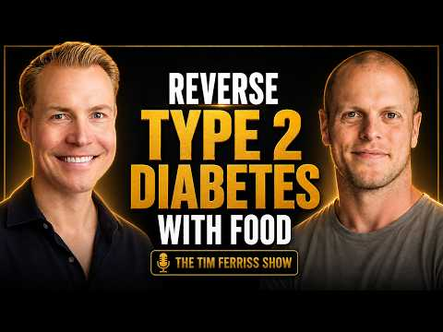 Reversing Type 2 Diabetes and Rowing 2,750 Miles — Sami Inkinen of Virta Health (122:01)

Work-context books Inkinen still recommends

The Score Takes Care of Itself
- Content type: Book
- Author/creator: Bill Walsh
- Link/URL: Direct book link was not provided in the source; source discussion: Reversing Type 2 Diabetes and Rowing 2,750 Miles — Sami Inkinen of Virta Health [1]
- Who recommended it: Sami Inkinen
- Key takeaway: Inkinen named it among the professional books he recommends in the context of his Virta team. [1]
- Why it matters: Even without a long explanation, it stands out because it is one of the titles he reaches for in a work setting. [1]

High Growth Handbook
- Content type: Book
- Author/creator: Elad Gil
- Link/URL: Direct book link was not provided in the source; source discussion: Reversing Type 2 Diabetes and Rowing 2,750 Miles — Sami Inkinen of Virta Health [1]
- Who recommended it: Sami Inkinen
- Key takeaway: Inkinen listed it alongside his go-to professional recommendations and noted that it is “much much much newer.” [1]
- Why it matters: It appears in the same work-oriented recommendation set as Walsh’s book, suggesting Inkinen sees it as practically useful rather than merely interesting. [1]

One timely operating read

Business Insider article (title not provided in source)
- Content type: Article
- Author/creator: Business Insider; individual byline not provided in the source
- Link/URL: https://www.businessinsider.com/y-combinator-advice-ai-native-company-tokenmaxx-leaner-teams-headcount-2026-5 [2]
- Who recommended it: Garry Tan
- Key takeaway: “Tokenmax, don’t headcount max.” [2]
- Why it matters: Tan’s endorsement was brief, but it delivered the sharpest operating slogan in today’s set and pointed directly to the underlying article. [2]
“Tokenmax, don’t headcount max” [2]

Bottom line
If you open only one resource, start with Trejo for the richest and most human endorsement in today’s set. If you want the fastest work-relevant takeaway, save Garry Tan’s linked article for its compact operating rule. [1, 2]

Sources
- Reversing Type 2 Diabetes and Rowing 2,750 Miles — Sami Inkinen of Virta Health
- 𝕏 post by @garrytan

