Turn Agent Feedback Into Project Memory
Coding Agents Alpha Tracker
2026-07-26

Turn Agent Feedback Into Project Memory
By Coding Agents Alpha Tracker • July 26, 2026
Today’s strongest coding-agent pattern is cumulative feedback: preserve corrections as searchable project guidance, then pair parallel execution with bounded scope and independent review. Also covered: signed-in Work browsing, OpenClaw autoreview, and practical Opus 5 routing signals.

🔥 TOP SIGNAL
Make agent feedback cumulative. ThePrimeagen records every agent exchange and commit, then has an agent distill the history into a searchable project field guide/; after 10 sessions, he reports that deep feedback fell sharply without changing the model or harness. [1] Peter Steinberger’s release-prep QA loop applies the same principle at larger scale: bounded parallel work, root-cause fixes, and a continuously updated test report instead of repeated ad-hoc prompting. [2]

⚡ TRY THIS
- Create a retrievable field guide from your corrections. Start by being exact about the code you want—ThePrimeagen uses voice dictation and nitpicks output. Save every back-and-forth plus the resulting commit hash in Markdown. Periodically ask an agent to review that record and write durable, generalized guidance into field guide/, with an init.md containing links and short descriptions. Let future agents tool-search that directory rather than loading the entire history into context. [1]
- Run parallel QA with explicit non-negotiables. Steinberger’s OpenClaw release-prep request: use 12 subagents split by functionality; run dev gateways on separate ports and reserve some for stress tests; use worktrees and create PRs autonomously; target 200 bugs; fix root causes rather than patches; allow refactors except across the plugin-SDK boundary; and keep a Markdown test report continuously updated. [2] This is a replicable pattern: parallelize discovery, but constrain the fix scope and require an auditable artifact.
- Make planning a separate, reviewable phase. Theo’s workflow is to run Claude Code with Opus 5 at high effort to explore a codebase and propose a plan, have another model independently review that plan, then revise based on the critique. For work intended to merge, he plans to use Opus for implementation and ask Fable and/or 5.6 SOL for a thumbs-up/down review. [3]
- Feed lint output directly to an agent. Simon Willison notes that Ruff v0.16.0’s output contains everything a coding agent needs to fix reported problems. Use the linter output as the handoff artifact, then have the agent make and verify the fixes rather than translating errors into a separate prose prompt. [4]

📡 WHAT SHIPPED
- ChatGPT Work agent: signed-in cloud browsing. You can take over its cloud browser to authenticate on a site, then return control to the agent; the login persists across sessions. Tibo reports the capability is already available in the ChatGPT app. [5, 6]
- OpenClaw autoreview skill: Steinberger reports a record 66 review rounds on a complex refactor. The skill definition is public at openclaw/agent-skills. [7]
- Opus 5: strong practitioner results, but watch fit and usage. Theo calls it the first Anthropic model he has used that follows instructions without repeated constraints, and reports using roughly 20–25% lower cost per task than Fable in his own work. [3] But reports are not uniform: Armin Ronacher says he likes Opus 5 while finding it expensive and token-hungry, while another early tester reported that existing skills and plugins had to be rebuilt after it argued with instructions and stopped early. [8, 9] Treat a model upgrade as a harness regression test, not a drop-in swap.
- High-velocity production signal: Kent C. Dodds reports 135 merged PRs in kodykoala since Monday, using Cursor with Fable, Grok, and GPT models plus CodeRabbitAI. [10, 11]

🎬 GO DEEPER
- 29:20–31:52 — Theo on where Opus 5 fits in a coding stack. A candid model-routing discussion: Opus’s diligence versus Fable’s taste and SOL’s tendency to overproduce code, plus the rationale for independent review. [3] 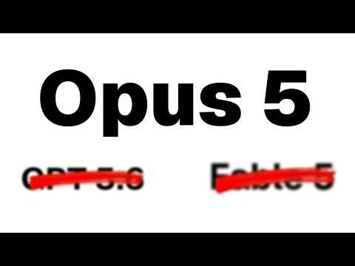 Opus 5 is my new go-to model (29:20)
- 20:16–21:52 — Record a workflow; turn it into a skill. Riley Brown demonstrates Claude desktop recording screen actions and converting them into a reusable skill—an alternative to writing brittle step-by-step instructions. [9]  Opus 5 Is Here… But NEW Claude Voice Is Even Bigger (20:16)
- Repo to study: OpenClaw’s autoreview skill. The public definition behind a 66-round refactor review is a useful reference for designing persistent critique loops. Read the skill. [7]
Editorial take: the durable advantage is not a single model—it is a workflow that converts failures, reviews, and tool output into compact project memory for the next run. [1, 2]

Sources
- 𝕏 post by @ThePrimeagen
- 𝕏 post by @steipete
- Opus 5 is my new go-to model
- Ruff v0.16.0
- 𝕏 post by @OpenAIDevs
- 𝕏 post by @thsottiaux
- 𝕏 post by @steipete
- 𝕏 post by @mitsuhiko
- Opus 5 Is Here… But NEW Claude Voice Is Even Bigger
- 𝕏 post by @kentcdodds
- 𝕏 post by @kentcdodds

