Two Paths to Prosperity, AI-Uncertainty Frameworks, and Relevant History
Recommended Reading from Tech Founders
2026-06-06

Two Paths to Prosperity, AI-Uncertainty Frameworks, and Relevant History
By Recommended Reading from Tech Founders • June 6, 2026
Satya Nadella’s recommendation of Two Paths to Prosperity is the strongest signal in this batch because he connected the book’s long-run history of China and the West to moral philosophy, markets, democracy, and AI. Marc Andreessen adds two shorter but useful pointers: a framework for reasoning backward from AI scenarios and a historical article he called directly relevant to current policy choices.

Most compelling recommendation

Two Paths to Prosperity — Joel Mokyr and co-authors
Satya Nadella’s book pick stands out because he did more than name it. He described it as a study of the thousand-year history of China and the West, then used it to frame a current question: whether moral philosophy, markets, democracy, and scientific and technological revolutions can reinforce one another in the AI age [1].
- Content type: Book
- Author/creator: Joel Mokyr and co-authors
- Link/URL: No direct book URL appeared in the notes; discussed in this YouTube conversation
- Who recommended it: Satya Nadella
- Key takeaway: Nadella pointed to the book’s account of how cultural and societal constructs helped the West use the scientific and industrial revolutions to create modern prosperity [1]
- Why it matters: He explicitly connected that historical frame to AI-era questions about abundance, stakeholder benefit, and maintaining social permission for technological change [1] 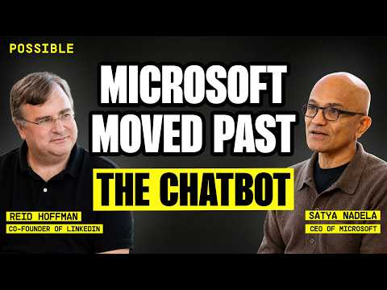 Satya Nadella on making human and token capital compound (48:10)

Two shorter links worth keeping

Podcast conversation with @dwarkesh_sp and @pawtrammell
Marc Andreessen endorsed a post summarizing this conversation as “Self recommending” [2]. The linked summary’s main argument is that economics is most useful here not for precise long-range forecasts, but for working backward from important AI scenarios and tracking the conditions and data that would make them plausible [3].
- Content type: Podcast episode / conversation
- Author/creator: Conversation involving @dwarkesh_sp and @pawtrammell
- Link/URL: Episode post and summary post
- Who recommended it: Marc Andreessen
- Key takeaway: The summary highlights specific signals to watch, including latent demand for human involvement, substitution between AI and human interaction, task bundling inside jobs, and AI bottlenecks [3]
- Why it matters: It gives readers a practical way to reason under AI uncertainty without pretending that 5- to 10-year forecasts are reliable [3]

Click, Ma, Is Ringing Off
Andreessen also shared this Time archive piece with a very specific endorsement:
“The directly relevant history” [4]
- Content type: Article
- Author/creator: Not specified in the provided notes
- Link/URL: https://time.com/archive/6860225/click-ma-is-ringing-off/
- Who recommended it: Marc Andreessen
- Key takeaway: He presented the article as historical context directly relevant to current AI policy choices [4]
- Why it matters: It is the clearest explicit prompt in today’s set to study an earlier technology-policy moment before making present AI decisions [4]

What stands out
The common thread is better framing, not just more information. Nadella reached for long-run comparative history to think about AI-era prosperity, while Andreessen’s two picks pointed to one framework for reasoning under uncertainty and one historical precedent for policy judgment [1, 3, 4]

Sources
- Satya Nadella on making human and token capital compound
- 𝕏 post by @pmarca
- 𝕏 post by @alexolegimas
- 𝕏 post by @pmarca

