Undersea Sensing, Inference Hardware, and the Open-Model Cost Challenge
VC Tech Radar
2026-07-24

Undersea Sensing, Inference Hardware, and the Open-Model Cost Challenge
By VC Tech Radar • July 24, 2026
Andrenam’s $18M undersea-sensing round and Etched’s full-stack inference bet lead this investor update. The broader signals are accelerating open-model competition, model-agnostic AI product layers, and autonomous security systems built for machine-speed threats.

1. Funding & Deals

Andrenam raises $18M Series A for distributed undersea sensing
Andrenam announced an $18M Series A led by UpfrontVC, with Valor Equity Partners, CapitalAlso, FirstRound, and LongJourneyVC participating. The company is scaling a distributed undersea sensing network built around PEARL passive acoustic buoys and OBSIDIAN, software that converts underwater sound into real-time maritime awareness. Its thesis is persistent monitoring in an undersea environment it describes as increasingly contested, autonomous, and difficult to observe with legacy systems. [1]
Mark Suster frames the market around trade and national security, noting Andrenam’s focus on tracking UUVs, USVs, and vessels near critical shipping infrastructure. [2]

a16z partners with inference-system builder Etched
Etched founders Gavin Uberti, Robert Wachen, and Chris Zhu left Harvard in 2022 to build a full AI-inference stack—chips, boards, interconnects, and racks—from scratch. a16z characterizes the project as a contrarian wager on inference, which it calls a potentially consequential workload, and says it is partnering with the company. [3]

2. Emerging Teams

Asecurity targets the shift from human to machine adversaries
Asecurity is building an offensive-security and remediation platform intended to protect enterprises against weaponized AI. CEO and co-founder Yossi Turadi previously spent six years at incident-response firm Signia; the team also includes CTO Yuval, with AI/security product experience at Hunters and 8200, and Omer, whose background includes zero-day discovery. [4]
The product thesis is a closed loop of autonomous offense and defense: agents emulate advanced threat actors, identify chainable attack paths, reduce false positives, and suggest compensating controls for remediation. Lightspeed and Cyberstarts are backing the company. [4]

Dust pursues a model-agnostic collaboration layer for work
Dust builds AI teammates that work across an organization. Founder Stanislas Polu spent five years at Stripe and three years at OpenAI working on LLMs and math before returning to product building with co-founder Gabriel. [5, 6]
The company began applying LLMs to the workplace in 2022/early 2023 and chose a horizontal, model-agnostic platform focused on human-agent collaboration. Polu argues that model independence is something frontier labs cannot offer. [6]

Autobot automates the software-agency workflow
Autobot is an autonomous Replit-based agency. Founder Viktor Thulin says it reduces the cost of agency-built software by 90%: users describe a project, answer questions, and receive a first working version in roughly an hour at no charge. Amjad Masad describes the underlying insight as automating the whole agency workflow—not only coding—through an agent loop and MCP integration. [7, 8]

3. AI & Tech Breakthroughs

Chinese open models are pressing on capability and cost
Moonshot AI’s Kimi K3 took the lead on the frontend Code Arena benchmark three months after Kimi K2.6, according to Exponential View. The publication reports that K3 may lower the cost of frontier-standard tasks and that Microsoft engineers are reportedly testing it for use in Copilot. [9]
Alibaba has announced Qwen3.8, a forthcoming 2.4-trillion-parameter open-weight model, though benchmarks and further details had not yet been released. [9]

Unified multimodal architectures extend beyond text and images
Flux-3 from Black Forest Labs is described as jointly learning from images, video, and audio in a unified architecture, with an extension into the physical world. [10]

Deterministic tools can constrain agent error in high-stakes workflows
OpenTax Invaro is presented as an open-source deterministic tax engine that AI models can use for tax research and preparation. Its creator reports a 96% score on TaxCalcBench, including two missed cases that were subsequently identified as benchmark inconsistencies by maintainers. These are project-reported results, but the underlying approach—pairing language models with deterministic calculation systems—merits attention for regulated workflows. [11]

4. Market Signals

Model independence is becoming a product and margin strategy
Dust’s Polu sees AI products moving from narrowly vertical offerings toward horizontal platforms for human-agent interaction. He argues that exploding usage and longer agent loops are compressing flat-rate margins, prompting Dust to transition to credit-based pricing. [6]
That view aligns with the company’s model-agnostic positioning: a product layer that can work across labs rather than depend on a single provider. [6]

Compute efficiency is emerging as a competitive variable
Exponential View estimates that Chinese labs are achieving 4–7x more output from available compute than U.S. labs, while leading open-weight models are estimated to be 4–7 months behind the frontier on cyber capabilities, versus 6–10 months in 2025. These are publication estimates, not company disclosures, but they point to a narrowing capability gap alongside improving efficiency. [9]

AI security is moving toward continuous testing and remediation
Asecurity’s view is that frontier models are shortening exploitation windows to hours or minutes, making periodic human-led testing inadequate for machine adversaries. Its proposed response—autonomous testing tied directly to remediation—highlights a potential category shift from point security tools to continuous adversarial systems. [4]

Open models face a more explicit policy tension
A U.S. official stated that covert, industrial-scale distillation by PRC firms that crosses into IP theft could result in sanctions or Entity List designations, while emphasizing support for open-source AI. Separately, The Pragmatic Engineer raised the possibility that Kimi K3’s closed-model-level performance could prompt U.S. restrictions on Chinese open models. The latter is a question, not a reported policy action. [12, 13]

5. Worth Your Time
- The Model-Agnostic AI Platform Betting That No Single Lab Will Win — Dust founder Stanislas Polu on building at the product layer, modest fundraising, horizontal platforms, model independence, and AI-product pricing. 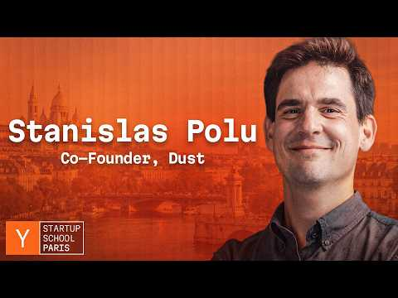 The Model-Agnostic AI Platform Betting That No Single Lab Will Win (12:39)
- The End of Human-Based Cyber Defense — Asecurity’s Yossi Turadi and Lightspeed on autonomous offense, lower false positives, and remediation for machine-speed threats. 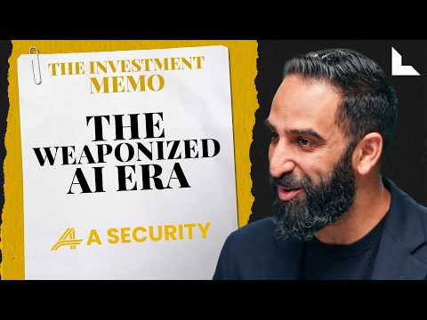 The End of Human-Based Cyber Defense | Yossi Torati, A Security (18:25)
- Will Kimi K3 change the economics of AI? — a useful read on Kimi K3, Qwen3.8, Chinese lab efficiency, and the narrowing gap between open and frontier models. [9]

Sources
- 𝕏 post by @_Andrenam_
- 𝕏 post by @msuster
- 𝕏 post by @a16z
- The End of Human-Based Cyber Defense | Yossi Torati, A Security
- 𝕏 post by @ycombinator
- The Model-Agnostic AI Platform Betting That No Single Lab Will Win
- 𝕏 post by @ViktorThulin
- 𝕏 post by @amasad
- 🔮 Will Kimi K3 change the economics of AI?
- 𝕏 post by @nathanbenaich
- r/venturecapital post by u/Intelligent_Prompt18
- 𝕏 post by @SecScottBessent
- The Pulse: Quitting Spotify Podcasts over reliability

