Validation Becomes the Bottleneck for Coding Agents
Coding Agents Alpha Tracker
2026-06-25

Validation Becomes the Bottleneck for Coding Agents
By Coding Agents Alpha Tracker • June 25, 2026
Today’s brief is about the new control plane for coding agents: isolated sandboxes, critique/review loops, contextual policies, and the most relevant releases from Crabbox, Databricks, Cursor, and Sourcegraph.

🔥 TOP SIGNAL
The big shift in today’s sources: teams already deep into coding agents are no longer asking whether the agent can write code — they’re redesigning the validation layer around it. Boris Cherny says Claude Code has written 100% of the Quad Code codebase for 6+ months and that he runs hundreds to thousands of agents overnight [1], while Jason Zhou says that after his team adopted autonomous loops and 10+ concurrent sessions, the bottleneck moved from code generation to safe review and merge [2]. That is why the interesting work today is isolated sandboxes, review councils, narrow deploy primitives, and contextual policies — not just better prompting [2, 3, 4, 5].
“The AI step of writing the code is moving the bottleneck to other parts of the SDLC.” [3]

⚡ TRY THIS
- Give every agent its own disposable test box. Jason Zhou and AI Jason’s Crabbox recipe is explicit: build a Docker image with the repo’s tools, write crabbox.yaml with a fast provider like Daytona plus snapshot/sync excludes/env vars, add a one-command setup.sh, then run crabbox warmup → crabbox run ... → crabbox stopbox [2]. Add Playwright CLI and artifact commands (artifacts collect, artifacts videos, artifacts publish) so the PR comes back with screenshots/video instead of a trust-me summary [2]. If you want a starting point, copy the open-sourced skill in AI-Builder-Club/skills [6, 2].
- Split generation from critique. Boris Cherny’s literal pattern is to have one agent build, then ask Claude to double check the result and open the app and test it by itself while 15+ other agents run in parallel [1]. Shopify describes the same structure at org scale: parallel subtasks for production, then sequential critique loops with high-reasoning models; they also restrict engineering to the biggest models because human time is worth more than model cost [3]. Keep the human on the hook at the end — the AI can write the code, but your name still goes on the PR [3].
- For production-touching agents, expose primitives — not raw power. PlanetScale’s demo is the right template: let the agent query platform recommendations, make changes on a branch, open a deploy request, watch live impact, and roll back fast if the change misbehaves [4]. Databricks applies the same idea one layer up: track session state (for example risky package installs or large confidential-doc reads), map low-level tool events to high-level policies, and cap a sub-agent to $5 unless it asks for more [5]. Narrow interfaces + stateful controls are the pattern.
- Delete prompt no-ops from your skills. Matt Pocock’s test, amplified by Kent C. Dodds, is brutally simple: remove a line from the skill, rerun, and if the output does not change, the line was a no-op [7, 8]. This trims token waste and makes skills easier to evaluate and maintain [7].

📡 WHAT SHIPPED
- Crabbox setup skill + deep dive — Jason Zhou open-sourced a Crabbox setup skill and says the pattern helped his team ship 10x more PRs; Crabbox gives each local agent a cloud box that syncs uncommitted changes, runs the full stack in isolation, and returns screenshots/videos as proof. Repo: AI-Builder-Club/skills [6].
- Databricks Omnigen — Open-sourced meta-harness/common API for sessions, files, streams, tool calls, and cancellation across Claude Code, Codex, Cursor CLI, OpenAI SDK, and more, with collaborative hosting, contextual policies, and spend controls [9, 5]. Databricks says it had around 400 merges soon after release, roughly half from outside the team, with Kubernetes and additional sandbox integrations already landing [5]. Background: Latent Space writeup
- Cursor ↔ Notion — You can now delegate tasks to Cursor directly from Notion; because it uses the Cursor SDK, the cloud agent runs on the same models, harness, and runtime as Cursor. The user flow is simple: assign @Cursor to a spec/task and it opens a PR the team can review [10]. Details: Notion build post [11].
- GLM 5.2 in Cursor — Cursor now supports GLM 5.2, its first GLM integration; Jediah Katz explicitly asked users to report any strange behavior, and the launch included eval results [12, 13].
- Sourcegraph Deep Search auto-compaction — Deep Search now automatically compacts long conversations when a follow-up gets close to the context window limit. Changelog: sourcegraph.com/changelog/deep-search-auto-compaction [14, 15].

🎬 GO DEEPER
- 19:36-22:39 — Matei Zaharia on contextual policies. Best clip today if you’re building internal agent infra: why static allow/deny breaks down, how to track risky actions across a session, and why spend caps should live in the session state [5].
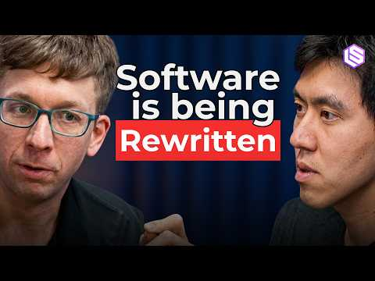 The Agent Cloud: Databricks’ Bet on the Future of AI — Matei Zaharia and Reynold Xin (19:36)
- 0:53-1:21 — AI Jason on proof-first PRs. Short, concrete rationale for making agents return Playwright artifacts so reviewers merge based on evidence, not narration [2].
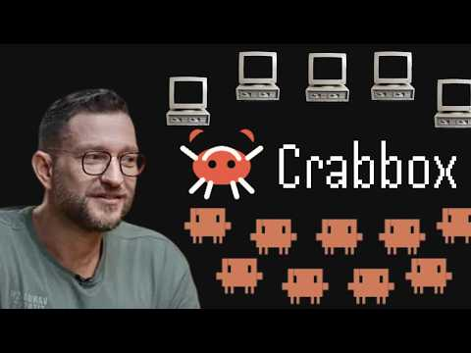 OpenClaw Creator’s new secret project… (0:53)
- 21:57-22:51 — Farhan Thawar on the Council of LLMs. A useful review architecture: have different models judge different aspects of a change before production, but keep a human responsible for the final PR [3].
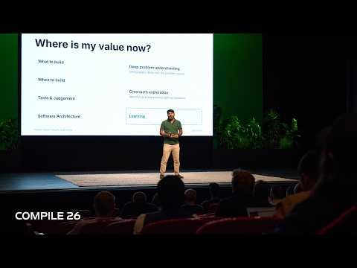 What Is Your Job Now, Farhan Thawar | Compile 26 (21:56)
- Study AI-Builder-Club/skills. It is one of the rare public, copyable setups that turns isolated sandboxes + verification artifacts into a reusable agent skill rather than a one-off demo [6, 2].
Editorial take: the winning teams are standardizing the control plane around agents — isolated runtimes, narrow deploy interfaces, session-aware policies, and explicit human ownership — because code generation is no longer the bottleneck. [2, 3, 5]

Sources
- Claude Code Creator: “I Run Thousands of AI Agents Every Night”
- OpenClaw Creator’s new secret project…
- What Is Your Job Now, Farhan Thawar | Compile 26
- Agents and Infrastructure, Sam Lambert | Compile 26
- The Agent Cloud: Databricks’ Bet on the Future of AI — Matei Zaharia and Reynold Xin
- 𝕏 post by @jasonzhou1993
- 𝕏 post by @mattpocockuk
- 𝕏 post by @kentcdodds
- Why the Frontier Ecosystem must be Open — Matei Zaharia and Reynold Xin, Databricks
- 𝕏 post by @cursor_ai
- 𝕏 post by @cursor_ai
- 𝕏 post by @leerob
- 𝕏 post by @jediahkatz
- 𝕏 post by @Sourcegraph
- 𝕏 post by @Sourcegraph

