Verification-First Agents and Durable Goals
Coding Agents Alpha Tracker
2026-07-23

Verification-First Agents and Durable Goals
By Coding Agents Alpha Tracker • July 23, 2026
Today’s strongest practical pattern is verification-first autonomy: use agents to build the tests, harnesses, and evidence around critical code. Also covered: durable acceptance criteria, context-management tactics, model routing, and new evaluation tooling.

🔥 TOP SIGNAL
The highest-leverage use of generated code is verification capacity—not a reason to lower the bar for production changes. Theo’s practical rule: keep verifying the important code, while using agents to generate disposable harnesses, edge-case explorers, custom debuggers, and stress tests around it; that code should stay out of the product. [1] Decode’s durable acceptance-criteria loop shows the complementary harness pattern: an agent should remain active until evidence meets the stated criteria, rather than stopping when it merely appears finished. [2]

⚡ TRY THIS
- Create a separate “verification slop” lane for every consequential diff. After a large change, ask the agent: “Summarize what changed in every file; flag anything surprising.” Then have it generate a throwaway test harness or one-off debugger to probe the risky assumptions—rather than merging that generated support code into production. Theo reports that per-file summaries surface odd changes quickly, and advocates disposable code specifically for verification. [1]
- Test a new API with weaker agents before users do. Package the API/SDK locally, then spin up several lower-capability agents and ask each to build something on top of it. Treat failures as integration feedback: fix the API, rerun the test, and only then ship. Theo’s version uses 10 agents and Grok models as deliberately cheap, imperfect API consumers. [1]
- Turn a long task into visible, editable acceptance criteria. In Decode, run Goal Add [task], review and edit the generated criteria, use goal amend to add constraints such as ensure that CI passes at the end, then goal resume. The goal persists until its criteria are met or the run is blocked—avoiding repeated restatement of the task. [2]
- Keep long-running agents out of context overload. Store oversized tool results in files, show the agent only the latest relevant slice, summarize at thresholds, and remove old write inputs once the file itself is durable. LangChain’s DeepAgents example stores a 60k-token response and initially exposes only the last 1k tokens, while preserving prompt-cache usefulness where possible. [3]

📡 WHAT SHIPPED
- Cursor Router: Cursor launched an Auto-mode model router that sends demanding requests to frontier models and simpler work to cheaper models. Cursor claims frontier-quality results at 60% lower cost; early-access users reportedly saw no quality drop versus routing every request to Opus 4.8. Teams and Enterprise admins can set defaults, allow/block models, and disable optimization modes. Read the Router post. [4, 5, 6]
- LangChain Eval Engineering Skill + langchain-skills: LangChain released an Eval Engineering Skill for helping coding agents build evals from repository context and agent traces. Its new langchain-ai/langchain-skills repo can be installed in Codex or Claude Code to generate a Harbor task, a target run, and a check on whether the verifier measured the intended behavior. [7, 8]
- Open-source Codex harness: Romain Huet described Codex’s app server and CLI harness as open source, with the app positioned as a command center for delegating work to agents. The harness emphasizes sandboxing so agents access only approved resources. [9]
- T3 Code’s inbox-style sidebar: The latest nightly build adds a settings toggle that treats agent threads as an inbox; clicking settle moves a completed thread to the bottom. Theo reports the workflow has helped him finish more work. [10]
- Claude voice + tools: Riley Brown reports that Claude voice mode now supports external-tool calls and Opus, including access to email, docs, Notion, and Vercel deployment workflows from voice. [11]

🎬 GO DEEPER
- 5:46–7:42 — Decode’s /goal loop in action. Watch an implementation reach native browser control, tests, and passing CI after the agent is given durable criteria rather than a one-shot prompt. The presenter reports starting at 3pm and returning around 7pm without having to keep a mental checklist.
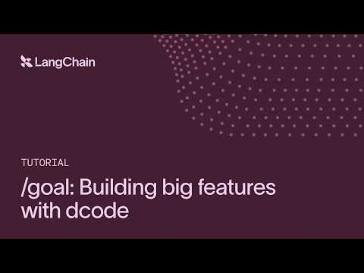 /goal: Building big features with dcode (5:46)
- 30:59–32:35 — Context engineering that keeps agents cheap and coherent. Harrison Chase walks through file-backed large outputs, threshold summaries, and trimming persisted write inputs without casually breaking prompt caching.
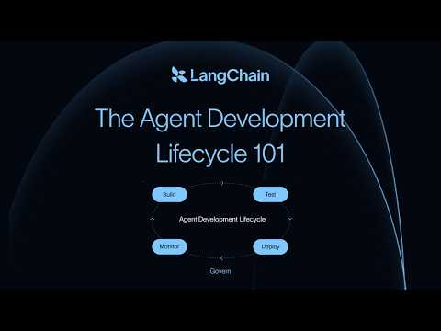 The Agent Development Lifecycle 101 by Harrison Chase (30:59)
- 71:16–73:21 — Poolside’s case for a minimal harness. Eiso Kant argues that, for long-horizon work, a model with a container, codebase, binaries, and a small tool set can write scripts with real control flow instead of selecting from an enormous tool menu. It is a useful counterpoint when deciding whether another MCP integration actually simplifies your agent.
 Poolside’s Model Factory, Laguna S, Open Models, and the Race to AGI — Eiso Kant, Poolside AI (71:16)
Editorial take: the emerging edge is not unrestricted autonomy—it is durable goals, cheap adversarial verification, and harnesses that make “done” demonstrable. [2, 1]

Sources
- You need to read less code (hear me out)
- /goal: Building big features with dcode
- The Agent Development Lifecycle 101 by Harrison Chase
- 𝕏 post by @cursor_ai
- 𝕏 post by @cursor_ai
- 𝕏 post by @cursor_ai
- 𝕏 post by @LangChain
- 𝕏 post by @LangChain
- The Agentic Harness: What Makes AI Agents Work in Production | Snowflake Dev Day 2026
- 𝕏 post by @theo
- 𝕏 post by @rileybrown

