Verification Loops Become the Coding-Agent Moat
Coding Agents Alpha Tracker
2026-07-28

Verification Loops Become the Coding-Agent Moat
By Coding Agents Alpha Tracker • July 28, 2026
Verification loops, context ablation, and scheduled maintenance agents lead today’s practical coding-agent playbook. Also covered: Deep Agents v0.7.0b2, Kimi K3 in Cursor, Buzz, and divergent early reports on Opus 5.

🔥 TOP SIGNAL
As agents run longer, verification is becoming the core engineering skill—not more detailed prompting. Claude Code lead Boris Cherny argues the practical challenge is giving an agent a hard task and making its work verifiable along the way; he calls verification the part most people get wrong. [1] LangChain CEO Harrison Chase makes the complementary case: evals define what an agent should do, and complex stateful agents need simulated environments with known-good and known-bad outcomes. [2]

⚡ TRY THIS
- Ablate your agent context after every model upgrade. Start with a repeatable task suite. Delete the entire system prompt, then restore instructions one line at a time only when you observe a concrete failure—Cherny describes this as an eval-like ablation process. In Claude Code, experiment with --system-prompt; CLAUDE_CODE_SIMPLE=1 removes system prompts, including tool prompts. Cherny says Anthropic removed 80% of its system prompt for newer models. [1]
- Give the agent an outcome plus a verification loop, not a recipe. For a UI rewrite, Cherny’s team used a short task: run the original Electron app in a Mac VM, screenshot it, compare it pixel-by-pixel with the Swift version, and keep going until complete. The reusable pattern: state the target, specify the observable check, then let the agent choose the implementation path. [1]
- Put recurring repository work on a scheduled agent loop. LangSmith Engine runs every six hours against traces to identify issues and propose code changes, evals, or datasets. For simpler maintenance, Cherny describes daily routines that find dead code using static and dynamic analysis, open deletion PRs, add needed tests, and unify duplicated abstractions. Start with one narrow routine and a PR-producing output. [2, 1]
- Audit CLAUDE.md as executable context. Jason Zhou’s agent-context-audit skill checks for conflicting instructions across CLAUDE.md, skills, and tools; flags rules that should be judgment calls; detects docs drift; and quizzes docs for missing gotchas. Zhou reports cutting his own CLAUDE.md by about 50%. Study or run the skill repository. [3]

📡 WHAT SHIPPED
- LangChain Deep Agents v0.7.0b2: base input prompting was cut by more than half; any default middleware can now be overridden; LangChain describes the base harness as more performant and configurable. Changelog. [4, 5]
- Kimi K3 in Cursor: Cursor says K3 scores close to the frontier on CursorBench. It is offered through US-based inference partners Fireworks, Together, and Baseten, with Zero Data Retention support. [6]
- Buzz: an emerging open-source, decentralized agent manager built on Nostr. It can put agents from multiple harnesses—Claude Code, Codex, and Pi among them—into chat, delegate work in parallel Git worktrees, and use local models or pooled community compute. Riley Brown finds it promising for teams and shallow tasks, but not yet ready for large complex work; he also misses a terminal-level activity view. [7]
- Early Opus 5 reports are mixed—route and verify. Theo found it more likely to catch issues Fable missed, but later reported over-correction and unnecessary large fixes. Separately, Salvatore Sanfilippo’s early hands-on comparison found GPT-5.6 Sol stronger for his kernel work, longer autonomous runs, and explanations. These are practitioner observations, not a general ranking. [8, 9, 10]

🎬 GO DEEPER
- 20:13–20:35 — Boris Cherny on verification as the missing agent skill. A compact framing for designing long-running tasks: make the result checkable rather than micromanaging the execution. [1] 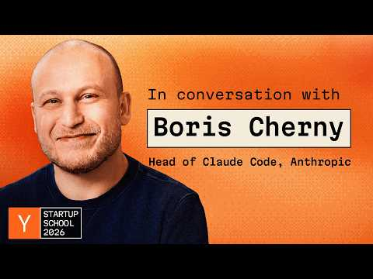 Boris Cherny: Building Claude Code (20:13)
- 06:16–06:36 — Harrison Chase on an ambient agent that turns traces into proposed improvements. LangSmith Engine’s six-hour loop is a concrete example of moving from dashboards to action: it proposes code, eval, and dataset changes from observed traces. [2] 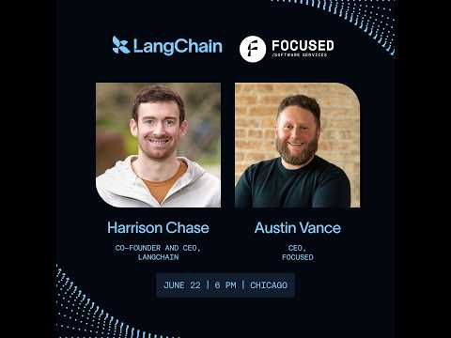 Agents in the Enterprise: Deep Agents, Evals, and Ambient UX | Austin Vance and Harrison Chase (6:16)
- Repo to study: AI-Builder-Club/skills. The agent-context-audit skill is a useful reference for treating agent instructions as a maintained, testable artifact rather than static documentation. [3]
Editorial take: agent autonomy is rising fast; the durable workflow advantage is a compact context plus an explicit loop that proves the agent’s output is right. [1, 2]

Sources
- Boris Cherny: Building Claude Code
- Agents in the Enterprise: Deep Agents, Evals, and Ambient UX | Austin Vance and Harrison Chase
- 𝕏 post by @jasonzhou1993
- 𝕏 post by @sydneyrunkle
- 𝕏 post by @LangChain
- 𝕏 post by @cursor_ai
- 𝕏 post by @hot_town
- 𝕏 post by @theo
- 𝕏 post by @theo
- Considerazioni durante un viaggio di ritorno da Portopalo a Catania

