Verification Loops Take Center Stage as Agents Move Into Review and Security
Coding Agents Alpha Tracker
2026-04-11

Verification Loops Take Center Stage as Agents Move Into Review and Security
By Coding Agents Alpha Tracker • April 11, 2026
The biggest practical theme today is verification. Engineers are getting the most leverage from coding agents when every generation feeds a test, linter, screenshot, exploit check, or human review step — and the strongest examples now span security research, UI review, and solo product workflows.

🔥 TOP SIGNAL
Frontier coding agents look most real where outputs can be mechanically checked. Salvatore Sanfilippo’s Redis pipeline uses GPT 5.4 xhigh in a strict target → audit → validate loop and has already produced 122 validated crash-class reports, while Theo’s recap of Nicholas Carlini’s Anthropic workflow describes file-by-file exploit hunting with ~100% verification success on 500 validated findings [1, 2]. The durable takeaway is not “trust the model” but “wrap the model in verification, dedupe, and human judgment” — which is exactly the loop LangChain is now formalizing for teams deploying agents [3].

🛠️ TOOLS & MODELS
- Artifact review is becoming a product feature. Cursor cloud agents can now attach demos and screenshots to PRs; Theo says Cursor’s cloud stack looks ahead right now, and Addy notes GitHub Copilot Agent already shows before/after visual diffs for requested UI changes. Review surface is shifting from raw patches to artifacts teammates can inspect quickly [4, 5, 6, 7].
- Chrome DevTools MCP + Figma MCP is a practical new loop. DevTools MCP gives agents browser-level runtime context — rendered UI, console logs, network logs — while Figma MCP lets the agent pull design context; Addy explicitly recommends combining them so the agent implements from design, then checks the real render in Chrome [7].
- Local/open model signal is mixed, not uniform. Google says Gemma 4 spans 2B to 32B models, with the smallest running on phones and even Raspberry Pi, the 31B fitting a consumer GPU, and demos showing multiple on-device agentic/coding sessions running offline; at the same time, Theo says Gemma 4 posted “horrible numbers” in his benches, while cmgriffing says Minimax 2.7 has been strong for his code tasks [8, 9, 10].
- Meta’s tool surface is worth watching because the primitives are familiar. Simon Willison found a remote Python sandbox, file-editing tools (container.view/insert/str_replace), and subagents.spawn_agent; his read is that file editors and sub-agent tools are becoming standard harness building blocks across ecosystems [11].

💡 WORKFLOWS & TRICKS
- Run a human-judgment loop, not a hope loop. LangChain’s new guide on human judgment in the agent improvement loop says: deploy early, have domain experts review what broke, convert that feedback into automated evals, and repeat. Armin’s team describes a concrete version in PI: let the agent auto-fix mechanical issues, but flag human-only callouts like DB migrations and permission changes for explicit judgment [3, 8].
- Steal Salvatore’s 3-pass security pipeline. Step 1: scan candidate C files, pick one risky surface (parser, state transition, cleanup path), and dedupe against already validated findings. Step 2: investigate a single crash-class candidate. Step 3: hand the markdown report to a separate validator and accept it only if it can show a realistic path or strict sanitizer-backed reproduction. That setup is what produced the 122 validated Redis reports [1].
- Context engineering still beats vague prompting. Addy recommends feeding agents requirements, examples, docs, conversation history, and codebase background — not just a high-level ask. Then force an explanation pass: ask why this is the best approach, ask it to search the monorepo for prior art, and read the reasoning/architecture summary after generation so you actually understand the change [7].
- Jason’s Alpha Henge harness is basically LLM fuzzing with a ruthless gate. Write or dictate a spec, let VS Code Insiders + Copilot generate tasks, route work across models with Thompson/GP sampling, keep the agents from talking to each other, and let linters/tests/retries kill bad outputs. His evaluation loop is intentionally brutal: success/fail only over ZeroMQ, linter-driven retries, and overlong code gets disqualified [12].
- Cheap hack: add brevity constraints. ThePrimeTime’s “caveman” preset strips articles, pleasantries, and hedging while leaving technical terms, code blocks, and quoted errors untouched. He shows 69→19-token and 1180→159-token examples, and points to a March 2026 result claiming brief responses improved accuracy by 26 percentage points [13].
- Solo-builder loop worth copying. Ashe Magalhaes prototypes inside a private template library, posts the promising ones publicly for feedback, and when something gets traction she tells 5.4/Codex to break the validated chunk into a standalone product or open-source repo. She runs the whole thing through Slack channels with instrumentation so agents can alert, patch, and up-manage her asynchronously [14].

👤 PEOPLE TO WATCH
- Salvatore Sanfilippo — High signal because he is publishing an actual security pipeline on a real codebase, with strict validation and false-positive filtering instead of vague “AI found bugs” claims [1].
- Addy Osmani — Worth following for grounded advice on where agents help, where they break, how to use MCP/browser tooling, and why code review + critical thinking are becoming more important, not less [7].
- Ashe Magalhaes — Useful if you are a solo builder: her workflow is concrete, fast, and instrumented — prototype privately, validate publicly, then let agents split products out and maintain them [14].
- Lalit Maganti — His syntaqlite writeup is one of the clearest recent explanations of where AI is great (concrete prototypes) and where it can be actively harmful (high-level architecture and deferred design decisions) [11].
- Ido Salman — AgentCraft matters because it treats orchestration as an interface problem — visibility, heatmaps, quick reactions, review bundles, and shared workspaces — not just better chat prompts [8].

🎬 WATCH & LISTEN
- 0:11-4:44 — Redis bug-finding pipeline. Salvatore explains the full target → audit → validate loop and, crucially, why strict reproducibility filters matter more than raw bug counts [1].
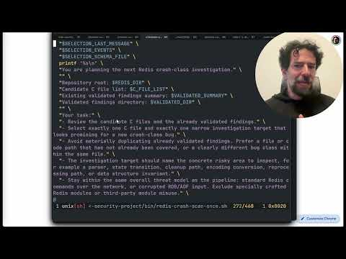 Trovare bug di sicurezza (su Redis) con GPT 5.4 xhigh (0:11)
- 5:43-7:43 — Addy on why code review is the new leverage point. Strong two-minute case for using review to teach juniors, surface team history/best practices, and catch the architecture issues models still miss [7].
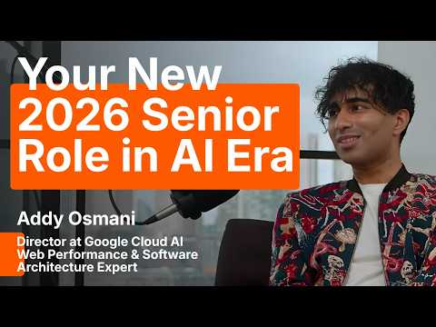 Addy Osmani on Why 2026 Seniors are just highly-paid Code Editors (5:42)
- 44:54-46:23 — Alpha Henge’s evaluation loop. Jason’s short demo of the part that matters: hundreds of agents, almost no agent-to-agent chatter, and linters inside VS Code Insiders acting as the final gate [12].
 Hyper Engineering SF - Spending trillions of tokens (44:54)

📊 PROJECTS & REPOS
- AgentCraft. Free, experimental orchestrator that turns agent work into something you can actually supervise: filesystem map, mission status, change lineage, collision heatmaps, campaign containers, review bundles with screenshots/video, and human/agent shared workspaces [8].
- Hunk. Ben Vinegar’s terminal diff reviewer. The interesting idea is not just “better diffs” but letting the agent annotate the diff so review comments can be separated between what goes back to the model, what goes back to your brain, and what needs another human reviewer. He says it is already attracting contributors [15].
- syntaqlite. Lalit Maganti’s “high-fidelity devtools that SQLite deserves.” Claude Code helped get the first prototype over the hump, but the retrospective is the real value: AI accelerated implementation while making deferred design decisions more expensive later [11].
- CCR router / CCR Rust. The routing layer behind Jason’s Alpha Henge: combine multiple token plans/models, route tasks with GP/Thompson logic, and save 40-70% tokens in the creator’s own setup. Worth studying if you are stitching together a multi-model harness [12].
- Caveman. Julius Brussy’s tiny prompt hack repo is low-tech but practical: same results, far fewer output tokens, and lower cost if you live in long Claude sessions [13].
Editorial take: the edge is moving to teams that add more verification surfaces — tests, screenshots, logs, diff review, and explicit human judgment — around their agents, not teams that just ask the model to “go build it.” [3, 7, 1]

Sources
- Trovare bug di sicurezza (su Redis) con GPT 5.4 xhigh
- I’m scared about the future of security
- 𝕏 post by @LangChain
- 𝕏 post by @cursor_ai
- 𝕏 post by @theo
- 𝕏 post by @theo
- Addy Osmani on Why 2026 Seniors are just highly-paid Code Editors
- AIE Europe Day 2: ft Google Deepmind, Anthropic, Cursor, Factory, Linear, HF, Cerebras & more
- 𝕏 post by @theo
- 𝕏 post by @cmgriffing
- Meta’s new model is Muse Spark, and meta.ai chat has interesting new tools
- Hyper Engineering SF - Spending trillions of tokens
- No way this actually works
- Builders Unscripted: Ep. 2 - Ashe Magalhaes, Founder of Hearth AI
- State of Agentic Coding #5 with Armin and Ben

