Vertical AI Rounds and the Next Layer of Agent Infrastructure
VC Tech Radar
2026-04-30

Vertical AI Rounds and the Next Layer of Agent Infrastructure
By VC Tech Radar • April 30, 2026
Bolto, Lance, and AgentMail led fresh early-stage financing, while Legora, p0, Reachy Mini, Mesa, LlamaParse MCP, and GPT-5.5-Cyber highlighted where founders and frontier systems are pushing next. Investor commentary sharpened around compute bottlenecks, application durability, rising model-cost pressure, and how tiny AI-native teams may be formed.

Funding & Deals
- Bolto — $12M Series A. YC S23 company Bolto raised a $12M Series A led by Standard_Cap. The company is building a single AI-native product spanning recruiting, HR, and payroll; founders are Mrinal Singh and Jake. [1]
- Lance — $5M seed for hotel operations. YC says Lance raised a $5M seed. Its AI agents answer guest calls and messages, create and route work orders, update systems, and coordinate staff in real time inside a workflow still run through calls, radios, and manual coordination. [2]
- AgentMail — $6M seed for agent-native email. SaaStr reports AgentMail raised $6M from General Catalyst, Paul Graham, and Dharmesh Shah, with Python and TypeScript SDKs, webhooks, and SPF/DKIM/DMARC handled. In one SaaStr test, Claude ranked it first for agent email because the company clearly named the category, kept pricing and docs public, and had fresh authority signals. [3]

Emerging Teams
- Legora. Paul Graham called Legora the most impressive startup he has visited in years, predicted it will surpass Harvey by 2027, and argued law may be one of the few domains that can be defended against model companies. That matches Elad Gil’s broader view that legal AI can be durable when the product improves with model quality and becomes deeply embedded in workflow. [4, 5]
- p0 / parallel.ai. Sarah Sachs said the best agentic web search provider balances token use, total trajectory latency, and net new information, and singled out p0 for having a solid product and strong technology. Parag highlighted the team’s “craft, obsession, fun,” launched pioneers.parallel.ai, and is hiring. Andrew Reed separately linked p0’s framing to his view that 2026 is becoming the year of long-horizon agents. [6, 7, 8, 9]
- Reachy Mini / Xenova. Clement Delangue described Reachy Mini as the first robot shipping with agentic software and later called it the first “agent-native robot.” The open-source hardware project shipped 1,000 units last week and 1,000 this week, with more expected in early May; Delangue also said he built his first app for the new version in under an hour with Claude. [10, 11]
- Two YC vertical AI launches. Saudara AI says it connects US brands with vetted overseas factories through an AI-powered broker that is 10x faster than traditional sourcing agents; founders are Edward Haryono and Jen. Zolvo says it automates reconciliation, collections, and monitoring for commercial lenders at 80% lower operational cost per dollar; founders are Isabela and Tony. [12, 13]

AI & Tech Breakthroughs
- GPT-5.5-Cyber is moving from model release to targeted deployment. Sam Altman said OpenAI is starting rollout of GPT-5.5-Cyber to critical cyber defenders within days and plans to work with the broader ecosystem and government on trusted access. [14]
- Agent infrastructure is getting real file and document primitives. Mesa describes itself as a POSIX-compatible filesystem with built-in version control for agent artifacts, including branches, durable storage, sparse materialization, access control, and full history; design partners are already using it in production across legal, healthcare, GTM, business ops, and coding agents. Jerry Liu said the product is “really well thought out” and argued filesystems are becoming the default abstraction for agent-document interaction. LlamaIndex’s LlamaParse MCP server addresses the adjacent document layer by parsing to markdown, classifying files, splitting long documents, and adding upload, auth, rate limiting, and observability for production MCP deployments. [15, 16, 17, 18]
- Pi points toward more minimal, self-modifying coding harnesses. Pragmatic Engineer reports Mario Zechner built Pi after Claude Code became unpredictable. Pi is intentionally minimalist, can modify itself to create specialized harnesses for specific tasks, and is the foundation for OpenClaw. [19]
- Runway is pushing video models toward world models and real-time agents. Runway says training on video lets models implicitly learn properties of the physical world such as physics, gravity, reflection, and cause/effect. It is pairing that direction with omni models and “Characters,” real-time interactive video agents available via API, while also positioning “physical AI” as a path into robotics simulation and policy testing. [20]

Market Signals
- Near-term lab competition may stay tighter than expected. Elad Gil said HBM memory is the main bottleneck across labs today, which limits how far any one player can pull ahead; he expects data centers and power to become the next constraints. His base case remains a durable oligopoly among core labs unless one unexpectedly opens a major capability gap. [5]
- Application-layer diligence now turns on durability. Elad Gil’s test is whether the product improves as models improve, embeds deeply into workflows, and accumulates proprietary data. He is bullish on AI overall but says most companies in the cycle will fail and many should explicitly ask whether the next 12-18 months is their value-maximizing exit window. [5]
- Fundraising is sharply bifurcated. Elizabeth Yin says founders with genuinely new AI ideas are still raising large amounts of capital, while teams in crowded categories often cannot raise at all. [21]
- Cost pressure is pushing buyers toward cheaper and open models—and toward usage pricing. Harrison Chase called high closed-model cost a defining 2026 theme, said LangChain is focused on making deepagents work well with OSS models, and pointed to materially cheaper alternatives that produced the same result. In parallel, a SaaS discussion around GitHub Copilot’s move to usage-based “AI Credits” argues flat seat pricing breaks once agentic workflows make token burn unpredictable. [22, 23, 24, 25]
- Small-team startup formation may change, but co-founder history still matters. Sam Altman argued AI enables a “revenge of the idea guys,” making non-technical founders with deep user understanding more fundable, and said two- to three-person startups become unusually productive when AI gets access to meetings, code, Slack, and email. He also said long prior relationships between co-founders remain one of the strongest predictors of startup success. [26]

Worth Your Time
- Elad Gil interview. Covers compute bottlenecks, AI app durability criteria, and why many teams should test whether they are building one of the durable few. Watch here [5] 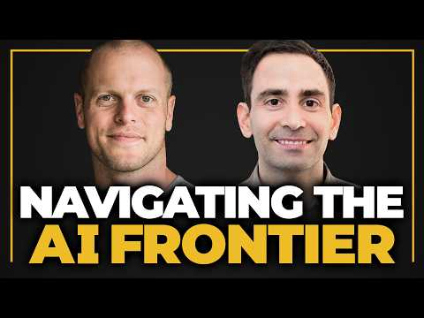 The AI Frontier and How to Spot Billion-Dollar Companies Before Everyone Else — Elad Gil (18:03)
- Sam Altman x Patrick Collison. Covers the “revenge of the idea guys,” data-rich two- to three-person startups, and co-founder history as a predictor of success. Watch here [26] 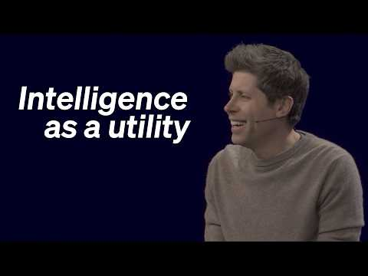 Sam Altman in conversation with Patrick Collison (32:08)
- Pragmatic Engineer on Pi. Explains why Pi was built, how self-modifying harnesses work, and why automation bias can reduce code quality. Read here [19]
- Bolto founder interview. Interview with the Bolto founders following the company’s $12M Series A. Watch here [1, 27]

Sources
- 𝕏 post by @daltonc
- 𝕏 post by @ycombinator
- I Need Agentic Email. Claude Said Try AgentMail For a New Project. So I Did. And Never Looked At Anything Else.
- 𝕏 post by @paulg
- The AI Frontier and How to Spot Billion-Dollar Companies Before Everyone Else — Elad Gil
- 𝕏 post by @sarahmsachs
- 𝕏 post by @paraga
- 𝕏 post by @andrew__reed
- 𝕏 post by @paraga
- 𝕏 post by @ClementDelangue
- 𝕏 post by @ClementDelangue
- 𝕏 post by @ycombinator
- 𝕏 post by @ycombinator
- 𝕏 post by @sama
- 𝕏 post by @olvrgln
- 𝕏 post by @jerryjliu0
- 𝕏 post by @llama_index
- 𝕏 post by @jerryjliu0
- Building Pi, and what makes self-modifying software so fascinating
- For Runway, AI video was step one. Now they’re trying to build worlds | Equity Podcast
- 𝕏 post by @dunkhippo33
- 𝕏 post by @hwchase17
- 𝕏 post by @GitMaxd
- r/SaaS post by u/Responsible-Can6007
- r/SaaS comment by u/Emerald-Bedrock44
- Sam Altman in conversation with Patrick Collison
- 𝕏 post by @daltonc

