Zero to One, The Bitter Lesson, and an Austin Housing Case Study
Recommended Reading from Tech Founders
2026-04-15

Zero to One, The Bitter Lesson, and an Austin Housing Case Study
By Recommended Reading from Tech Founders • April 15, 2026
Anj Midha credits Peter Thiel, Richard Feynman, and Rich Sutton with shaping how he thinks about competition, teaching, and compute-driven discovery. Bill Gurley adds a Pew article on Austin housing supply as an empirical read for affordability debates.

High-signal recommendations
Today’s authentic signal is concentrated: Anj Midha surfaced three durable resources on competition, teaching, and compute-driven discovery, while Bill Gurley highlighted one empirical article on housing affordability [1, 2].

Most compelling recommendation

Zero to One
- Content type: Book [1]
- Author/creator: Peter Thiel [1]
- Link/URL: Not provided in source material
- Who recommended it: Anj Midha [1]
- Key takeaway: Midha credits Thiel’s Stanford class, later turned into Zero to One, with shaping his business thinking. He updates the familiar line “competition is for losers” into a frontier-AI view: neither commoditized overcompetition nor monopoly is healthy; the best structure is “optimal competition” with three or four top teams in each frontier [1]
- Why it matters: This is the day’s strongest pick because the recommendation comes with an applied framework readers can use to think about startup positioning and market structure right now [1]
“competition is for losers” [1]

Also worth reading from the same conversation

The Bitter Lesson
- Content type: Essay [1]
- Author/creator: Rich Sutton [1]
- Link/URL: Not provided in source material
- Who recommended it: Anj Midha [1]
- Key takeaway: Midha says the essay still holds in unsaturated domains. He contrasts saturated areas like coding with materials science, where he says more compute is still generating super-exponential gains per iteration [1]
- Why it matters: This is a precise recommendation for readers trying to understand where scaling still appears most powerful, rather than treating the debate as one-size-fits-all [1] 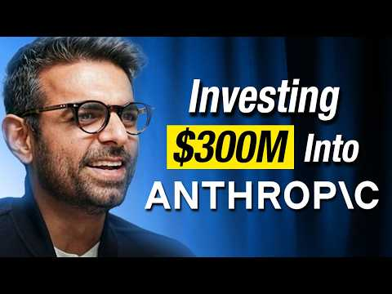 The Early Days of Anthropic & How 21 of 22 VCs Rejected It | The Four Bottlenecks in AI | Anj Midha (1:44)

The Feynman Lectures on Physics
- Content type: Lectures / book series [1]
- Author/creator: Richard Feynman [1]
- Link/URL: Not provided in source material
- Who recommended it: Anj Midha [1]
- Key takeaway: Midha says the lectures influence how he teaches because they combine technical education with life lessons [1]
- Why it matters: It stands out as a recommendation about explanatory style as much as subject matter: how to teach hard things without stripping away the human element [1]

One empirical policy read

Austin’s Surge of New Housing Construction Drove Down Rents
- Content type: Research article [2]
- Author/creator: Pew [2]
- Link/URL: https://www.pew.org/en/research-and-analysis/articles/2026/03/18/austins-surge-of-new-housing-construction-drove-down-rents?utm_campaign=pewtrusts&utm_source=twitter&utm_medium=social [2]
- Who recommended it: Bill Gurley [3]
- Key takeaway: Gurley points to Austin as a case where a surge in new housing construction drove down rents even as population grew [3, 2]
- Why it matters: He frames it as a seriousness test for leaders who say they care about affordability, which makes this a useful evidence read rather than a generic policy opinion [3]
“If your local leaders says they ‘care’ about housing affordability and can’t share all they have learned studying Austin, they aren’t serious. They are performative.” [3]

Bottom line
The clearest pattern today is that the best recommendations came with explicit models attached. Midha’s picks offer frameworks for competition, scaling, and teaching [1]. Gurley’s Austin article adds an empirical case study with immediate policy relevance [2, 3].

Sources
- The Early Days of Anthropic & How 21 of 22 VCs Rejected It | The Four Bottlenecks in AI | Anj Midha
- 𝕏 post by @scottlincicome
- 𝕏 post by @bgurley

